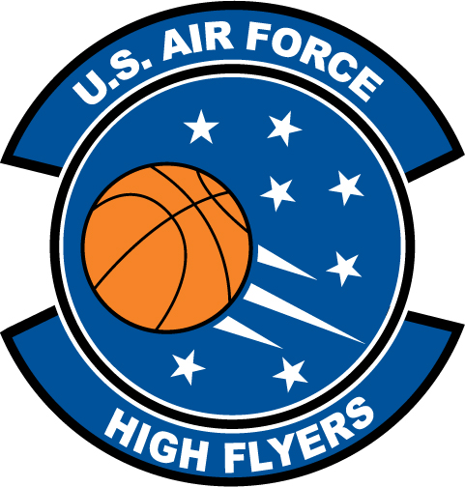

Denzel Ingram - Chapel Hill
U.S. Air Force High Flyer of the Week – North Carolina

The U.S. Air Force 337th Recruiting Squadron honors Chapel Hill High School’s Denzel Ingram as a 2011-2012 U.S. Air Force High Flyer of the Week as the best high school basketball player in North Carolina. Ingram poured in a career-high 43 points to lead Chapel Hill to a 75-71 win over Raleigh Broughton at the Holiday Invitational Tournament. The U.S. Air Force recognizes this exceptional individual performance and the incredible skill, dedication, and teamwork required to accomplish team goals.
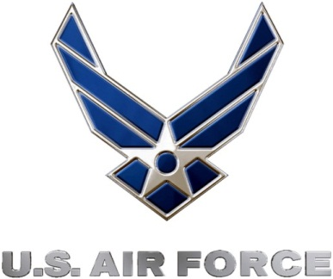 |  | Commanding Officer  U.S. Air Force 337th Recruiting Squadron

