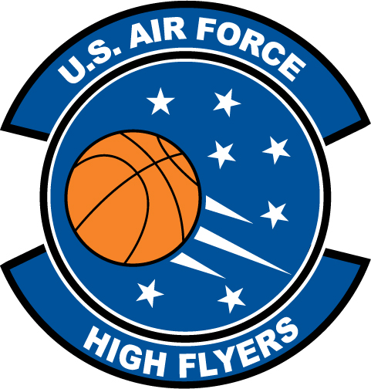

Martin Alston – Granville Central
U.S. Air Force High Flyer of the Week – North Carolina

The U.S. Air Force 337th Recruiting Squadron honors Granville Central’s Martin Alston as a 2011-2012 U.S. Air Force High Flyer of the Week as the best high school basketball player in North Carolina. Alston stripped the nets for 30 points to lead Granville Central to an 86-44 win over Voyager Academy. The U.S. Air Force recognizes this exceptional individual performance and the incredible skill, dedication, and teamwork required to accomplish team goals.
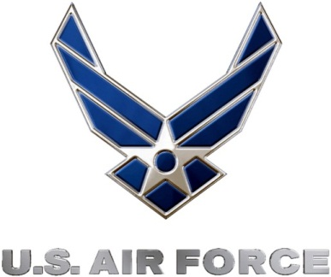 |  | TROY C. KIMBALL, Lieutenant Colonel, USAF  Commander, 337th Recruiting Squadron

