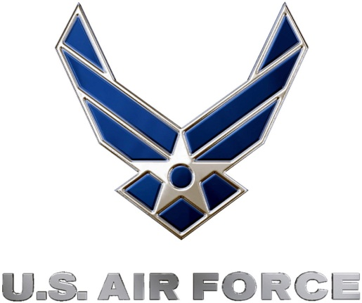
U.S. Air Force Precision Air Strike of the Week
Week Four Nominees
U.S. Air Force to honor the best passing combinations in high school football

FOR IMMEDIATE RELEASE CONTACT: Mike Sinnott
26 SEPTEMBER 2011 (517) 927-4570

OKLAHOMA CITY – The U.S. Air Force’s 349th Recruiting Squadron is proud to announce the nominees for the Precision Air Strike of the Week, honoring the best passing combinations in Kansas high school football.

Fans can vote online for the weekly winner at www.TheSportsFlash.com until 9:00 P.M. EDT on Thursday. The winner will be announced on Friday.

U.S. Air Force Precision Air Strike of the Week - Nominees
Basehor-Linwood  QB: Colin Murphy  WR: Ben Johnson | Murphy threw for 372 yards (20/30) with four scores without an interception while Ben Johnson had 11 receptions for 186 yards and three touchdowns in Basehor-Linwood’s 69-26 win over Bonner Springs.
Central  QB: Bo Savage  WR: Ky Biddle | Savage completed 11-of-15 passes for 264 yards with eight touchdowns in Central’s 62-0 win over Bucklin. Biddle had four catches for 103 yards with four scores in the Central win.
Emporia  QB: Braxton Marstall  WR: Jerel Morrow | Marstall completed 10-of-15 passes for 232 yards with three touchdowns, connecting with Morrow on three passes for 111 yards and an 87-yard scoring strike in Emporia’s 54-7 win over Topeka West.
White City  QB: Jaren Nittler  WR: Paris McNeil | Nittler was 13-for-16 with 342 yards passing and seven touchdowns, connecting with McNeil for five completions for 159 yards with four scores in White City’s 52-6 win over Centre.

“The Sports Flash” (TSF) Radio Network will accept nominations each week from high school football coaches, athletic directors, the media, and high school football fans. High school football fans will vote online for the weekly winner and each weekly winner will be a finalist for the U.S. Air Force Precision Air Strike of the Year. Each U.S. Air Force Precision Air Strike of the Week will receive a tee-shirt and certificate.

Throughout the campaign, fans can visit www.TheSportsFlash.com to state updated on the campaign, vote for the weekly winner, and much more.

For the U.S. Air Force, people are its most valuable asset. Without them, even the most advanced systems are rendered useless. The U.S. Air Force recruits quality airmen from a cross-section of America to meet the Air Force’s ever-changing needs. The Air Force has more than 140 enlisted career opportunities available for qualified men and women. For more information about the enlisted, officer, and healthcare professional job opportunities in the U.S. Air Force, contact your local Air Force recruiter. Recruiter contact information is available by calling 1-800-423-USAF (8723) or visit the Recruiter Locator link on the official Air Force recruiting web site at www.airforce.com.

“The Sports Flash” (TSF) Radio Network delivers customized, local sports reports for 190 network affiliates in 13 states. TSF Radio Network coordinates the U.S. Air Force Air Strike of the Week campaign for the 349th Recruiting Squadron. For more information, please contact TSF Radio Network’s Mike Sinnott at (517) 927-4570.

###

