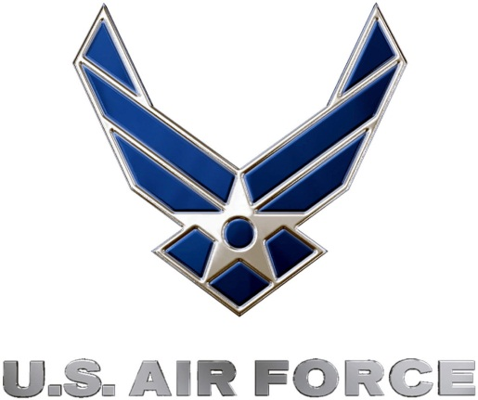
U.S. Air Force Precision Air Strike of the Week
Week Three Nominees
U.S. Air Force to honor the best passing combinations in high school football

FOR IMMEDIATE RELEASE CONTACT: Mike Sinnott
19 SEPTEMBER 2011 (517) 927-4570

OKLAHOMA CITY – The U.S. Air Force’s 349th Recruiting Squadron is proud to announce the nominees for the Precision Air Strike of the Week, honoring the best passing combinations in Kansas high school football.

Fans can vote online for the weekly winner at www.TheSportsFlash.com until 9:00 P.M. EDT on Thursday. The winner will be announced on Friday.

U.S. Air Force Precision Air Strike of the Week - Nominees
Bishop Miege  QB: Montel Cozart  WR: McKinley Johnson | Cozart was 19 of 28 with 233 yards and four touchdown tosses, including two scoring strikes to McKinley Johnson (24, 45) in Bishop Miege’s 34-0 win over Gardner Edgerton.
Dodge City  QB: Taylor Murphy  WR: Isaiah Bradshaw | Murphy threw for 280 yards with three scores in Dodge City’s 63-6 win over North. Bradshaw had five receptions for 94 yards with a score.
Herington  QB: Dylan Geissert  WR: Dylan Barber | Geissert had 30 completions for 418 yards with four scores in Harington’s 42-26 win over Council Grove. Barber had four catches for 113 yards and two scores.
Lawrence Free State  QB: Kyle McFarland  WR: Calloway Schmidt | McFarland completed 10 for 19 with 205 yards and five touchdowns, connecting with Calloway Schmidt on the game-winning scoring strike from 28 yards out late in the fourth-quarter.
Macksville  QB: Seth Filbert  WR: Adam Oak | Filbert threw for 367 yards with four touchdowns with Oak making 12 catches for 252 yards and all four scores in Macksville’s 48-14 win over Fairfield.

Mulvane  QB: Ty Redington  WR: Todd Parton | Redington was 20 for 34 with 325 yards and four touchdowns in Mulvane’s 40-12 win over Pratt. Redington connected with Parton on five passes for 106 yards with two touchdowns.

“The Sports Flash” (TSF) Radio Network will accept nominations each week from high school football coaches, athletic directors, the media, and high school football fans. High school football fans will vote online for the weekly winner and each weekly winner will be a finalist for the U.S. Air Force Precision Air Strike of the Year. Each U.S. Air Force Precision Air Strike of the Week will receive a tee-shirt and certificate.

Throughout the campaign, fans can visit www.TheSportsFlash.com to state updated on the campaign, vote for the weekly winner, and much more.

For the U.S. Air Force, people are its most valuable asset. Without them, even the most advanced systems are rendered useless. The U.S. Air Force recruits quality airmen from a cross-section of America to meet the Air Force’s ever-changing needs. The Air Force has more than 140 enlisted career opportunities available for qualified men and women. For more information about the enlisted, officer, and healthcare professional job opportunities in the U.S. Air Force, contact your local Air Force recruiter. Recruiter contact information is available by calling 1-800-423-USAF (8723) or visit the Recruiter Locator link on the official Air Force recruiting web site at www.airforce.com.

“The Sports Flash” (TSF) Radio Network delivers customized, local sports reports for 190 network affiliates in 13 states. TSF Radio Network coordinates the U.S. Air Force Air Strike of the Week campaign for the 349th Recruiting Squadron. For more information, please contact TSF Radio Network’s Mike Sinnott at (517) 927-4570.

###

