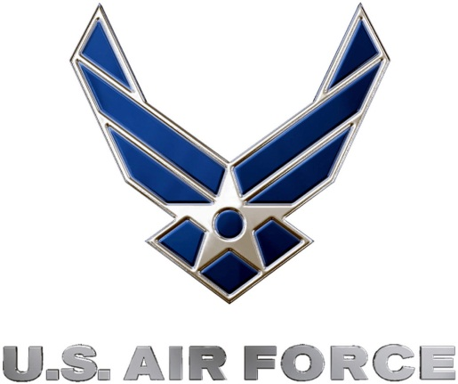
U.S. Air Force Precision Air Strike of the Week
Week Two Nominees
U.S. Air Force to honor the best passing combinations in high school football

FOR IMMEDIATE RELEASE CONTACT: Mike Sinnott
12 SEPTEMBER 2011 (517) 927-4570

OKLAHOMA CITY – The U.S. Air Force’s 349th Recruiting Squadron is proud to announce the nominees for the Precision Air Strike of the Week, honoring the best passing combinations in Kansas high school football.

Fans can vote online for the weekly winner at www.TheSportsFlash.com until 9:00 P.M. EDT on Thursday. The winner will be announced on Friday.

U.S. Air Force Precision Air Strike of the Week - Nominees
Buhler  QB: Chandler Shantz  WR: J.P. Lohrentz | Shantz completed six passes for 151 yards with a touchdown, completing five of his passes to Lohrentz with a touchdown as Buhler whipped Wellington, 56-6.
Cherryvale  QB: Devon Hestand  WR: Cody O’Brien | Hestand completed 6-of-8 passing attempts for 164 yards with two scores while O’Brien had two receptions for 91 yards with a score in Cherryvale’s 54-6 win over Northeast-Arma.
Newton  QB: Coleman Kingsley  WR: Seth Hill | Kingsley threw for 153 yards with one touchdown hitting Hill for 136 yards and a touchdown in Newton’s 45-23 win over Andover.
Waverly  QB: Travis Sipe  WR: Tanner Smith | Sipe threw for 157 yards with two scoring strikes to Smith, who finished with four total catches for 107 yards, as Waverly knocked off Southern Cofey, 38-18.
Wichita East  QB: Desmond McGee  WR: DaAnte Brandon | McGee was 15-for-22 with 224 yards and four touchdowns, connecting with Brandon for five times for 115 yards with four scores in Wichita East’s 49-33 win over Wichita West.

“The Sports Flash” (TSF) Radio Network will accept nominations each week from high school football coaches, athletic directors, the media, and high school football fans. High school football fans will vote online for the weekly winner and each weekly winner will be a finalist for the U.S. Air Force Precision Air Strike of the Year. Each U.S. Air Force Precision Air Strike of the Week will receive a tee-shirt and certificate.

Throughout the campaign, fans can visit www.TheSportsFlash.com to state updated on the campaign, vote for the weekly winner, and much more.

For the U.S. Air Force, people are its most valuable asset. Without them, even the most advanced systems are rendered useless. The U.S. Air Force recruits quality airmen from a cross-section of America to meet the Air Force’s ever-changing needs. The Air Force has more than 140 enlisted career opportunities available for qualified men and women. For more information about the enlisted, officer, and healthcare professional job opportunities in the U.S. Air Force, contact your local Air Force recruiter. Recruiter contact information is available by calling 1-800-423-USAF (8723) or visit the Recruiter Locator link on the official Air Force recruiting web site at www.airforce.com.

“The Sports Flash” (TSF) Radio Network delivers customized, local sports reports for 190 network affiliates in 13 states. TSF Radio Network coordinates the U.S. Air Force Air Strike of the Week campaign for the 349th Recruiting Squadron. For more information, please contact TSF Radio Network’s Mike Sinnott at (517) 927-4570.

###

