Mulvane
Ty Redington & Todd Parton
U.S. Air Force Precision Air Strike of the Week - Kansas

The U.S. Air Force 349th Recruiting Squadron honors Mulvane High School’s Ty Redington and Toddd Parton as the U.S. Air Force Precision Air Strike of the Week as the top high school football passing combination in Kansas. Redington threw for 269 yards with five touchdowns, hitting Parton on two scoring strikes in a 46-13 win over Winfield. The U.S. Air Force recognizes the skill, dedication, and teamwork required of both players to accomplish team goals.
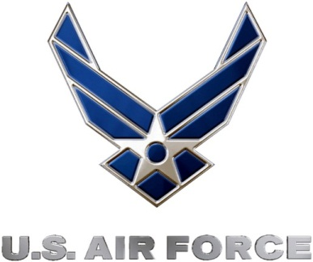 |  | Commanding Officer  U.S. Air Force 349th Recruiting Squadron

