Emporia
Braxton Marstall & Jerel Morrow
U.S. Air Force Precision Air Strike of the Week - Kansas

The U.S. Air Force 349th Recruiting Squadron honors Emporia’s Braxton Marstall & Jerel Morrow as the U.S. Air Force Precision Air Strike of the Week as the high school football passing combination in Kansas. On 23 September 2011, Marstall completed 10-of-15 passes for 232 yards with three scores, connecting with Morrow on three passes for 111 yards and an 87-yard score in a 54-7 win over Topeka West. The U.S. Air Force recognizes the skill, dedication, and teamwork required of both players to accomplish team goals.
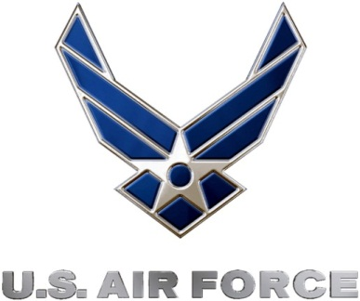 |  | Commanding Officer  U.S. Air Force 349th Recruiting Squadron

