Sunrise Christian
Zach Powell & Preston Atherton
U.S. Air Force Precision Air Strike of the Week - Kansas

The U.S. Air Force 349th Recruiting Squadron honors Sunrise Christian quarterback Zach Powell and wide receiver Preston Atherton as the U.S. Air Force Precision Air Strike of the Week as the high school football passing combination in Kansas. Howell threw for 529 yards, completing 40-of-54 passes for 529 yards with four touchdowns, hitting Atherton for 257 yards in Sunrise Christian’s 26-13 win over Christ Prep. The U.S. Air Force recognizes the skill, dedication, and teamwork required of both players to accomplish team goals.
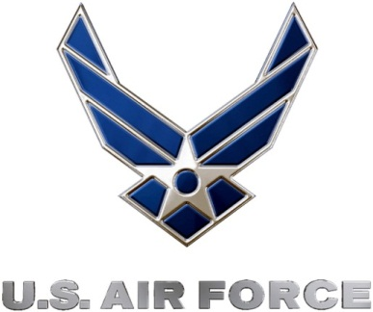 |  | Commanding Officer  U.S. Air Force 349th Recruiting Squadron

