Dodge City
Taylor Murphy & Isaiah Bradshaw
U.S. Air Force Precision Air Strike of the Week - Kansas

The U.S. Air Force 349th Recruiting Squadron honors Dodge City’s Taylor Murphy and Isaiah Bradshaw as the U.S. Air Force Precision Air Strike of the Week as the high school football passing combination in Kansas. Murphy threw for 280 yards with three scores while Bradshaw had five receptions for 94 yards with a touchdown in Dodge City’s 63-6 win over North. The U.S. Air Force recognizes the skill, dedication, and teamwork required of both players to accomplish team goals.
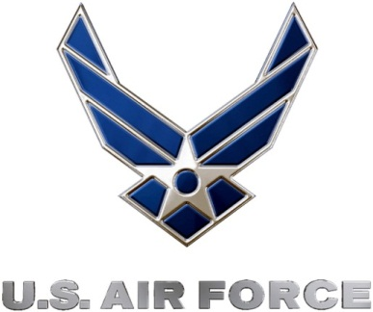 |  | Commanding Officer  U.S. Air Force 349th Recruiting Squadron

