Basehor-Linwood
Colin Murphy & Ryan Murphy
U.S. Air Force Precision Air Strike of the Week - Kansas

The U.S. Air Force 349th Recruiting Squadron honors Basehor-Linwood High School’s Colin Murphy and Ryan Murphy as the U.S. Air Force Precision Air Strike of the Week as the high school football passing combination in Kansas. Colin Murphy threw for 200 yards with two touchdowns, hitting his twin brother, Ryan Murphy, on a 39-yard strike as Basehor-Linwood knocked off previously-unbeaten Mill Valley, 42-21. The U.S. Air Force recognizes the skill, dedication, and teamwork required of both players to accomplish team goals.
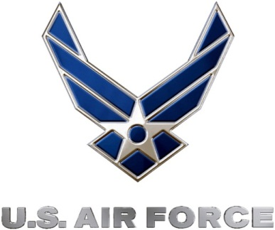 |  | Commanding Officer  U.S. Air Force 349th Recruiting Squadron

