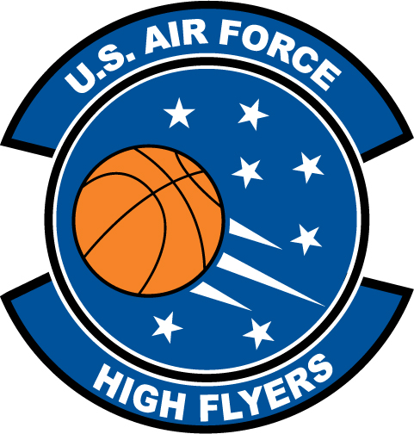

Gabby Bevillard – Oconee County
U.S. Air Force High Flyer of the Week - Georgia

The U.S. Air Force 336th Recruiting Squadron honors Oconee County’s Gabby Bevillard as the U.S. Air Force High Flyer of the Week as the best high school basketball player in Georgia. On 22 November, Bevillard recorded a triple-double with 23 points, 18 rebounds, and 13 blocks in Oconee County’s narrow 61-60 loss to North Hall. The U.S. Air Force recognizes this exceptional individual performance and the incredible skill, dedication, and teamwork required to accomplish team goals.
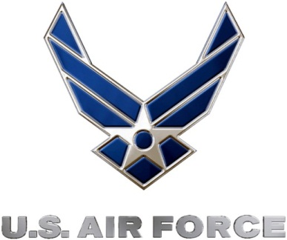 |  | Commanding Officer  U.S. Air Force 336th Recruiting Squadron

