

A’Miracle Jones – Mitchell County
U.S. Air Force High Flyer of the Week - Georgia

The U.S. Air Force 336th Recruiting Squadron honors Mitchell County High School’s A’Miracle Jones as the U.S. Air Force High Flyer of the Week as the best high school basketball player in Georgia. Jones recorded a double-double of 27 points, 15 rebounds to lead Mitchell County to a 54-48 win over Pelham in the Region 1-1A championship game. The U.S. Air Force recognizes this exceptional individual performance and the incredible skill, dedication, and teamwork required to accomplish team goals.
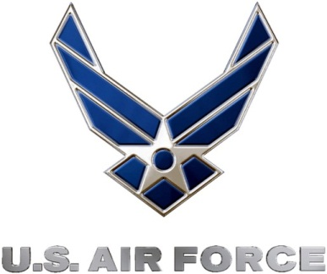 |  | Commanding Officer  U.S. Air Force 336th Recruiting Squadron

