

DeQuenna Moore – Lee County
U.S. Air Force High Flyer of the Week - Georgia

The U.S. Air Force 336th Recruiting Squadron honors Kendrick’s Christian Bradford as a 2011-2012 U.S. Air Force High Flyer of the Week as the best high school basketball player in Georgia. Kendrick dropped in a game-high 21 points to lead Kendrick to an 80-71 win over Hardaway. The U.S. Air Force recognizes this exceptional individual performance and the incredible skill, dedication, and teamwork required to accomplish team goals.
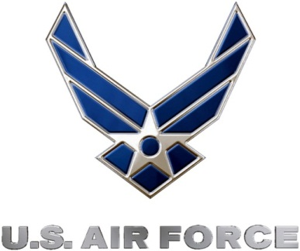 |  | Commanding Officer  U.S. Air Force 336th Recruiting Squadron

