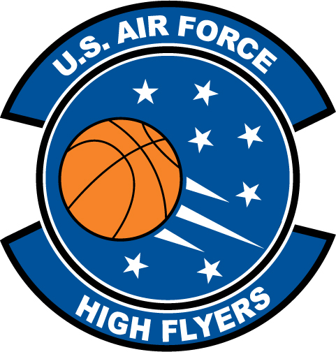

Kym Ellison - Hardaway
U.S. Air Force High Flyer of the Week - Georgia

The U.S. Air Force 336th Recruiting Squadron honors Hardaway’s Kym Ellison as the U.S. Air Force High Flyer of the Week as the best high school basketball player in Georgia. On 2 December 2011, Ellison had 17 points, 10 assists to lead Hardaway to a 64-27 win over Kendrick, handing the Lady Cherokee’s their first regular-season loss in 2009. The U.S. Air Force recognizes this exceptional individual performance and the incredible skill, dedication, and teamwork required to accomplish team goals.
 |  | Commanding Officer  U.S. Air Force 336th Recruiting Squadron

