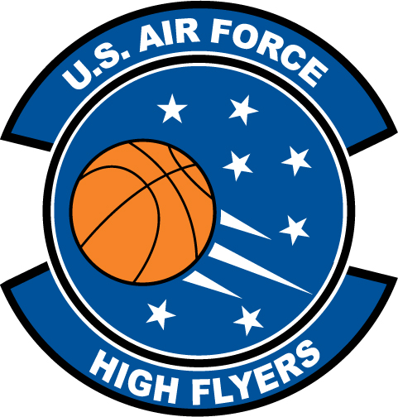

Ariel Butts – Carver High School
U.S. Air Force High Flyer of the Week - Georgia

The U.S. Air Force 336th Recruiting Squadron honors Carver High School’s Ariel Butts as a 2011 U.S. Air Force High Flyer of the Week as the best high school basketball player in Georgia. Butts poured in 31 points and collected 21 rebounds to lead Carver to a 63-57 win over Kendrick. The U.S. Air Force recognizes this exceptional individual performance and the incredible skill, dedication, and teamwork required to accomplish team goals.
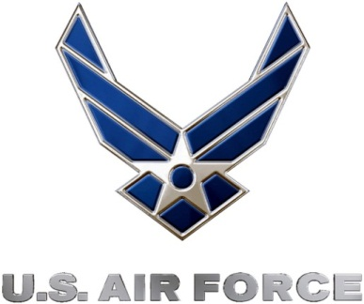 |  | Commanding Officer  U.S. Air Force 336th Recruiting Squadron

