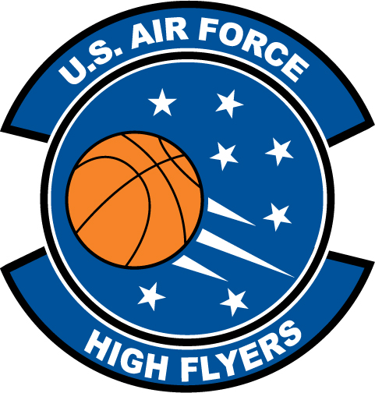

Jevan Billinger - Columbus
U.S. Air Force High Flyer of the Week - Georgia

The U.S. Air Force 336th Recruiting Squadron honors Columbus High School’s Jevan Billinger as a 2011-2012 U.S. Air Force High Flyer of the Week as the best high school basketball player in Georgia. Billinger had a game-high 25 points and collected seven rebounds in a 71-53 loss to Hardaway and added 30 points and nine rebounds in a 58-53 loss to Spencer. The U.S. Air Force recognizes this exceptional individual performance and the incredible skill, dedication, and teamwork required to accomplish team goals.
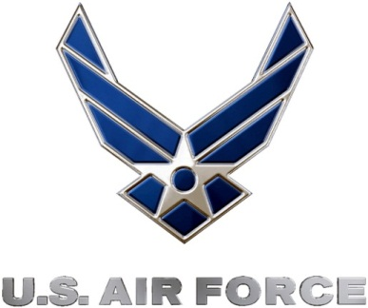 |  | Commanding Officer  U.S. Air Force 336th Recruiting Squadron

