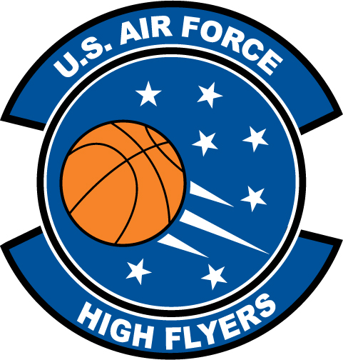

Amber Curtis - Beach
U.S. Air Force High Flyer of the Week - Georgia

The U.S. Air Force 336th Recruiting Squadron honors Beach High School’s Amber Curtis as the U.S. Air Force High Flyer of the Week as the best high school basketball player in Georgia. On 19 November, Curtis scored 25 points and added eight assists in Beach’s 69-60 win over Liberty County. The U.S. Air Force recognizes this exceptional individual performance and the incredible skill, dedication, and teamwork required to accomplish team goals.
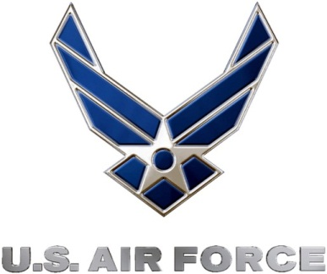 |  | Commanding Officer  U.S. Air Force 336th Recruiting Squadron

