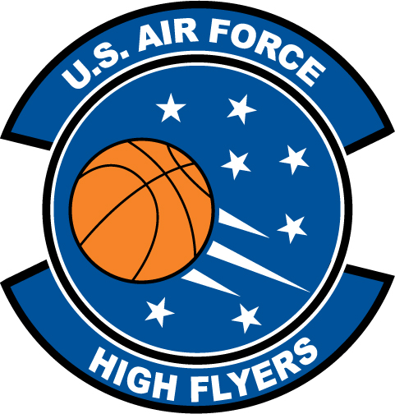

R’Kiyah Scott – West Port High School
U.S. Air Force High Flyer of the Week - Florida

The U.S. Air Force 336th Recruiting Squadron honors West Port High School’s R’Kiyah Scott as the U.S. Air Force High Flyer of the Week as the best high school basketball player in Florida. Scott scored a school-record 57 points, hitting 22-of-41 shots, to lead West Port to a 73-48 win over Dunnellon. The U.S. Air Force recognizes this exceptional individual performance and the incredible skill, dedication, and teamwork required to accomplish team goals.
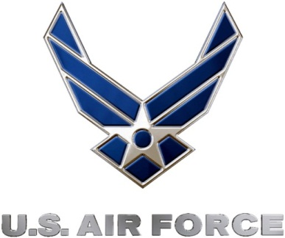 |  | Commanding Officer  U.S. Air Force 336th Recruiting Squadron

