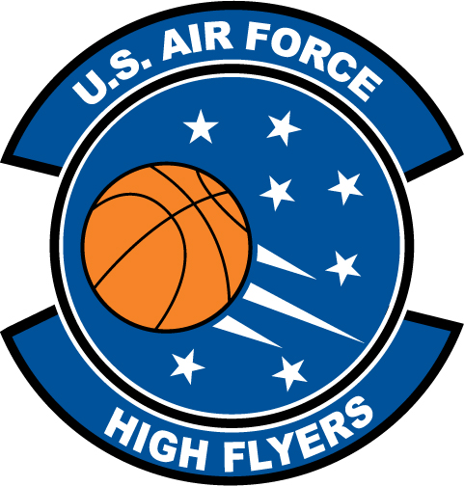

Alec Jewell – West Port High School
U.S. Air Force High Flyer of the Week - Florida

The U.S. Air Force 336th Recruiting Squadron honors West Port’s Alec Jewell as the U.S. Air Force High Flyer of the Week as the best high school basketball player in Florida. Jewell scored 30 points and collected nine rebounds to lead West Port to a 66-52 win over Winter Springs at the 2011 KSA Holiday Classic. The U.S. Air Force recognizes this exceptional individual performance and the incredible skill, dedication, and teamwork required to accomplish team goals.
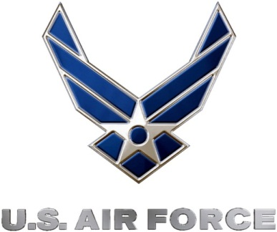 |  | Commanding Officer  U.S. Air Force 336th Recruiting Squadron

