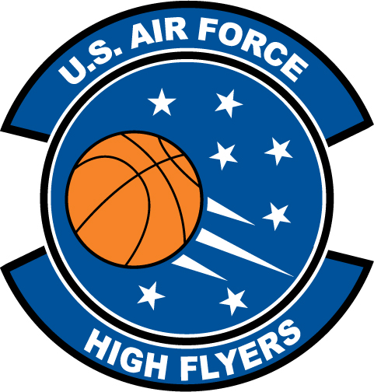

Raheem Freeman - Vanguard
U.S. Air Force High Flyer of the Week - Florida

The U.S. Air Force 336th Recruiting Squadron honors Vanguard’s Raheem Freeman as the U.S. Air Force High Flyer of the Week as the best high school basketball player in Florida. Freeman scored 22 points to lead Vanguard to a 62-49 win over Vanguard. The U.S. Air Force recognizes this exceptional individual performance and the incredible skill, dedication, and teamwork required to accomplish team goals.
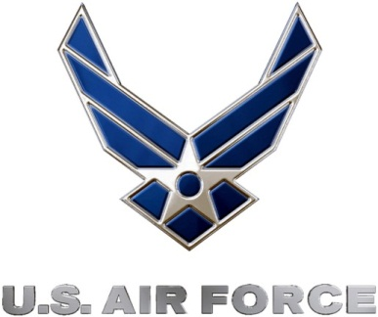 |  | Commanding Officer  U.S. Air Force 336th Recruiting Squadron

