

O.J. Williams – St. Joseph’s High School
U.S. Air Force High Flyer of the Week - Florida

The U.S. Air Force 336th Recruiting Squadron honors St. Joseph’s O.J. Williams as the U.S. Air Force High Flyer of the Week as the best high school basketball player in Florida. Williams scored a school-record 62 points to lead St. Joseph’s in a 120-102 loss to P.K. Yonge. The U.S. Air Force recognizes this exceptional individual performance and the incredible skill, dedication, and teamwork required to accomplish team goals.
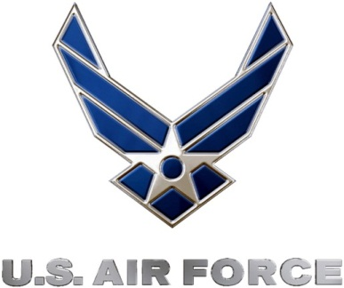 |  | Commanding Officer  U.S. Air Force 336th Recruiting Squadron

