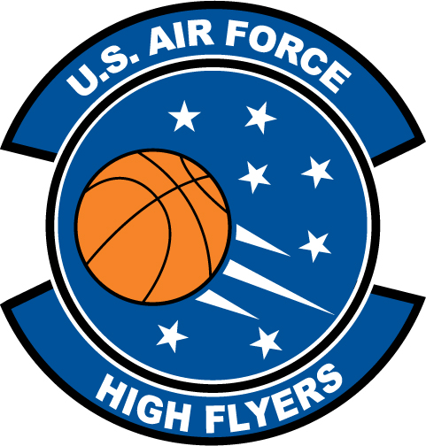

Richard Bryson – St. Augustine High School
U.S. Air Force High Flyer of the Week - Florida

The U.S. Air Force 336th Recruiting Squadron honors St. Augustine High School’s Richard Bryson as the U.S. Air Force High Flyer of the Week as the best high school basketball player in Florida. Bryson’s game-high 26 points led St. Augustine’s to a 66-58 win over Columbia while dropping in another 26 points in a 66-47 win over Nease. The U.S. Air Force recognizes this exceptional individual performance and the incredible skill, dedication, and teamwork required to accomplish team goals.
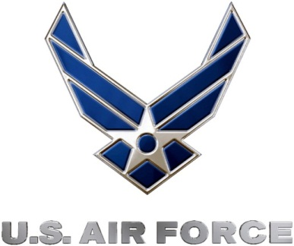 |  | Commanding Officer  U.S. Air Force 336th Recruiting Squadron

