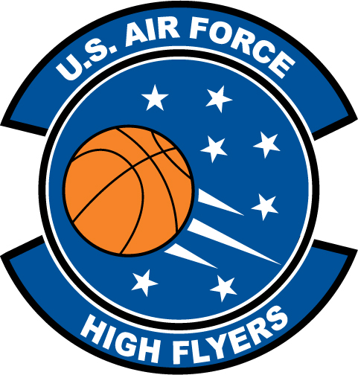

Sherranda Reddick – Ribault High School
U.S. Air Force High Flyer of the Week - Florida

The U.S. Air Force 336th Recruiting Squadron honors Ribault High School’s Sherranda Reddick as the U.S. Air Force High Flyer of the Week as the best high school basketball player in Florida. Reddick stripped the nets for 30 points to lead Ribault to a 52-35 win over Mandarin to clinch the Mighty Trojans second-straight Gateway Conference title. The U.S. Air Force recognizes this exceptional individual performance and the incredible skill, dedication, and teamwork required to accomplish team goals.
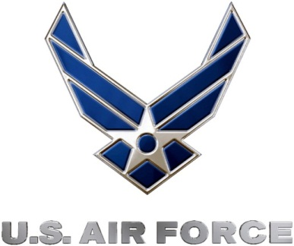 |  | Commanding Officer  U.S. Air Force 336th Recruiting Squadron

