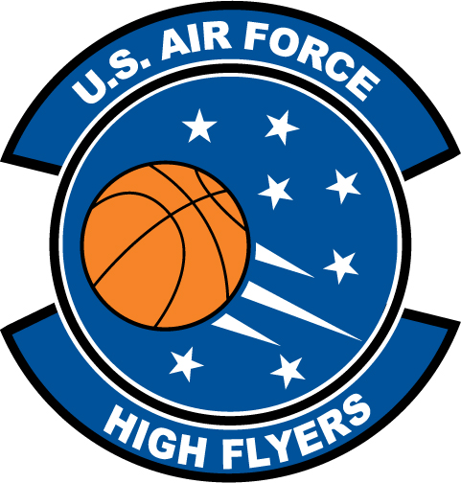

Beau Beech – Ponte Vedra
U.S. Air Force High Flyer of the Week - Florida

The U.S. Air Force 336th Recruiting Squadron honors Ponte Vedra’s Beau Beech as the U.S. Air Force High Flyer of the Week as the best high school basketball player in Florida. On 29 November 2011, Beech scored 34 points in a 79-63 win over Bartram Trail.; on 1 December 2011, Beech scored 45 points in leading Ponte Vedra to a 64-60 win over Nease. The U.S. Air Force recognizes this exceptional individual performance and the incredible skill, dedication, and teamwork required to accomplish team goals.
 |  | Commanding Officer  U.S. Air Force 336th Recruiting Squadron

