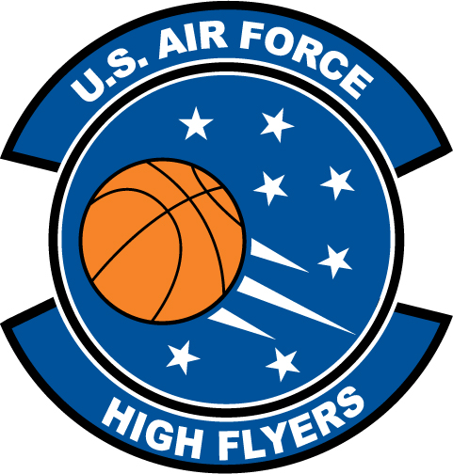

Niki Perez - Nease High School
U.S. Air Force High Flyer of the Week - Florida

The U.S. Air Force 336th Recruiting Squadron honors Nease High School’s Niki Perez as the U.S. Air Force High Flyer of the Week as the best high school basketball player in Florida. Perez dropped in 22 points to lead Nease to a 45-33 win over Menendez for the school’s first District 4-5A title since 200. The U.S. Air Force recognizes this exceptional individual performance and the incredible skill, dedication, and teamwork required to accomplish team goals.
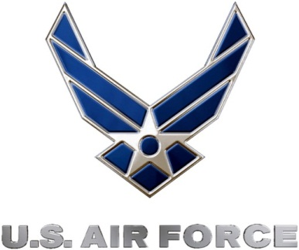 |  | Commanding Officer  U.S. Air Force 336th Recruiting Squadron

