

Tiesha Flagler – Mendndez High School
U.S. Air Force High Flyer of the Week - Florida

The U.S. Air Force 336th Recruiting Squadron honors Menendez High School’s Tiesha Flagler as the U.S. Air Force High Flyer of the Week as the best high school basketball player in Florida. Flagler put together back-to-back 30-point games at the Matanzas Holiday Shoot Our, dropping in 30 in a 42-27 win over Crescent City and adding 30 in a 61-45 loss to Harmony. The U.S. Air Force recognizes this exceptional individual performance and the incredible skill, dedication, and teamwork required to accomplish team goals.
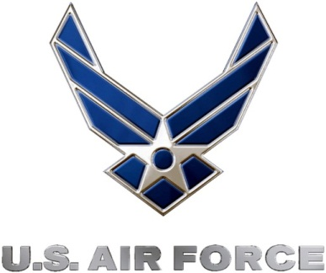 |  | Commanding Officer  U.S. Air Force 336th Recruiting Squadron

