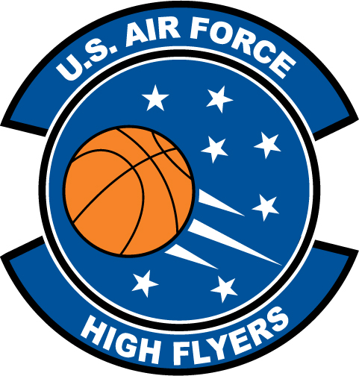

Dee Lewis – Lake Weir High School
U.S. Air Force High Flyer of the Week - Florida

The U.S. Air Force 336th Recruiting Squadron honors Lake Weir’s Dee Lewis as a 2011 U.S. Air Force High Flyer of the Week as the best high school basketball player in Florida. Lewis dropped in 38 points, collected 11 rebounds, added nine assists, and registered eight steal to lead Lake Weir to a 76-58 win over South Lake. In a 75-60 win over West Port, Lewis poured in 37 points, snagged nine rebounds, added six assists, and registered two steals. The U.S. Air Force recognizes this exceptional individual performance and the incredible skill, dedication, and teamwork required to accomplish team goals.
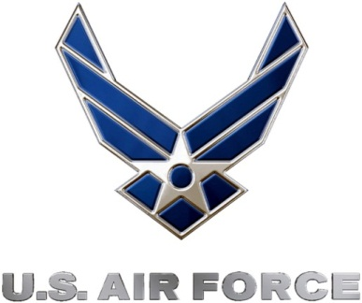 |  | Commanding Officer  U.S. Air Force 336th Recruiting Squadron

