

Ed Porter – Gainesville High School
U.S. Air Force High Flyer of the Week - Florida

The U.S. Air Force 336th Recruiting Squadron honors Gainesville High School’s Ed Porter as the U.S. Air Force High Flyer of the Week as the best high school basketball player in Florida. Porter poured in 24 points to lead Gainesville to a 63-51 win over Lecanto in the Region 2-6A quarterfinal. The U.S. Air Force recognizes this exceptional individual performance and the incredible skill, dedication, and teamwork required to accomplish team goals.
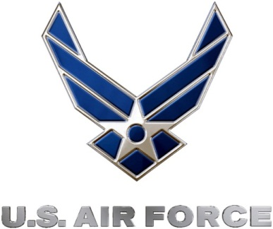 |  | Commanding Officer  U.S. Air Force 336th Recruiting Squadron

