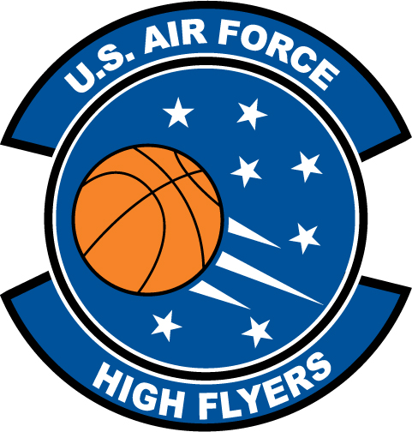

Devonta Mosley – Eastside High School
U.S. Air Force High Flyer of the Week - Florida

The U.S. Air Force 336th Recruiting Squadron honors Eastside High School’s Devonta Mosley as the U.S. Air Force High Flyer of the Week as the best high school basketball player in Florida. Mosley scored 15 and grabbed nine rebounds to lead Eastside to a 52-44 win over North Marion in the District 6-5A championship game. The U.S. Air Force recognizes this exceptional individual performance and the incredible skill, dedication, and teamwork required to accomplish team goals.
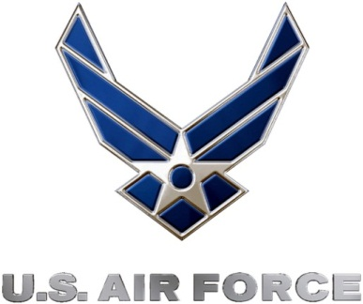 |  | Commanding Officer  U.S. Air Force 336th Recruiting Squadron

