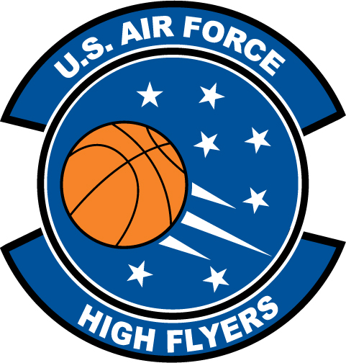

Tanika Jackson - Dunnellon High School
U.S. Air Force High Flyer of the Week - Florida

The U.S. Air Force 336th Recruiting Squadron honors Dunnellon High School’s Tankia Jackson as the U.S. Air Force High Flyer of the Week as the best high school basketball player in Florida. Jackson scored 21, grabbed five rebounds, and added three steals in Dunnellon’s 38-30 win over North Marion. The U.S. Air Force recognizes this exceptional individual performance and the incredible skill, dedication, and teamwork required to accomplish team goals.
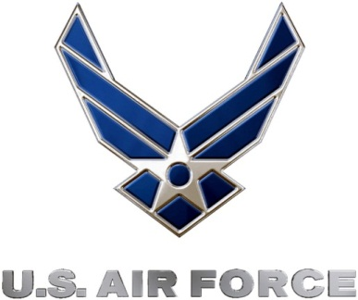 |  | Commanding Officer  U.S. Air Force 336th Recruiting Squadron

