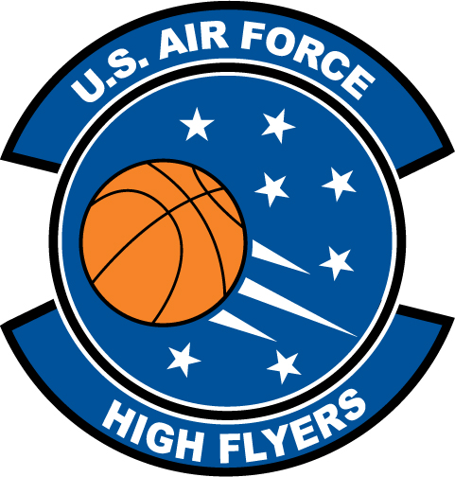

Tyler Irish – Bartram Trail High School
U.S. Air Force High Flyer of the Week - Florida

The U.S. Air Force 336th Recruiting Squadron honors Bartram Trail High School’s Tyler Irish as the U.S. Air Force High Flyer of the Week as the best high school basketball player in Florida. Irish scored 35 points with six rebounds, five assists, and four steals to lead Bartram Trail to a 67-55 win over Fernandina Beach. The U.S. Air Force recognizes this exceptional individual performance and the incredible skill, dedication, and teamwork required to accomplish team goals.
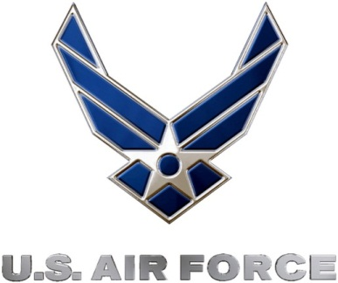 |  | Commanding Officer  U.S. Air Force 336th Recruiting Squadron

