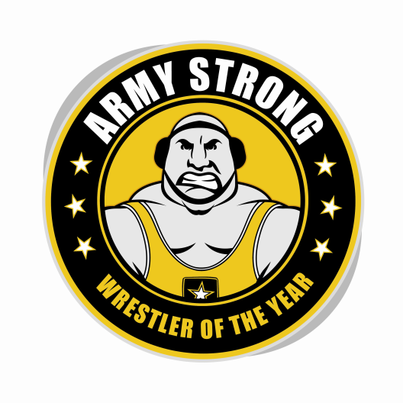
Army STRONG Wrestler of the Week - Pennsylvania
Ryan Diehl – Cumberland Valley

The U.S. Army’s Harrisburg Recruiting Battalion is proud to honor Cumberland Valley High School’s Ryan Diehl as the Army STRONG Wrestler of the Week. The campaign honors Pennsylvania’s best high school wrestlers. Diehl earned Most Outstanding Wrestler honors at the Cumberland Valley Kickoff Classic, beating Penn Trafford’s Willie Bohince in the semis and knocking off Middletown’s Bryce Killan in the championship match in an effort that demonstrated physical and emotional strength as well as strength of character. The Army STRONG Wrestler of the Week, Ryan Diehl of Cumberland Valley, embodies the qualities of Army STRONG.
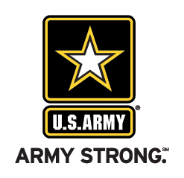 | Commanding Officer  U.S. Army Harrisburg Recruiting Battalion

