U.S. Army Coach of the Week - Pennsylvania
Ray Braszo of West Mifflin

The U.S. Army’s Harrisburg Recruiting Battalion is proud to honor West Mifflin High School’s Ray Braszo as the U.S. Army Coach of the Week in Pennsylvania for the week ending 2 September 2011. Braszo led West Mifflin to a 21-13 win over defending WPIAL-champion South Fayette, handing the Lions their first regular-season loss since 2008. The U.S. Army is proud honor West Mifflin’s Ray Braszo, whose exceptional leadership ensured the success of his team and whose continued dedication to his student-athletes will ensure their future success in life and athletics.
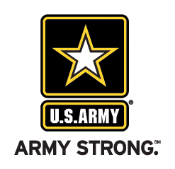 | Commanding Officer  U.S. Army Harrisburg Recruiting Battalion

