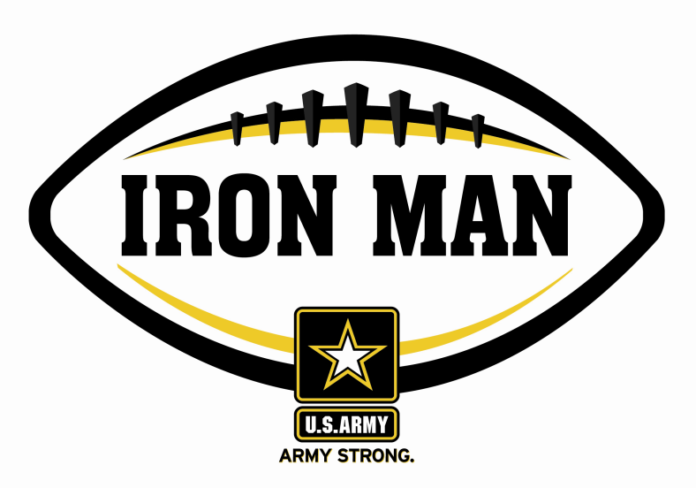
Claxton’s Shavez Mincey voted
Army Iron Man of the Week
Army Iron Man honors the best two-way high school football players in Georgia

FOR IMMEDIATE RELEASE CONTACT: Mike Sinnott
22 September 2011 (517) 927-4570

JACKSONVILLE, FL - The U.S. Army Jacksonville Recruiting Battalion is proud to announce that Claxton’s Shavez Mincey is the Army Iron Man of the Week as the best two-way high school football player in the battalion’s recruiting territory in Georgia. Mincey rushed for 198 yards with a touchdown and kicked four extra-points in Claxton’s 34-6 win over Toombs County. As a weekly winner, Mincey is a finalist for the Army Iron Man of the Year.

Playing and excelling on offense and defense, the Army Iron Man must demonstrate physical and emotional strength, as well as strength of character. The Army Iron Man embodies the qualities of Army STRONG. The campaign honors the best two-way high school football players in the battalion’s South Carolina recruiting territory. Fans can vote online for the weekly winner at www.TheSportsFlash.com.

TSF Radio Network is now accepting nominations for the Army Iron Ma of the Week. Voting for the Army Iron Man of the Week ends on Thursdays at 9:00 P.M. EDT with the winner being announced on Friday morning.

The United States Army is charged with protecting America’s freedom and preserving peace. The Army trains and equips its soldiers to be the best, especially when it comes to their job, leadership, and soldiering skills. With more than 150 jobs available in many exciting fields, the U.S. Army provides many job training and leadership training opportunities. From working with computers to assisting doctors to fixing helicopters, there’s an Army job that’s right for you. For more information, go online to www.GoArmy.com.

For questions about the U.S. Army Iron Man Award, please contact TSF Radio Network’s Mike Sinnott at (517) 927-4570 or the U.S. Army’s Jerry Patton at (304) 252-0422.

###

