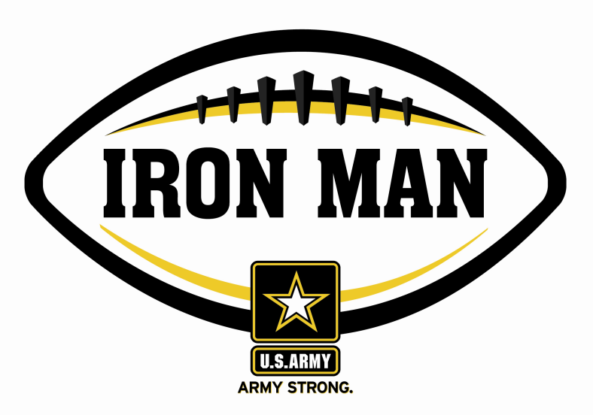
Army Iron Man – Georgia
Week Two Nominees
Army Iron Man honors the best two-way high school football players in Georgia

FOR IMMEDIATE RELEASE CONTACT: Mike Sinnott
5 September 2011 (517) 927-4570

JACKSONVILLE, FL - The U.S. Army Jacksonville Recruiting Battalion is proud to announce the nominees for the U.S. Army Iron Man of the Week for Georgia. The campaign honors the best two-way high school football players in the battalion’s South Carolina recruiting territory. Fans can vote online for the weekly winner at www.TheSportsFlash.com.

Army Iron Man – Georgia – Week 2 Nominees
Donta Beckham – Baldwin | Beckham ran for two touchdowns, caught a touchdown pass, and blocked a punt that was returned for another score in Baldwin’s 41-7 win over Central.
Duncan Fletcher – Brookstone | Fletcher recovered a fumble on defense, threw two touchdown passes (30, 16), and scored the game-winning two-point conversion in a 21-20 win over Dooly County.
Deion Goshay – Glenwood | Goshay scored three touchdowns with two rushing scores (66, 7) and a 55-yard interception return for a touchdown in Glenwood’s 54-0 win over Lowndes Academy.
Juwan Johnson – Groves | Johnson scored on two touchdown runs (2, 37) and returned an interception for an 87-yard score in Groves’ 35-31 win over South Effingham.
Akebren Ralls – Mary Persons | Ralls returned an interception for a 47-yard touchdown and returned a punt 74 yards to set up a field-goal to lead Mary Persons to a 10-6 win over Veterans.
Spenser Spellman – Johnson | Spellman had a 12-yard touchdown catch and knocked down a couple of passes late in the game to help Johnson to a 14-7 win over Jenkins.
Skylar Strickland – Calvary Day | Strickland plays linebacker, but rushed for 110 yards on nine carries with three touchdowns (3, 4, 70) to lead Calvary Day to a 25-14 win over Walker.

Voting for the Army Iron Man of the Week ends on Thursdays at 9:00 P.M. EDT with the winner being announced on Friday morning.

The United States Army is charged with protecting America’s freedom and preserving peace. The Army trains and equips its soldiers to be the best, especially when it comes to their job, leadership, and soldiering skills. With more than 150 jobs available in many exciting fields, the U.S. Army provides many job training and leadership training opportunities. From working with computers to assisting doctors to fixing helicopters, there’s an Army job that’s right for you. For more information, go online to www.GoArmy.com.

For questions about the U.S. Army Iron Man Award, please contact TSF Radio Network’s Mike Sinnott at (517) 927-4570.

###

