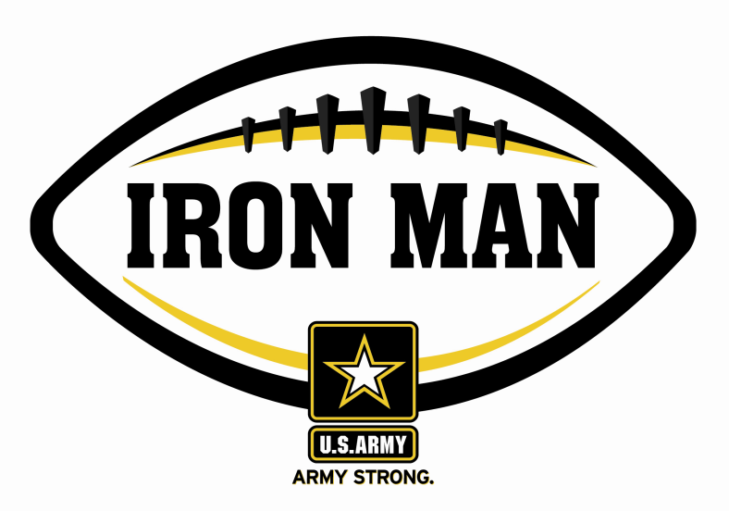
Army Iron Man – Georgia
Week One Nominees
Army Iron Man honors the best two-way high school football players in Georgia

FOR IMMEDIATE RELEASE CONTACT: Mike Sinnott
29 August 2011 (517) 927-4570

JACKSONVILLE, FL - The U.S. Army Jacksonville Recruiting Battalion is proud to announce the nominees for the U.S. Army Iron Man of the Week for Georgia. The campaign honors the best two-way high school football players in the battalion’s South Carolina recruiting territory. Fans can vote online for the weekly winner at www.TheSportsFlash.com.

Army Iron Man – Georgia – Week 1 Nominees
Chris Brown – Seminole County | Brown rushed for 98 yards with two touchdowns while grabbing an interception on defense in Seminole County’s 43-40 loss to Wesleyan.
Josh Clemons – Lowndes | Clemons scored two rushing touchdowns (3, 4) and grabbed an interception on defense in Lowndes’ 45-14 win over Pebblebrook.
Cequanti Ford – Carver | Ford scored on an eight-yard run and returned a punt for a 48-yard touchdown in Carver’s 52-0 win over Spencer. It was Carver’s 13th-straight win in the 49th Annual Heritage Bowl.
Keshon Hill – Northside | Hill had eight receptions for 130 yards with two touchdowns and returned a punt for a 61-yard score in Northside’s 35-7 victory over Jordan.
Jeconiah Jackson – Albany | Jackson had three touchdown receptions for 153 yards and recorded three sacks on defense in Albany’s 39-7 win over Dougherty.
Vincent Powell – Calhoun County | Powell had a 30-yard touchdown catch, and grabbed a two-point conversion pass, and grabbed an interception on defense in Calhoun County’s 24-14 loss to Lanier County.
Nick Scott – Bryan County | Scott, a starting linebacker, rushed for 115 yards in the second-half and scored the game-winning touchdown with a 17-yard run in Bryan County’s 28-21 win over Logan County.

Cory Walker – Portal | Walker scored a rushing touchdown, returned a punt 45 yards, and grabbed an interception on defense in Portal’s 9-0 win over Southeast Bulloch.
Alex Waldron – Valwood | Waldron scored on a 14-yard run and returned an interception for a 65-yard score in Valwood’s 62-0 win over Tiftarea.
Shidel Williams – Bethesda | Williams rushed for 120 yards with a touchdown, returned a punt for a 47-yard touchdown, and grabbed two interceptions on defense in Bethesda’s 39-0 win over Bible.
Darius Wright – Screven County | Wright scored on a 95-yard kick-off return for a touchdown while rushed for 85 yards on 15 carries in Screven County’s 44-29 loss to Effingham County.

Voting for the Army Iron Man of the Week ends on Thursdays at 9:00 P.M. EDT with the winner being announced on Friday morning.

The United States Army is charged with protecting America’s freedom and preserving peace. The Army trains and equips its soldiers to be the best, especially when it comes to their job, leadership, and soldiering skills. With more than 150 jobs available in many exciting fields, the U.S. Army provides many job training and leadership training opportunities. From working with computers to assisting doctors to fixing helicopters, there’s an Army job that’s right for you. For more information, go online to www.GoArmy.com.

For questions about the U.S. Army Iron Man Award, please contact TSF Radio Network’s Mike Sinnott at (517) 927-4570.

###

