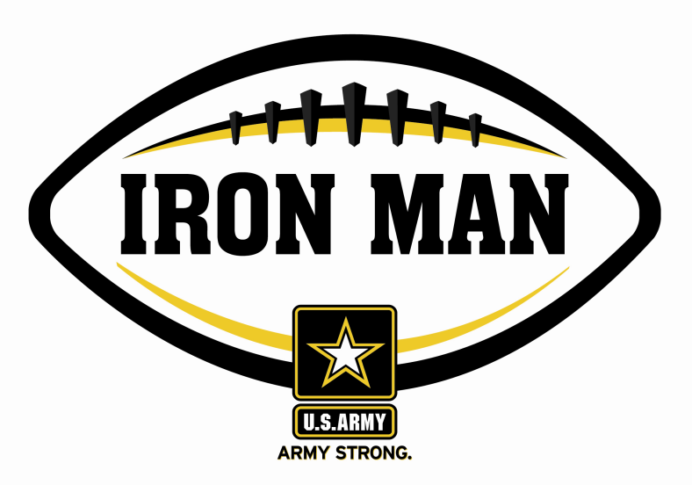
Army Iron Man – South Carolina
Week Five Nominees
Army Iron Man honors the best two-way high school football players in South Carolina

FOR IMMEDIATE RELEASE CONTACT: Mike Sinnott
19 September 2011 (517) 927-4570

FLORENCE, SC - The U.S. Army Florence Recruiting Company is proud to announce the nominees for the U.S. Army Iron Man of the Week for the Grand Strand and Pee Dee regions of South Carolina. The campaign honors the best two-way high school football players in the company’s South Carolina recruiting territory. Fans can vote online for the weekly winner at www.TheSportsFlash.com.

Army Iron Man – South Carolina – Week 5 Nominees
Hakeem Hampton – Carvers Bay | Hampton rushed for 82 yards, scored on a one-yard touchdown run in overtime, and secured the victory with an interception in the end zone as Carvers Bay knocked off Latta, 19-13.
Trell Harrell – Myrtle Beach | Harrell rushed for a 30-yard score, had a long kick-off return to set up a field-goal, and grabbed an interception on defense as Myrtle Beach knocked off South Florence, 28-21.
Travis Spence – Holly Hill Academy | Spence ran for two touchdowns (2, 50) and returned a punt for a 55-yard touchdown in Holly Hill Academy’s 56-28 win over Pee Dee Academy.
Aaron Williams – Carolina Forest | Williams had a 70-yard touchdown reception and returned a fumble for a 32-yard score as Carolina Forest rolled to a 68-0 win over Kingstree.

Voting for the Army Iron Man of the Week ends on Thursdays at 9:00 P.M. EDT with the winner being announced on Friday morning.

The United States Army is charged with protecting America’s freedom and preserving peace. The Army trains and equips its soldiers to be the best, especially when it comes to their job, leadership, and soldiering skills. With more than 150 jobs available in many exciting fields, the U.S. Army provides many job training and leadership training opportunities. From working with computers to assisting doctors to fixing helicopters, there’s an Army job that’s right for you. For more information, go online to www.GoArmy.com.

For questions about the U.S. Army Iron Man Award, please contact TSF Radio Network’s Mike Sinnott at (517) 927-4570.

###

