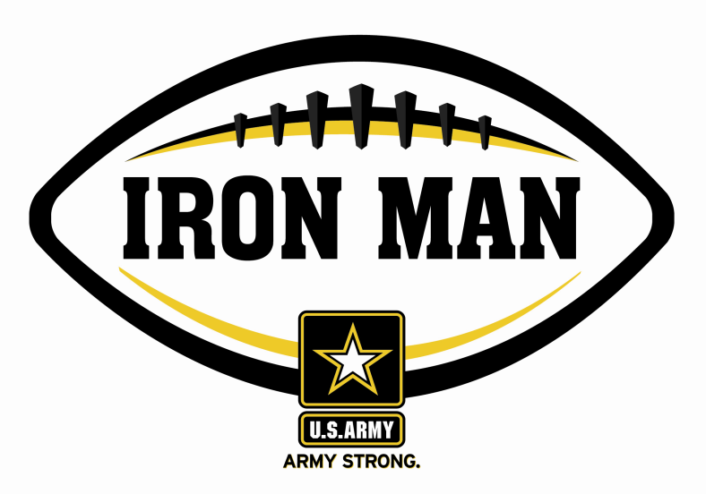
Army Iron Man – South Carolina
Week Two Nominees
Army Iron Man honors the best two-way high school football players in South Carolina

FOR IMMEDIATE RELEASE CONTACT: Mike Sinnott
29 August 2011 (517) 927-4570

FLORENCE, SC - The U.S. Army Florence Recruiting Company is proud to announce the nominees for the U.S. Army Iron Man of the Week for the Grand Strand and Pee Dee regions of South Carolina. The campaign honors the best two-way high school football players in the company’s South Carolina recruiting territory. Fans can vote online for the weekly winner at www.TheSportsFlash.com.

Army Iron Man – South Carolina – Week 2 Nominees
Erion Black – Johnsonville | Black returned a punt for a 74-yard touchdown and had a 29-yard touchdown catch as Johnsonville beat Hanna-Pamplico, 32-6
Dylan Bryant – The King’s Academy | Bryant rushed for two scores and returned an interception for a 90-yard touchdown in The King’s Academy’s 56-14 win over SCSBD.
Chantwan Damon – The Byrnes Schools | Damon rushed for 112 yards while making eight tackles with 2.5 sacks on defense in The Byrnes Schools’ 25-20 win over Florence Christian.
Zack Rush – Williamsburg Academy | Rush returned the opening kick-off for a 90-yard touchdown and scored on a 30-yard run as Williamsburg Academy beat Carolina Academy, 33-8.
Kwinton Smith – Dillon | Smith had a 28-yard touchdown catch and returned a punt for an 80-yard score as Dillon beat Lake View, 34-0.

Voting for the Army Iron Man of the Week ends on Thursdays at 9:00 P.M. EDT with the winner being announced on Friday morning.

The United States Army is charged with protecting America’s freedom and preserving peace. The Army trains and equips its soldiers to be the best, especially when it comes to their job, leadership, and soldiering skills. With more than 150 jobs available in many exciting fields, the U.S. Army provides many job training and leadership training opportunities. From working with computers to assisting doctors to fixing helicopters, there’s an Army job that’s right for you. For more information, go online to www.GoArmy.com.

For questions about the U.S. Army Iron Man Award, please contact TSF Radio Network’s Mike Sinnott at (517) 927-4570.

###

