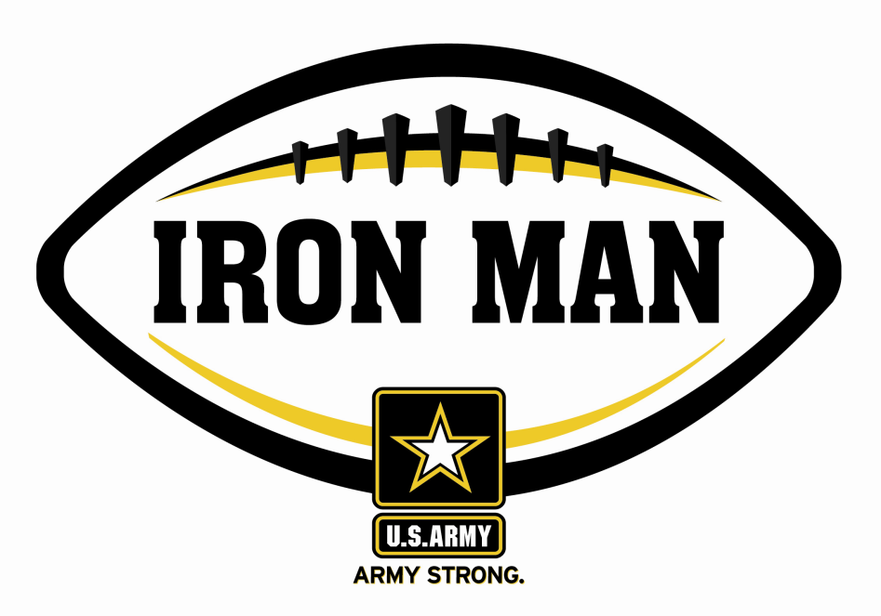
ARMY IRON MAN – South Carolina
Jamal Stanton of Marlboro County

The U.S. Army Florence Recruiting Company is proud to honor Marlboro County’s Jamal Stanton as the Army Iron Man of the Week as the best two-way high school football player in the company’s South Carolina recruiting company. On 19 August, 2011, Stanton returned a kick-off for a 95-yard touchdown and scored on an eight-yard run in a 38-34 win over Calhoun County. Playing and excelling on offense and defense, the Army Iron Man must demonstrate physical and emotional strength, as well as strength of character. The Army Iron Man embodies the qualities of Army STRONG.

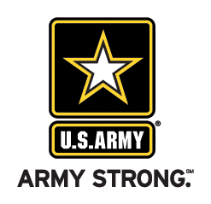 |  | Commanding Officer,  U.S. Army Recruiting – Florence, SC

