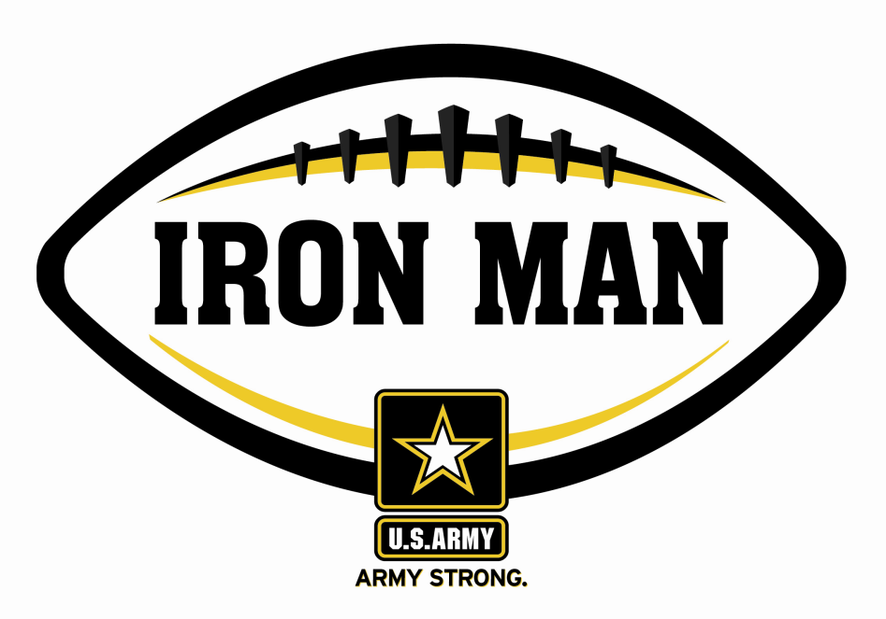
ARMY IRON MAN – South Carolina
Mykal Moody - Conway

The U.S. Army Florence Recruiting Company is proud to honor Conway’s Mykal Moody as the Army Iron Man of the Week as the best two-way high school football player in the company’s South Carolina recruiting company. On 21 October 2011, Moody had 451 yards of total offense with six touchdowns in Conway’s 46-35 win over South Florence. Playing and excelling on offense and defense, the Army Iron Man must demonstrate physical and emotional strength, as well as strength of character. The Army Iron Man embodies the qualities of Army STRONG.

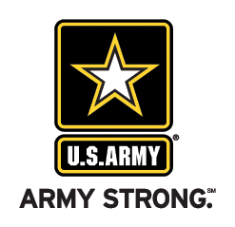 |  | Commanding Officer,  U.S. Army Recruiting – Florence, SC

