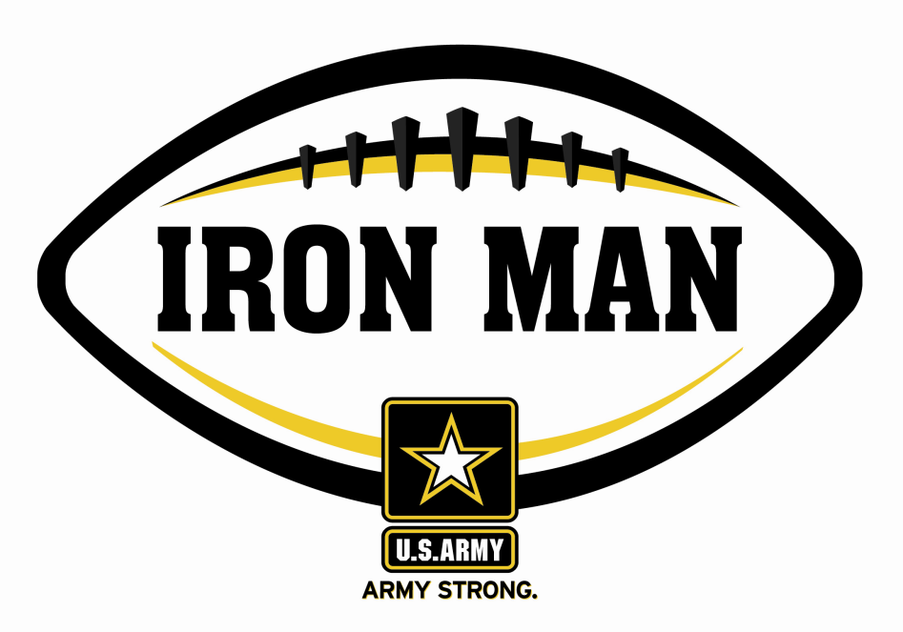
ARMY IRON MAN – South Carolina
Keyonta Foxworth of Marion

The U.S. Army Florence Recruiting Company is proud to honor Marion High School’s Keyonta Foxworth as the Army Iron Man of the Week as the best two-way high school football player in the company’s South Carolina recruiting company. On 23 September 2011, Foxworth rushed for 95 yards with two touchdowns (1, 30) and returned a punt for a 65-yard score in a 28-6 win over Timmonsville. Playing and excelling on offense and defense, the Army Iron Man must demonstrate physical and emotional strength, as well as strength of character. The Army Iron Man embodies the qualities of Army STRONG.

 |  | Commanding Officer,  U.S. Army Recruiting – Florence, SC

