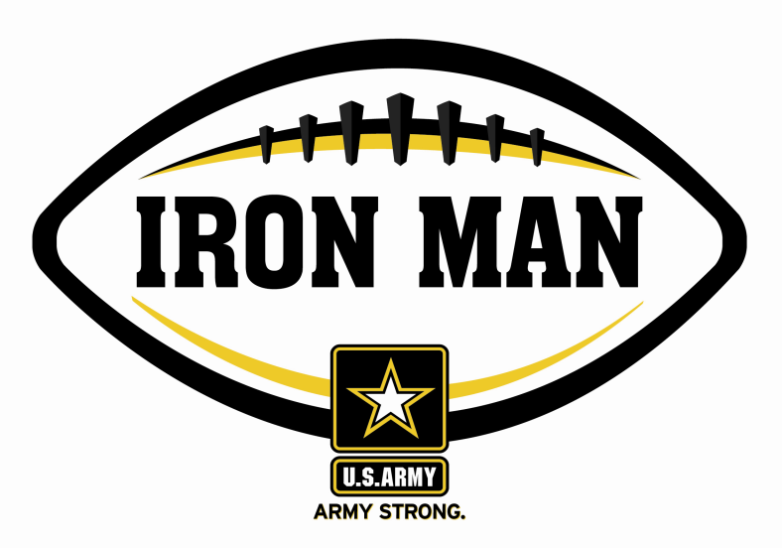
Bishop England’s Andrew Bunch voted U.S. Army Iron Man
of the Week for South Carolina’s Low Country
Army Iron Man honors the best two-way high school football players in South Carolina

FOR IMMEDIATE RELEASE CONTACT: Mike Sinnott
8 September 2011 (517) 927-4570

JACKSONVILLE, FL - The U.S. Army Jacksonville Recruiting Battalion is proud to announce that Bishop England’s Andrew Bunch is the U.S. Army Iron Man of the Week for the Low Country of South Carolina. Bunch had five receptions for 102 yards, intercepted a pass on defense, and returned a kick-off 73 yards as Bishop England outscored Hanahan, 49-35. As a weekly winner, Bunch is now a finalist for the U.S. Army Iron Man of the Year.

Playing and excelling on offense and defense, the Army Iron Man must demonstrate physical and emotional strength, as well as strength of character. The Army Iron Man embodies the qualities of Army STRONG. The campaign honors the best two-way high school football players in the battalion’s South Carolina recruiting territory. Fans can vote online for the weekly winner at www.TheSportsFlash.com.

TSF Radio Network is now accepting nominations for the Army Iron Ma of the Week. Voting for the Army Iron Man of the Week ends on Thursdays at 9:00 P.M. EDT with the winner being announced on Friday morning.

The United States Army is charged with protecting America’s freedom and preserving peace. The Army trains and equips its soldiers to be the best, especially when it comes to their job, leadership, and soldiering skills. With more than 150 jobs available in many exciting fields, the U.S. Army provides many job training and leadership training opportunities. From working with computers to assisting doctors to fixing helicopters, there’s an Army job that’s right for you. For more information, go online to www.GoArmy.com.

“The Sports Flash” (TSF) Radio Network delivers customized, local sports reports for 190 radio stations in 13 different states. TSF Radio Network coordinates the Army Iron Man Award campaign. High school football fans can vote for the weekly Army Iron Man winner and the annual award at www.TheSportsFlash.com. For questions about the U.S. Army Iron Man Award, please contact TSF Radio Network’s Mike Sinnott at (517) 927-4570.

###

