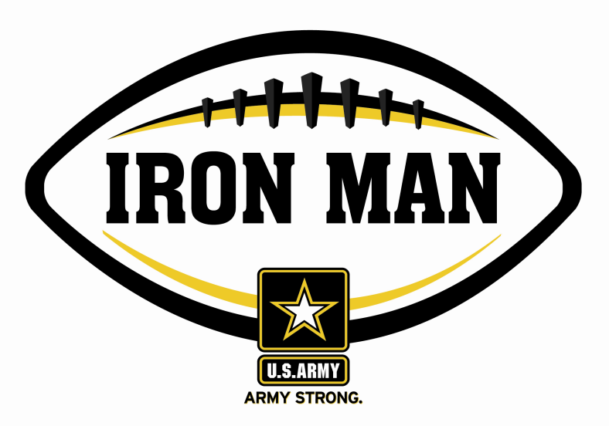
Army Iron Man – South Carolina
Week Three Nominees
Army Iron Man honors the best two-way high school football players in South Carolina

FOR IMMEDIATE RELEASE CONTACT: Mike Sinnott
5 September 2011 (517) 927-4570

JACKSONVILLE, FL - The U.S. Army Jacksonville Recruiting Battalion is proud to announce the nominees for the U.S. Army Iron Man of the Week for the Low Country of South Carolina. The campaign honors the best two-way high school football players in the battalion’s South Carolina recruiting territory. Fans can vote online for the weekly winner at www.TheSportsFlash.com.

Army Iron Man – Week 3 Nominees
Andrew Bunch – Bishop England | Bunch had five catches for 102 yards, intercepted a pass on defense, and returned a kick-off for 73 yards in Bishop England’s 49-35 win over Hanahan.
Josh Fields – Whale Branch | Fields had a 74-yard touchdown catch and returned a kick-off for another score in Whale Branch’s 50-14 win over Military Magnet.
John Little – Whale Branch | Little scored on a 12-yard run and recorded a safety on defense in Whale Branch’s 50-14 win over Military Magnet.
Alex Martin – Hilton Head Christian | Martin had seven receptions for 123 yards with three touchdowns and grabbed an interception on defense in Hilton Head Christian’s 35-22 win over Florence Christian.
James Middleton – Beaufort | Middleton blocked a punt and returned an interception for a 38-yard score in Beaufort’s 62-6 win over Battery Creek.
Trey Pierce – Porter-Gaud | Pierce scored four touchdowns rushing for two scores (12, 12), grabbing a 24-yard touchdown pass, and returning a fumble for a 23-yard score in Porter-Gaud’s 56-23 win over Heathwood Hall.

Voting for the Army Iron Man of the Week ends on Thursdays at 9:00 P.M. EDT with the winner being announced on Friday morning.

The United States Army is charged with protecting America’s freedom and preserving peace. The Army trains and equips its soldiers to be the best, especially when it comes to their job, leadership, and soldiering skills. With more than 150 jobs available in many exciting fields, the U.S. Army provides many job training and leadership training opportunities. From working with computers to assisting doctors to fixing helicopters, there’s an Army job that’s right for you. For more information, go online to www.GoArmy.com.

“The Sports Flash” (TSF) Radio Network delivers customized, local sports reports for 190 radio stations in 13 different states. TSF Radio Network coordinates the Army Iron Man Award campaign. High school football fans can vote for the weekly Army Iron Man winner and the annual award at www.TheSportsFlash.com. For questions about the U.S. Army Iron Man Award, please contact TSF Radio Network’s Mike Sinnott at (517) 927-4570.

###

