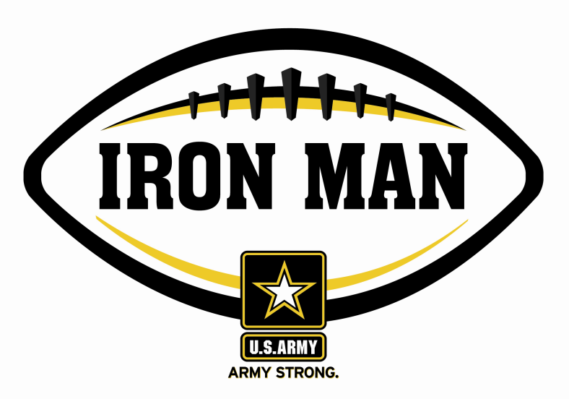
Army Iron Man – South Carolina
Week Two Nominees
Army Iron Man honors the best two-way high school football players in South Carolina

FOR IMMEDIATE RELEASE CONTACT: Mike Sinnott
August 20, 2011 (517) 927-4570

JACKSONVILLE, FL - The U.S. Army Jacksonville Recruiting Battalion is proud to announce the nominees for the U.S. Army Iron Man of the Week for the Low Country of South Carolina. The campaign honors the best two-way high school football players in the battalion’s South Carolina recruiting territory. Fans can vote online for the weekly winner at www.TheSportsFlash.com.

Army Iron Man – Week 2 Nominees
Jerome Deas – Pinewood Prep | Deas returned an interception for a 38-yard touchdown and caught the game-winning 35-yard score with one second left in Pinewood Prep’s 28-21 win over Northwood Academy.
Jack Griffith – Beaufort Academy | Griffith rushed for 71 yards with a touchdown, had 30 yards receiving, recorded five tackles, and recovered a fumble in Beaufort Academy’s 34-8 loss to Trinity Collegiate.
Dominique Robinson – St. John’s | Brown returned an interception for an 83-yard score and ran for a 14-yard score in St. John’s 37-12 loss to James Island.
Thomas Woodhead – West Ashley | Woodhead had 220 all-purpose yards and scored two touchdowns to lead West Ashley to a 14-12 win over Bishop England.

Voting for the Army Iron Man of the Week ends on Thursdays at 9:00 P.M. EDT with the winner being announced on Friday morning.

The United States Army is charged with protecting America’s freedom and preserving peace. The Army trains and equips its soldiers to be the best, especially when it comes to their job, leadership, and soldiering skills. With more than 150 jobs available in many exciting fields, the U.S. Army provides many job training and leadership training opportunities. From working with computers to assisting doctors to fixing helicopters, there’s an Army job that’s right for you. For more information, go online to www.GoArmy.com.

“The Sports Flash” (TSF) Radio Network delivers customized, local sports reports for 190 radio stations in 13 different states. TSF Radio Network coordinates the Army Iron Man Award campaign. High school football fans can vote for the weekly Army Iron Man winner and the annual award at www.TheSportsFlash.com. For questions about the U.S. Army Iron Man Award, please contact TSF Radio Network’s Mike Sinnott at (517) 927-4570.

###

