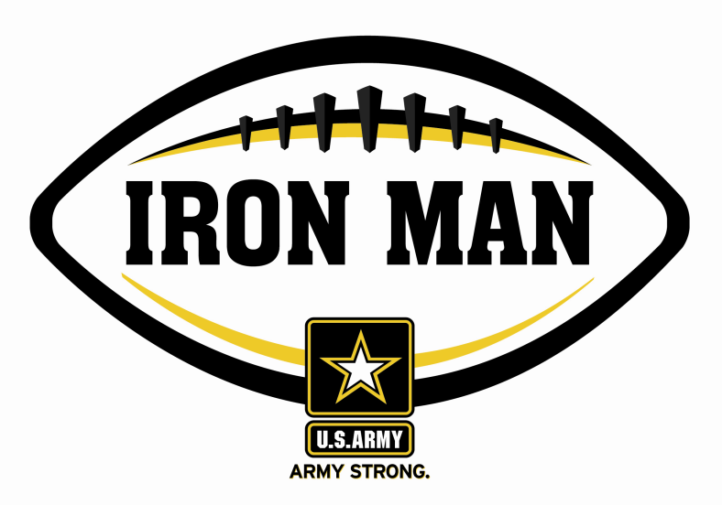
Army Iron Man – South Carolina
Week One Nominees
Army Iron Man honors the best two-way high school football players in South Carolina

FOR IMMEDIATE RELEASE CONTACT: Mike Sinnott
August 20, 2011 (517) 927-4570

JACKSONVILLE, FL - The U.S. Army Jacksonville Recruiting Battalion is proud to announce the nominees for the U.S. Army Iron Man of the Week for the Low Country of South Carolina. The campaign honors the best two-way high school football players in the battalion’s South Carolina recruiting territory. Fans can vote online for the weekly winner at www.TheSportsFlash.com.

Justin Bolus – James Island | Bolus is a two-way star for James Island and started the season with two touchdown runs (88, 5) as James Island opened with a 14-0 win over Colleton County.
Branford Hall – Cross | Hall rushed for 147 yards with two touchdowns while making two tackles on defense in Cross’ 46-14 win over Hunter-Kinard-Tyler.
Rutledge Schock – James Island Christian | Schock returned an interception for a touchdown and grabbed a touchdown pass in James Island Christian’s 36-18 win over Trinity Collegiate.
J.T. Waters – Palmetto Christian | Waters shined on both sides of the ball in leading Palmetto Christian to an 8-0 win over Military Magnet. Waters set up the only touchdown down of the game with an interception return inside the Magnet 10.

Voting for the Army Iron Man of the Week ends on Thursdays at 9:00 P.M. EDT with the winner being announced on Friday morning.

The United States Army is charged with protecting America’s freedom and preserving peace. The Army trains and equips its soldiers to be the best, especially when it comes to their job, leadership, and soldiering skills. With more than 150 jobs available in many exciting fields, the U.S. Army provides many job training and leadership training opportunities. From working with computers to assisting doctors to fixing helicopters, there’s an Army job that’s right for you. For more information, go online to www.GoArmy.com.

“The Sports Flash” (TSF) Radio Network delivers customized, local sports reports for 190 radio stations in 13 different states. TSF Radio Network coordinates the Army Iron Man Award campaign. High school football fans can vote for the weekly Army Iron Man winner and the annual award at www.TheSportsFlash.com. For questions about the U.S. Army Iron Man Award, please contact TSF Radio Network’s Mike Sinnott at (517) 927-4570.

###

