To: Bill Adee

From: Mike Sinnott

Date: April 1, 2019

Re: UPDATED VSiN Radio Information

This is a continuation of our discussion about VSiN Radio. I have expanded upon the discussion regarding affiliate attrition, affiliate acquisition, and sales. The new content begins on page 8 with all of the new sections headers highlighted for easy identification.

VSiN will purchase Gow Media’s SB Nation Radio, transitioning from the current format of traditional sports-talk radio to a network that focuses on sports gaming. VSiN will deliver sports betting news, information on a 24/7/365 terrestrial radio network with programming that originates from VSiN studios in Las Vegas, Atlantic City, and beyond.

Advantages of acquisition
A purchase of SB Nation Radio comes with many advantages, including:

-boosting awareness of VSiN to a general audience;
-launching the nation’s first-ever sports-gaming network on terrestrial radio;
-reaching a monthly audience of more than 7.5-million listeners;
-increasing premium subscriptions and sales of your special-event publications;
-tapping into a new multimillion dollar revenue stream; and,
-positioning your brand for success in a crowded sports-talk radio landscape.

Expanding your reach beyond SiriusXM
VSiN Radio will expand the reach of your brand beyond SiriusXM to a broader audience, reaching millions of potential new customers. As sports gaming expands to other states with more players, VSiN will need to broaden its audience to position itself as the leading content provider of sports-gaming information. VSiN Radio can accomplish this by reaching an audience of more than 7.5-million listeners each month. This audience will boost premium subscriptions for VSiN’s online content, increase sales for your special-event publications, and create a new revenue stream from network radio advertising.

Fourth-largest sports-radio network in the nation
Currently, SB Nation Radio is the fourth-largest sports radio network in the country in terms of our long-form programming with 215 affiliates. When you include our update business (Sports Flash; News Flash; Race Flash) of 717 network affiliates, Gow Media delivers radio programming heard on 932 network affiliates across the country, reaching more than 7.5-million listeners each month. VSiN Radio will use SB Nation Radio’s current affiliate base as its foundation for growth.

Gow Media’s Additional Networks
Excluding our partnership with VSiN for the Action Updates, Gow Media delivers customized local sports, news, and motorsports updates to 717 network affiliates across the country. We’re the nation’s largest sports update business, reaching more than 6-million listeners each month. This piece of our business is highly profitable and has helped us weather the competition and survive in a highly-competitive market.

717 AFFILIATES
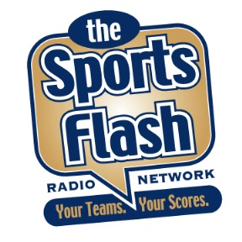 | 
503 | 95 | 119
6-MILLION LISTENERS EACH MONTH

Acquiring a multimillion-dollar revenue stream
At launch, VSiN Radio will take SB Nation’s place as the fourth-largest sports radio network in the country. More importantly, unlike a brand-new venture, VSiN Radio will launch with a multimillion-dollar revenue stream already in place. Imagine adding more than $2.5-$3.0-million in annual revenue to your books without a significant increase in overhead.

The current listener demographic profiles align for SB Nation Radio and VSiN. In fact, our analysis indicates that those interested in sports gaming are more likely than the average sports-talk listener to be college educated and earn, on average, more than $75,000 annually. This demographic is a good fit for many of our advertising partners.

SB Nation Radio generates advertising revenue from a diverse roster of partners, including:

-Advance Auto Parts;
-Chevrolet;
-GEICO;
-Home Depot;
-Indeed;
-Jeep;
-Liberty Mutual;
-Lowe’s Home Improvement;
-Mercedes;
-O’Reilly Auto Parts;
-Onstar;
-Progressive;
-Quicken Loans;
-Sprint;
-Staples, and many others.

SB Nation Radio will help VSiN maintain and grow this revenue stream while utilizing VSiN’s other platforms to deliver integrated advertising solutions to our partners.
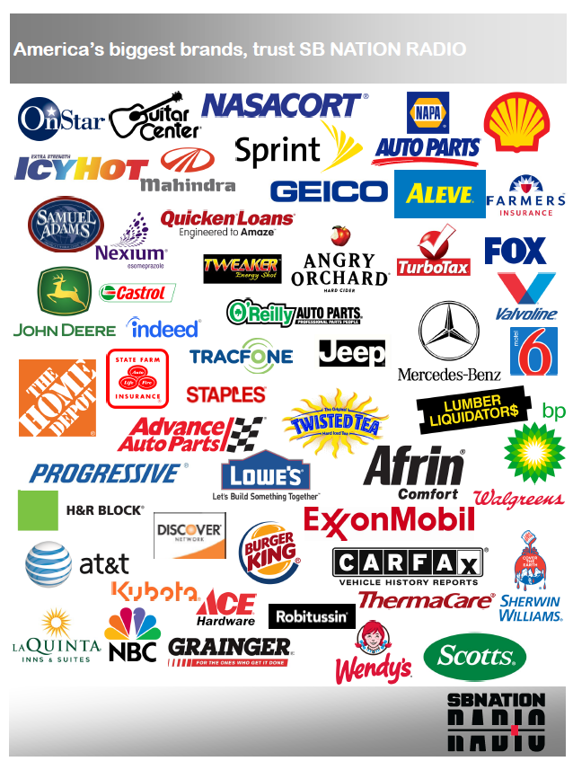

Current market landscape: Four full-time, sports-radio networks
Currently, Gow Media’s SB Nation Radio is one of four, full-time sports-talk radio networks in the country. The others are: ESPN Radio; Fox Sports Radio; and CBS Sports Radio. (NBC Sports Radio ceased operating as a full-time network in January 2019 and currently only offers limited programming and sports updates.) The competition for affiliates and listeners remains fierce among the four networks. Truth is, in many markets, an oversaturation of sports-talk radio programming exists with not enough available radio stations to clear all four networks.

NETWORK | AFFILIATES | PROFILE
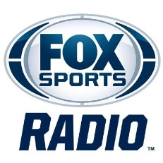 | 400 | Los Angeles-based Fox Sports Radio has a decidedly West Coast sound and identity. The network is home to Dan Patrick, Colin Cowherd, Rich Eisen, and Doug Gottlieb.
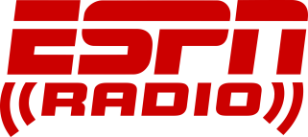 | 340 | Bristol, Connecticut-based radio arm of the worldwide leader is the radio arm of ESPN with Golic & Wingo; Dan Le Batard; Stephen A. Smith; and national play-by-play broadcasts that are unavailable to the other networks.
 | 300 | Based in New York City, CBS Sports Radio launched in 2013 and is currently home to the Jim Rome Show. Entercom operates the network under a licensing agreement with CBS Brands.
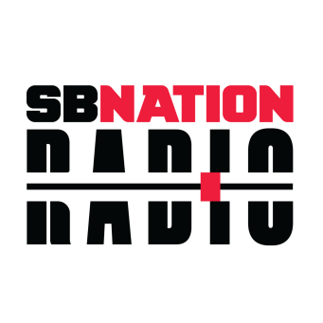 | 215 | Gow Media’s SB Nation Radio is a partnership with Vox Media and their property SB Nation, a collection of more than 300 community sites dedicated to professional and collegiate sports. Positioned as “The Next Generation of Sports Radio,” the network has a younger, edgier feel than traditional sports radio.

NBC Sports Radio: A cautionary tale
Launching VSiN Radio as the fifth sports network in this crowded marketplace represents a significant risk to the success of the venture. NBC Sports Radio could not generate enough revenue from its limited distribution to remain in the marketplace. This is a cautionary tale for VSiN’s proposed entrance into the market as the fifth network. Although a companion network to SB Nation Radio is possible, adding another network to the mix presents the same significant challenges that ultimately led to the demise of NBC Sports Radio.

Even with the reduction to four full-time sports-radio networks, the market remains saturated. Frankly, in many markets, there is a scarcity of available signals to support even four sports-talk stations. In addition, the thinning of revenue as a result of so many networks targeting the same demographic creates the challenge of revenue generation.

First-to-market terrestrial radio network that focuses exclusively on sports betting
VSiN is the first-ever 24/7 network dedicated to sports gambling news, information. As VSiN Radio, you’ll be the first-ever terrestrial radio network to deliver that content. This position as the first-to-market will be significant as competitors attempt to grab a share of this nascent content market. This will provide your network with a competitive advantage in the sports-talk radio format.

Currently, all four of the national sports radio networks, including SB Nation Radio, sound pretty much the same. The guests, topics, callers, and content are essentially alike with only slight variations between the networks. VSiN’s purchase of SB Nation Radio will remove one potential competitor for audience and advertisers, increase market share, and create an advantageous market position for VSiN Radio. The new network will come to market with one potential competitor out of the fray (SB Nation Radio) and exclusive, unique content that the other networks cannot deliver.

VSiN Radio: Changing the way you listen to sports
VSiN Radio will offer a unique, financial perspective on sports with passionate, entertaining hosts who have a real, vested interest in the games. No more sophomoric guy talk; no more hot takes; no more politics invading sports; no more hosts begging for callers and then berating them.

VSiN Radio will deliver sports talk that focuses on the games, the players, the coaches, and the fans that live for sports. The VSiN Radio approach will be sports-talk radio that is refreshing and creates an opportunity to position the network as an alternative to the homogenous sports-talk networks. ESPN, Fox Sports, and CBS Sports Radio will deliver more of the same while VSiN Radio delivers a new, refreshing, passionate, invested perspective of sports.

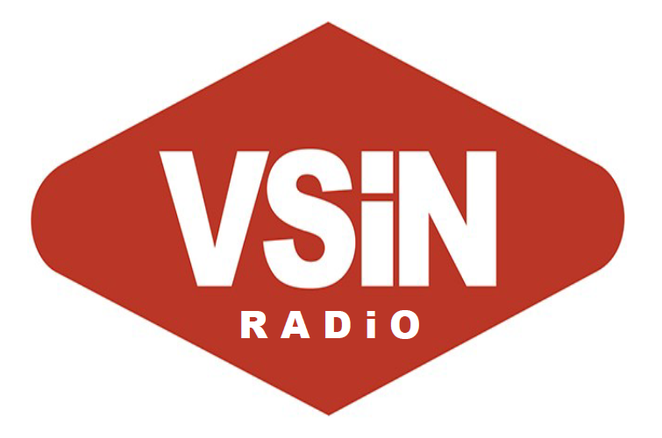

 | VSiN Radio Weekday Lineup
6A-7A | MY GUYS IN THE DESERT WITH BRENT MUSBURGER (ENCORE)
7A-10A | FOLLOW THE MONEY-MITCH & PAULY
10A-12P | A NUMBERS GAME WITH GILL ALEXANDER
12P-3P | PUSHING THE ODDS WITH MATT PERRAULT
3P-5P | THE EDGE
5P-6P | BETWEEN THE SIDELINES
6P-8P | MY GUYS IN THE DESERT WITH BRENT MUSBURGER
8P-12A | VSiN Game Night – NIGHTLY BETCAST (PROPOSED)
12A-6P | VSiN - OVERNIGHT (PROPOSED)

 | VSiN Radio Weekend Lineup
6A-7A | MY GUYS IN THE DESERT WITH BRENT MUSBURGER (ENCORE)
7A-10A | BEST OF FOLLOW THE MONEY-MITCH & PAULY
10A-12P | BETTING ACROSS AMERICA
12P-4p | THE GREEN ZONE
4P-7P | TBD
7P-12A | VSiN BETCAST OF THE WEEK (PROPOSED)
12A-6A | VSiN - OVERNIGHT (PROPOSED)

Market Landscape with the launch of VSiN Radio

NETWORK | AFFILIATES | PROFILE
 | 400 | Los Angeles-based Fox Sports Radio has a decidedly West Coast sound and identity. The network is home to Dan Patrick, Colin Cowherd, Rich Eisen, and Doug Gottlieb.
 | 340 | Bristol, Connecticut-based radio arm of the worldwide leader is the radio arm of ESPN with Golic & Wingo; Dan Le Batard; Stephen A. Smith; and national play-by-play broadcasts that are unavailable to the other networks.
 | 300 | Based in New York City, CBS Sports Radio launched in 2013 and is currently home to the Jim Rome Show. Entercom operates the network under a licensing agreement with CBS Brands.
 | 215 | With programming originating from Las Vegas, Atlantic City, and beyond, VSiN Radio will take SB Nation Radio’s place as the nation’s fourth-largest sports radio network with 215 nationwide affiliates.

Targeting ESPN, Fox Sports, CBS Sports Radio Affiliates
Immediately upon launch, VSiN Radio will target radio stations currently affiliated with our competitor networks. The goal will be to secure affiliations with 3-10% of our competitor stations.
Networks
Affiliates | 400 | 340 | 300
Flippers (3-5%) | 12-20 | 10-17 | 9-15
Flippers (6-10%) | 24-40 | 20-34 | 18-30
 | 360-388 | 306-330 | 270-291

We certainly can expect to lose affiliates with the flip of the network. Some stations will object to the network becoming a “gambling” network, regardless of our best efforts to educate them otherwise. It’s a reality that must be confronted. Using the same metric, if SB Nation loses between 3-10% of our affiliates with the flip of the format, then we can expect to lose between 11-22 affiliates, bringing our total down to 193-204 stations. Within two years of the launch of VSiN Radio, our goal would be a network of 224-308 affiliates.

NETWORK | MARKET PENETRATION YEAR 2 | PROFILE
 | 360-388 | Even though Clay Travis’s “Outkick the Coverage” has done well with securing new affiliations, there’s an opportunity for “Follow The Money” to secure affiliates, especially for morning drive in East Coast markets. Other shows are more formidable when pitted against the current VSiN lineup, including Dan Patrick & Rich Eisen.
 | 306-330 | Mike & Mike ended their 17-year run in 2017. Since then, ESPN Radio has been losing morning drive affiliates. The new pairing is not nearly as popular as the previous team. VSiN’s Follow The Money with Mitch & Pauly presents an opportunity to secure former Mike & Mike affiliates.
 | 224-308 | With programming originating from Las Vegas, Atlantic City, and beyond, VSiN Radio will take SB Nation Radio’s place as the nation’s fourth-largest sports radio network with 215 nationwide affiliates.
 | 270-291 | With the exception of Jim Rome, the VSiN Radio is very competitive against the CBS Sports Radio lineup.
Gow Media’s SB Nation Radio has survived and thrived in the crowded sports radio market. Since 2012, we have grown our affiliate base from approximately 202 affiliates to 932 affiliates. Our annual revenues are strong and getting stronger each year and we’re becoming profitable through the execution of a fiscally responsible plan of managing our overhead.

Four of the same in this sports-radio marketplace is a difficult position for us. Yet, VSiN presents a fresh, unique opportunity to engage the audience.

In VSiN, we see a groundbreaking opportunity. This nascent market is poised to explode as more states approve sports betting in their communities. In turn, the need for this unique content will only get stronger. Using SB Nation Radio’s foundation, VSiN Radio’s status as the first-to-market radio brand of this exclusive content, will position it for long-term success against ESPN Radio, Fox Sports Radio, and CBS Sports Radio.

Advertiser & Affiliate Challenges
Although gaining acceptance across the country, sports gambling is still not universally accepted. The social impact of gambling remains a highly contentious issue in many communities. Truth is, many radio stations will drop the programming immediately after a format flip to a network that focuses on sports betting. In some states, like Utah, sports gambling programming may never find a home on terrestrial radio.

After acquisition, VSiN Radio could launch with 215 network affiliates across the country. The goal is to retain as many SB Nation Radio affiliates as possible. Retaining all of our affiliates is not a realistic goal; therefore, we must plan for attrition. The goal will be to offset that attrition with new affiliates from the other sports radio networks; non-sports stations that flip formats to VSiN Radio; sponsor-supported brokered-time affiliates; and a la carte affiliates who air certain shows.

Advertiser resistance to a sports gambling network, both at the agency and corporate level, is a hurdle to the success of the venture. As we’ve seen with the VSiN Action Updates, many advertising agencies see the benefit to the audience numbers delivered by the updates. This is, however, a small content feature surrounded by traditional radio content. At the corporate level, there is still resistance to associating the brand with a “gambling” product. GEICO placed a “soft” hold on a six-figure sponsorship package for the Action Updates that was nixed at the corporate level. The insurance company did not want to be associated with a gambling enterprise.

This is not an insurmountable hurdle, but it will need to be addressed moving forward. That will require educating the media placement companies, advertising agencies, and corporate-level decision makers on the reality of the sports betting audience and the benefits to sponsoring that content.

In fact, since October, the VSiN Action Updates with limited inventory has billed more than $126,000 for nothing more than 15-second live reads in the updates that air on radio stations across the country with respected national advertisers, including: Blink; Blue Emu; Buffalo Wild Wings; Indeed; Lumber Liquidators; My Pillow; and WGN America.

If we can build a measureable audience, then we are confident in our ability to deliver advertising revenue with expanded programming offerings that include inventory on radio; television; satellite; print; and digital.

Increasing Advertising Revenue
Transactional sales are dependent upon audience delivery. For Gow Media, our “Sports Flash” product is sold on a mostly transactional basis that is dependent upon the large audience the product delivers.

In contrast, relationship sales are those made based on the relationships established through direct sales contact with the client. Selling the numbers is secondary to building the relationship with the clients, determining a measure of success for the campaign, and executing for the client. This relationship selling technique is why sports radio stations rarely deliver large audience numbers, but consistently are the strongest billing radio stations in a market.

In addition, VSiN can leverage its relationships throughout the gaming industry to secure advertising partners across the country. This can be done for national advertising and for local gambling companies to spend money with local affiliate stations.

VSiN Studio Naming Rights
Currently, SB Nation Radio has sold its studio naming rights to O’Reilly Auto Parts. Production elements are heard throughout the day that trumpets the programming originating from the O’Reilly Auto Parts Studio. We would develop a package to sell the naming rights to the VSiN Las Vegas and Atlantic City studios to a similar sponsor.

VSiN Guest Line
Currently, SB Nation Radio has sold its guest line to Progressive Insurance. Each time that a guest appears on a SB Nation Radio Show, we mention that the guest is appearing on the show via the “Progressive Insurance Guest Line.” On VSiN Radio, there are multiple guests throughout the day that call VSiN to appear on the network. For the advertiser, we’re wrapping their advertising message around content that the listener wants to hear. This reduces tune out, commercial fatigue, and delivers more impactful message for the advertiser.

VSiN’s Best Bets-Top 25
Modeled on collegiate Top 25 rankings, the VSiN Top 25 will rank the best bets of the week. Each week, VSiN hosts and contributors will submit their choices for the Top 25. The Top 10 or a random sampling from the Top 25 will be available online, with a subscription required to view the entire Top 25. An unveiling of the Top 10 or the random selections, could be a feature on multiple shows or a segment on My Guys in the Desert. This is one way of compiling all of the best bets of the week for the listeners and adding another reason for someone to pay for a subscription.

A few examples of possible Top 25 selections include Mitch & Pauly’s 1st-period overs, the morning show’s “Step Yo Game Up,” and Gill Alexander’s Tankapaloza. In addition to distribution online and on-air, VSiN could distribute a top 5 best bets to the New York Post and other publications nationwide.

Mitch & Pauly On the Road
VSiN’s morning show would take the show on the road to host the show in markets where we have an affiliate presence. An immediate opportunity to connect with the audience would be to host a show in Boston for the NESN fans. Philadelphia, Atlantic City, and Delaware would also be good fits for possible “On The Road” destinations for the show. Of course, the “On the Road” plan would require much more work logistically to do a remote show from a different location. Those costs can be offset with support of sponsors.

To test the appetite for 100% sports betting content on our network, we will conduct an affiliate survey that will be distributed to our current and potential affiliates.

The survey questions could include:

- How interested are your listeners in sports betting information?

-Very interested;
-Somewhat interested;
-Not interested.

- How interested are you in long-form programming that includes entertaining, in-depth, objective analysis of the sports news of the day from trusted sports journalists?

-Very Interested;
-Somewhat interested;
-Not interested.

- How interested would you be if that same network also incorporated into its programming actionable and objective betting information for your listeners? This could include point spreads, money lines, totals, and proposition bets on the sporting events of the day.

-Very interested;
-Somewhat interested;
-Less interested;
-Not interested.

- Would you be more interested or less interested if the long-form programming featured trusted sports journalists who discussed sports news and topics of the day that incorporated sports betting information from prominent sports business industry leaders and sports gambling industry guests?

- Would you be more interested or less interested if the long-form programming was a hybrid of traditional sports talk radio that also incorporated sports betting information from trusted journalists, sports gambling industry experts, and the biggest names in sports?

- Would you be more interested or less interested in that same network if you knew that the sports betting information was delivered objectively to the listeners without financial consideration to “push” picks, or betting services, or certain sports gambling entities?

- If your current sports network switched to a network that exclusively delivered sports betting news, would you:

-continue to air the programming;
-take a wait-and-see approach and decide based on listener reaction; or,
-drop the programming immediately.

- If your current sports network switched to a hybrid format that combined traditional sports talk and trusted, actionable sports betting information from trusted journalists, would you:

-continue to air the programming;
-take a wait-and-see approach and decide based on listener reaction, or,
-drop the programming immediately.

While I am confident in an 80-90% affiliate retention rate, this survey will give us quantitative data that we can use to determine how many affiliates VSiN Radio can expect at launch.

Tweaking your programming to appeal to a broader audience
VSiN should remain true to the core values that make the network so unique. First and foremost, VSiN is a sports betting network, but appealing to programmers of traditional “sports talk” stations may require a slight tweak of the on-air presentation. Again, there’s absolutely no change to the content delivered, just the presentation.

Sports first, then sports betting
VSiN is at its best when it talks sports. The analysis delivered by the hosts is among the best in the business. It is delivered by passionate hosts with a vested interest in the outcome of the games. The insights offered are refreshing in the world of “guy talk” sports radio that dominates the business. Listening to VSiN means you hear hosts actually talking about sports.

A slight variation of the on-air presentation will make a difference in an effort to appeal to a general audience. It’s simple: first sports, then sports betting. That’s it. Remaining true to your core values, the content remains exactly the same, but with a slight variation in delivery to appeal to a larger audience. This is what we’ve tried to accomplish with the Action Updates that air on terrestrial radio. The Action Updates deliver information of relevance to the game, stats of importance to the listener, followed by how the stats and information relate to the betting lines.

This is particularly critical for the morning, afternoon drive shows. A broader audience appeal is important to ensure advertiser support of the programs moving forward. We must generate sufficient general audience numbers to maintain advertiser support. If the content remains too niche-orientated, appealing to a narrow audience, advertising revenue will suffer. Another balancing act remains in play for VSiN Radio’s success. While tweaking the format to appeal to a larger audience, VSiN must remain true to its founding principles of delivering sports betting news and information that will appeal to both the causal and sharp bettor. That’s why we propose that for the next phase of VSiN’s evolution include new branding: VSiN: GET iN THE GAME.
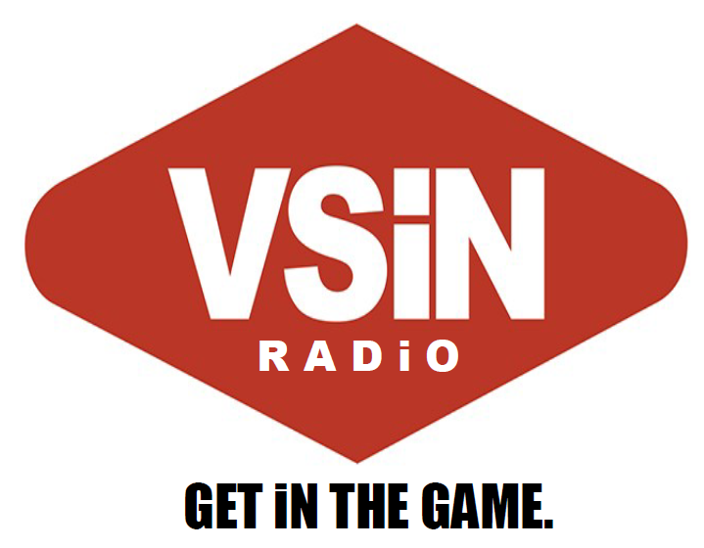

VSiN Radio: Get in the Game.
When positioned against the three other sports-radio networks, VSiN delivers an alternative. Unique content delivered by passionate hosts with a vested interest in the games of the day. Unlike the other sports-talk networks that offer opinions, weak analysis, and hosts who beg for caller interaction, VSiN Radio delivers the stats, information, and expert analysis that the listener needs to get in the game.

This positioning aligns with our “sports first, then sports betting” content philosophy. While remaining true to your core values, VSiN Radio will deliver content that will appeal to the average sports fan while fulfilling the need for sports betting information and analysis that bettors expect from the nation’s first-ever sports gambling information network.

A tweak in the presentation will be necessary to help VSiN Radio gain traction with affiliates and advertisers.

Expanding VSiN programming
Excluding your special BetCasts and special programming, VSiN consistently produces approximately 14 hours of live programming each week. That’s only 8.3% of the programming needed for a 168-hour broadcast week. VSiN will need to expand its show offerings to offer radio stations 24/7/365 programming. Often, SB Nation Radio serves as a “backstop” network for radio stations that produce a significant amount of local programming. SB Nation Radio fills a void of nights, overnights, and weekends when stations do not provide local programs.

Expanding VSiN programming to a 24-hour network does not necessarily mean a large outlay of capital for new shows. VSiN’s acquisition of SB Nation Radio will mean the purchase of an existing infrastructure with the ability to deliver daily programming to radio stations. Under a hybrid programming plan that appeals to a broad audience, we can train some of our current hosts to deliver gambling-centric programming.

The VSiN Radio programming does not necessarily need to originate from Las Vegas or the SB Nation Radio studios in Houston. Technology enables us to find the best talent available in the country, not just the best talent available who wants to move to Vegas or Houston to host a show. Our SB Nation Radio hosts and anchors are scattered throughout the country in many different markets, including: Boston, Atlanta, Orlando, Nashville, Orlando, and Atlantic City, among others.
If the goal is to provide 24/7/365 streaming of the live shows at VSiN, then we would need to make arrangements for the video streaming from remote locations. Most likely it would be similar to what is done for the “Betting Across America” shows that originate from Atlantic City,

We would suggest the launch of a nightly BetCast that focuses on in-game wagering. This would be an immediate programming offering that would be of interest to affiliate stations. Although many stations do air play-by-play during the evening hours, VSiN’s BetCast could fill the void when there are no play-by-play broadcasts to air during the evening.

Introducing VSiN Radio to new affiliates
The transition from SB Nation Radio will need to be finessed as we transition from a traditional sports radio network to one that focuses on sports betting. We will need to educate our different constituencies on the reasons behind the transition, the benefits of the new format, and the game plan moving forward to all involved.

To offset the loss, we will target stations that are currently affiliated with ESPN Radio; Fox Sports Radio; and CBS Sports Radio. VSiN delivers content that is unique to the current radio landscape. This unique selling proposition is a competitive advantage when marketing VSiN to radio stations. Nothing else sounds like VSiN Radio.

Current SB Nation Radio Affiliates
Entering into the conversation, we contend that approximately 10-15% of our current affiliate base with balk at the switch to format that focuses on sports betting. That’s our initial estimate, but even if that number climbs to 25-percent, then you’re still launching with 162 network affiliates. As mentioned, we do expect affiliate attrition and should get a good feel for what we can expect with our affiliate survey.

We anticipate VSiN Radio launching with a strong foundation of affiliates from our current roster of SB Nation Radio stations. The proposed affiliate survey will solidify those numbers.

Brokered Time
Traditionally, SB Nation has not engaged in buying time from radio stations to gain clearances in a market. There are a few exceptions when it was necessary for a certain advertiser or campaign, but we’ve always had revenue attached to the purchase. We recommend maintaining that philosophy moving forward. If there revenue is attached, then buying blocks of time on radio stations in certain markets does make a lot of sense. This could be a method of cracking into a significant market. It is critical, however, to have revenue attached to these clearances, because it could get expensive.

Finding sponsors to offset paying for station clearances would be advisable in certain markets, including New York City, Philadelphia, or New Orleans. The sponsors would be the local casino sports book operation. This model would require us to pay a monthly fee to stations to clear programming on the station. Depending upon the station and market, this could range from $5,000-$10,000+ per month to clear a major-market station. We can target ethnic and religious and other current brokered-time radio stations that would be interested in generating consistent monthly revenue with VSiN programming.

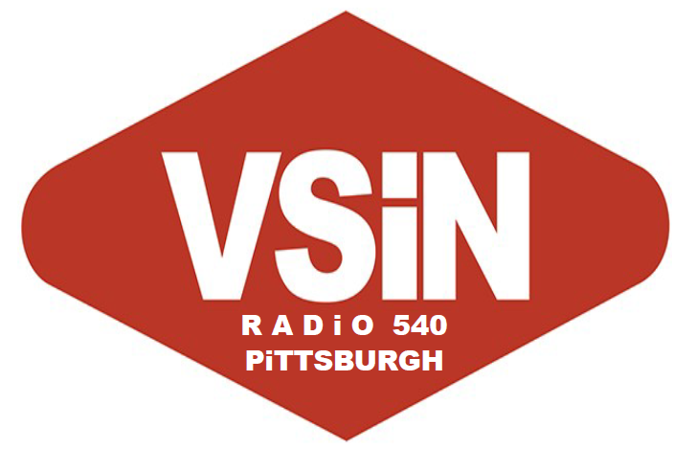
VSiN Radio Branded Stations
In key markets, we will encourage stations to brand their stations as VSiN Radio. This will be similar to what is done with ESPN, Fox Sports, CBS Sports Radio, and SB Nation Radio stations across the country. Our affiliates in Detroit and Pittsburgh air our programming 24/7/365. We will brand these stations as VSiN Radio 540 Pittsburgh and VSiN Radio 1090 Detroit.

A la carte stations
While we would prefer that radio station air all of our programming, that’s an unlikely proposition for all stations; therefore, we will try to fill programming voids for stations with our offerings. Although many stations are exclusively ESPN or Fox Sports, there are some stations that use a best-of-breed format that includes shows from Golic & Wingo; Rich Eisen; Dan Patrick; Jim Rome and more. These stations would be a prime candidate for “My Guys in the Desert” with the living legend Brent Musberger. For those stations, adding a name like Brent Musberger will very attractive to complete their all-star lineup of hosts.

VSiN’s “Follow The Money” with Mitch Moss & Pauly Howard is poised for tremendous growth as a radio show that could compete with Golic & Wingo for pure entertainment value. Although focused on sports gambling, the show deliver compelling and entertaining content that just needs an outlet for success.

Format Flippers
Each of our key markets will be populated with underperforming or neglected radio stations that could be ripe for a flip to VSiN Radio. The stations are not necessarily sports stations, but are currently airing a variety of formats. Some of the stations are neglected in that they’re just a simulcast of another station. Others are underperforming in terms of ratings and revenue. Still others are airing music formats that simply will not attract an audience on AM radio. We will identify radio stations in the markets and target those stations for a flip to VSiN Radio with an affiliate game plan for the station to attract an audience and generate revenue. Finding a sports book partner in the local market will make it possible to create a revenue stream with advertising support from the local sports book that will directly benefit the local station and our network.

Geo-targeting radio stations in states with legal sports betting
We cannot ignore the difficulty of convincing radio stations in states without legal sports gambling to air programming from a sports betting network. This will be a significant hurdle to gaining clearances in those states. Programmers will simply ask: Why should I air this on my station? People here cannot bet on sports. That’s what makes our “sports first, then sports betting” philosophy so important to the overall strategy of acquiring terrestrial affiliates. If we can demonstrate that we’re a great sports network that just happens to talk about sports betting, then the network will be ready to add affiliates in those states without sports betting.

Although shows like “Follow the Money” and “My Guys in the Desert” have a universal appeal to sports radio listeners, establishing success in sports-betting markets will be critical to gaining traction for the shows nationwide. Target the eight states with legalized sports betting, establish VSiN Radio as the network of choice for sports betting news and information, and build into new markets as legislation passes in each state.

Sports Book Affiliate Partners
In several key markets, where wagering is legal, we will work with the local affiliate to secure advertising partnerships with the local sports books. These partnerships could reflect a significant revenue stream for the local station, ensuring clearances in many markets. It will be critical to help the local stations build the relationships with the sports books. It is in the casino’s best interest to have a radio station that is exclusively dedicated to discussing sports betting.

Attaching revenue to radio stations without an additional outlay of capital or overhead expenses can make a real difference in locking down an affiliate in a particular market. Although the revenue would be spent with the local station, we would gain affiliates and commercial inventory that we can sell to national advertisers.

In markets with legal sports betting, VSiN will target local sports books/casinos to work as advertising partners for the local stations. There are multiple stations in each market which could be a good fit for this revenue-generating plan for the local stations.

Recapping the advantages of acquisition
A purchase of SB Nation Radio comes with many advantages, including:

-boosting awareness of VSiN to a general audience;
-launching the nation’s first-ever sports-gaming network on terrestrial radio;
-reaching a monthly audience of more than 7.5-million listeners;
-increasing premium subscriptions and sales of your special-event publications;
-tapping into a new multimillion dollar revenue stream; and,
-positioning your brand for success in a crowded sports-talk radio landscape.

In our opinion, this is the strongest play for VSiN’s entrance into terrestrial radio. This first-to-market plan will further demonstrate to the world that it is a trailblazer in the world of sports gambling content.

