Tweaking your programming to appeal to a broader audience
VSiN should remain true to the core values that make the network so unique. First and foremost, VSiN is a sports betting network, but appealing to programmers of traditional “sports talk” stations may require a slight tweak of the on-air presentation. Again, there’s absolutely no change to the content delivered, just the presentation.

Sports first, then sports betting
VSiN is at its best when it talks sports. The analysis, relevant information is among the best in the business. It is delivered by passionate hosts with a vested interest in the outcome of the games. The insights offered are refreshing in the world of “guy talk” sports radio that dominates the business. Listening to VSiN means you hear hosts actually talking about sports.

A slight variation of the on-air presentation will make a difference in an effort to appeal to a general audience. It’s simple: first sports, then sports betting. That’s it. Remaining true to your core values, the content remains exactly the same, but with a slight variation in delivery to appeal to a larger audience. This is what we’ve tried to accomplish with the Action Updates that air on terrestrial radio. The Action Updates deliver information of relevance to the game, stats of importance to the listener, followed by how the stats and information relate to the betting lines.

This is particularly critical for the morning, afternoon drive shows. A broader audience appeal is important to ensure advertiser support of the programs moving forward. We must generate sufficient general audience numbers to maintain advertiser support. If the content remains too niche-orientated, appealing to a narrow audience, advertising revenue will suffer. Another balancing act remains in play for VSiN Radio’s success. While tweaking the format to appeal to a larger audience, VSiN must remain true to its founding principles of delivering sports betting news and information that will appeal to both the causal and sharp bettor. That’s why we propose that for the next phase of VSiN’s evolution include new branding: VSiN: Get in the Game.

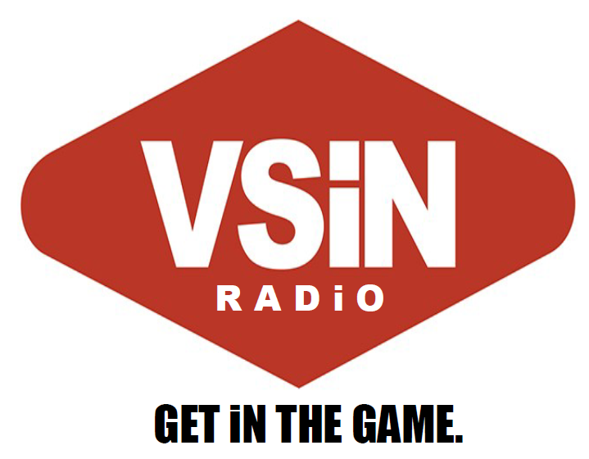
VSiN Radio: Get in the Game.
When positioned against the three other sports-radio networks, VSiN delivers an alternative. Unique content delivered by passionate hosts with a vested interest in the games of the day. Unlike the other sports-talk networks that offer opinions, weak analysis, and hosts who beg for caller interaction, VSiN Radio delivers the stats, information, and expert analysis that the listener needs to get in the game.

This positioning aligns with our “sports first, then sports betting” content philosophy. While remaining true to your core values, VSiN Radio will deliver content that will appeal to the average sports fan while fulfilling the need for sports betting information and analysis that bettors expect from the nation’s first sports betting network.

A tweak in the presentation will be necessary to help VSiN Radio gain traction with affiliates and advertisers.

Expanding VSiN programming
Excluding your special BetCasts and special programming, VSiN consistently produces approximately 14 hours of live programming each week. That’s only 8.3% of the programming needed for a168-hour broadcast week. VSiN will need to expand its show offerings to offer radio stations 24/7/365 programming. Often, SB Nation Radio serves as a “backstop” network for radio stations that produce a significant amount of local programming. SB Nation Radio fills a void of nights, weekends when stations do not provide local programs.

Expanding VSiN programming to a 24-hour network does not necessarily mean a large outlay of capital for new shows. VSiN’s acquisition of SB Nation Radio will mean the purchase of an existing infrastructure with the ability to deliver daily programming to radio stations. Under a hybrid programming plan that appeals to a broad audience, we can train some of our current hosts to deliver gambling-centric programming.

In addition, the programming does not necessarily need to originate from Las Vegas or the SB Nation Radio studios in Houston. While the streaming

To target this growing segment of the sports wagering business, a nightly BetCast that focuses in in-game wagering would be a nice nightly programming offering for radio affiliates.

Introducing VSiN Radio to new affiliates
The transition from SB Nation Radio will need to be finessed as we transition from a traditional sports radio network to one that focuses on sports betting. We will need to educate our different constituencies on the reasons behind the transition, the benefits of the new format, and the game plan moving forward to all involved.

To offset the loss, we will target stations that are currently affiliated with ESPN Radio; Fox Sports Radio; and CBS Sports Radio. VSiN delivers content that is unique to the current radio landscape. This unique selling proposition is a competitive advantage when marketing VSiN to radio stations. Nothing else sounds like VSiN Radio.

There are several well-defined markets for potential affiliate acquisition. These include:

Current SB Nation Radio Affiliates
Entering into the conversation, we contend that approximately 10-15% of our current affiliate base with balk at the switch to format that focuses on sports betting. That’s our initial estimate, but even if that number climbs to 25-percent, then you’re still launching with 162 network affiliates. As mentioned, we do expect affiliate attrition and should get a good feel for what we can expect with our affiliate survey.

We anticipate VSiN Radio launching with a strong foundation of affiliates from our current roster of SB Nation Radio stations.

Brokered Time
Traditionally, SB Nation has not engaged in buying time from radio stations to gain clearances in a market. There are a few exceptions when it was necessary for a certain advertiser or campaign, but we’ve always had revenue attached to the purchase. We recommend maintaining that philosophy moving forward. If there revenue is attached, then buying blocks of time on radio stations in certain markets does make a lot of sense. This could be a method of cracking into a significant market. It is critical, however, to have revenue attached to these clearances, because it could get expensive.

Finding sponsors to offset paying for station clearances would be advisable in certain markets, including New York City, Philadelphia, or New Orleans. The sponsors would be the local casino sports book operation.

Format Flippers
Each of our key markets will be populated with underperforming or neglected radio stations that could be ripe for a flip to VSiN Radio. The stations are not necessarily sports stations, but are currently airing a variety of formats. Some of the stations are neglected in that they’re just a simulcast of another station. Others are underperforming in terms of ratings and revenue. Still others are airing music formats that simply will not attract an audience on AM radio. We will identify radio stations in the markets and target those stations for a flip to VSiN Radio with an affiliate game plan for the station to attract an audience and generate revenue.

VSiN Radio Branded Stations
In key markets, we will encourage stations to brand their stations as VSiN Radio. This will be similar to what is done with ESPN, Fox Sports, CBS Sports Radio, and SB Nation Radio stations across the country. Our affiliates in Detroit and Pittsburgh air our programming 24/7/365. We will brand these stations as VSiN Radio 540 Pittsburgh and VSiN Radio 1090 Detroit.

Geo-targeting radio stations in states with legal sports betting
We cannot ignore the difficulty of convincing radio stations in states without legal sports gambling to air programming from a sports betting network. This will be a significant hurdle to gaining clearances in those states. Programmers will simply ask: Why should I air this on my station? People here cannot bet on sports. That’s what makes our “sports first, then sports betting” philosophy so important to the overall strategy of acquiring terrestrial affiliates. If we can demonstrate that we’re a great sports network that just happens to talk about sports betting, then the network will be ready to add affiliates in those states without sports betting.

Although shows like “Follow the Money” and “My Guys in the Desert” have a universal appeal to sports radio listeners, establishing success in sports-betting markets will be critical to gaining traction for the shows nationwide. Target the eight states with legalized sports betting, establish VSiN Radio as the network of choice for sports betting news and information, and build into new markets as legislation passes in each state.

Sports Book Affiliate Partners
In several key markets, where wagering is legal, we will work with the local affiliate to secure advertising partnerships with the local sports books. These partnerships could reflect a significant revenue stream for the local station, ensuring clearances in many markets. It will be critical to help the local stations build the relationships with the sports books. It is in the casino’s best interest to have a radio station that is exclusively dedicated to discussing sports betting.

Attaching revenue to radio stations without an additional outlay of capital or overhead expenses can make a real difference in locking down an affiliate in a particular market.

In those markets where sport wagering is legal, VSiN Radio will target the following affiliates and potential sports book partners.

SALES
Transactional sales are dependent upon audience delivery. For Gow Media, our “Sports Flash” product is sold on a mostly transactional basis that is dependent upon the large audience the product delivers.

In contrast, relationship sales are those made based on the relationships established through direct sales contact with the client. Selling the numbers is secondary to building the relationship with the clients, determining a measure of success for the campaign, and executing for the client. This relationship selling technique is why sports radio stations rarely deliver large audience numbers, but consistently are the strong billing radio stations in a market.

VSiN can leverage its relationships throughout the gaming industry to secure advertising partners across the country. This can be done for national advertising and for local gambling companies to spend money with local affiliate stations.

STUDIO NAMING RIGHTS
Currently, SB Nation Radio has sold its studio naming rights to O’Reilly Auto Parts. Production elements are heard throughout the day that trumpets the programming originating from the O’Reilly Auto Parts Studio. We would develop a package to sell the naming rights to the VSiN Las Vegas and Atlantic City studios to a similar sponsor.

STUDIO GUEST LINE
Currently, SB Nation Radio has sold its guest line to Progressive Insurance. Each time that a guest appears on a SB Nation Radio Show, we mention that the guest is appearing on the show via the “Progressive Insurance Guest Line.” On VSiN Radio, there are multiple guests throughout the day that call VSiN to appear on the network. For the advertiser, we’re wrapping their advertising message around content that the listener wants to hear. This reduces tune out, commercial fatigue, and delivers more impactful message for the advertiser.

VSiN’s Best Bets-Top 25
Modeled on collegiate Top 25 rankings, the VSiN Top 25 will rank the best bets of the week. Each week, VSiN hosts and contributors will submit their choices for the Top 25. The Top 10 or a random sampling from the Top 25 will be available online, with a subscription required to view the entire Top 25. An unveiling of the Top 10 or the random selections, could be a feature on multiple shows or a segment on My Guys in the Desert. This is one way of compiling all of the best bets of the week for the listeners and adding another reason for someone to pay for a subscription.

A few examples of possible Top 25 selections include Mitch & Pauly’s 1st-period overs, the morning show’s “Step Yo Game Up,” and Gill Alexander’s Tankapaloza. In addition to distribution online and on-air, VSiN could distribute a top 5 best bets to the New York Post and other publications nationwide.

Mitch & Pauly On the Road
VSiN’s morning show would take the show on the road to host the show in markets where we have an affiliate presence. A natural fit would be a trip to the Boston area to host the host at the home of NESN. Philadelphia, Atlantic City, and Delaware would also be good fits for possible “On The Road” destinations for the show.

Delaware
Sports wagering is available at Delaware Park Casino; Dover Downs Hotel & Casino; and Harrington Racing & Casino.

VSiN Radio will target the following for the 24/7 format:

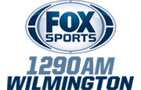 | 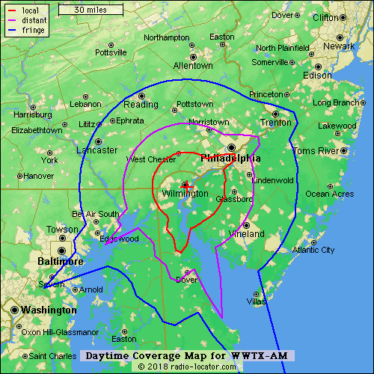

WWTX-AM – Fox Sports 1290
This is an iHeart Media station that currently airs the SB Nation AM show, and our VSiN Action Updates. At a minimum, this station will air “Follow the Money” in morning drive. This station gives us coverage in the state’s largest city and also reaches into the Philadelphia suburbs.

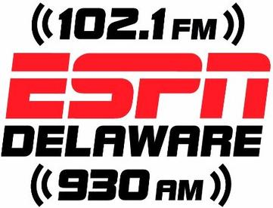 | 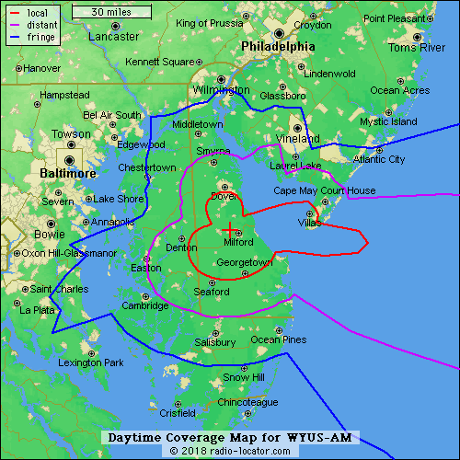

WYUS-AM - ESPN Delaware
This is a Delmarva Broadcasting station based in Milford and covering Dover and Milford with an AM signal and an FM translator signal that is strongest in Milford. The station currently airs all ESPN programming with the exception of the local Schofield on Sports show.

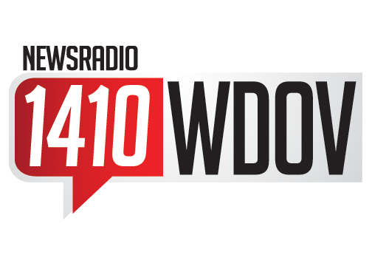 | 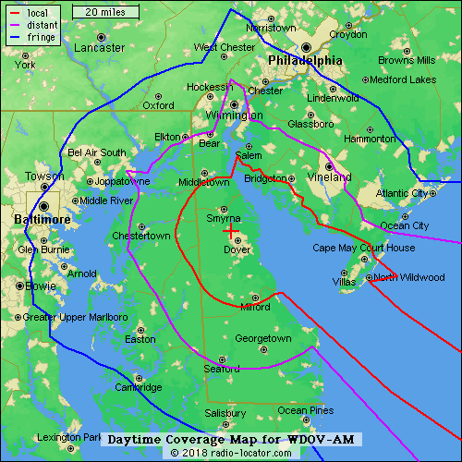

WDOV-AM - News Radio 1410 WDOV
This is an iHeart Media station that airs syndicated programs, including Rush Limbaugh and Sean Hannity. The station is Delaware’s News, Traffic, and Weather station.

Mississippi
There are 23 properties in Mississippi that offer sports betting.

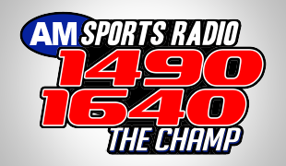 | 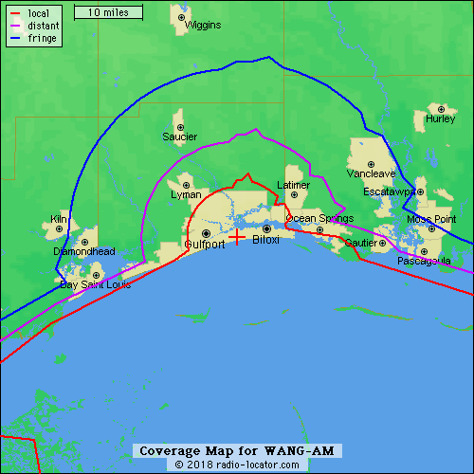 | 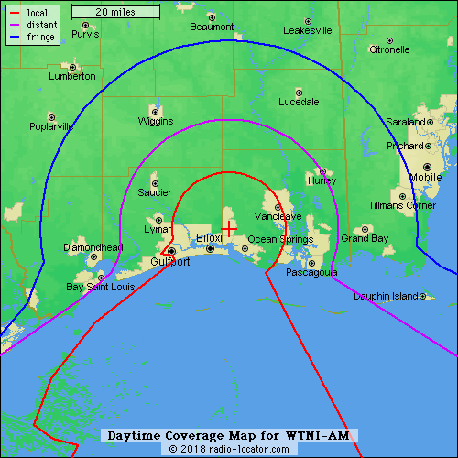

WANG-AM & WTNI-AM - Gulfport/Biloxi, MS
This is an Alpha Media simulcast that is branded as Sports Radio 1490 & 1640 The Champ. The station is home to ESPN national programming, including Golic & Wingo, Jim Rome, and the Paul Finebaum Show.

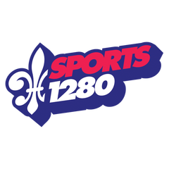 | 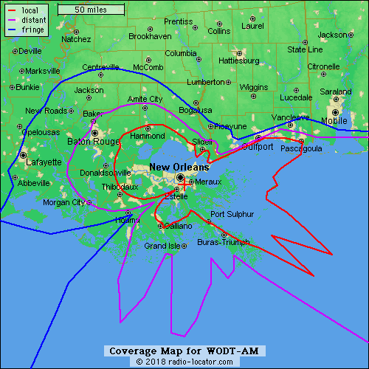

WODT-AM - New Orleans
This is an iHeart Media station that is branded as New Orleans home for home team talk. The station airs programming from Fox Sports.

PARTNER SPORTS BOOKS

- Beau Rivage Resort & Casino – Biloxi
- Boomtown Casino - Biloxi
- Golden Nugget – Biloxi
- Hard Rock Hotel & Casino – Biloxi
- Harrah’s Gulf Coast – Biloxi
- Hollywood Casino Gulf Coast – Bay Saint Louis
- IP Casino Resort Spa - Biloxi
- Island View Casino Resort – Gulfport
- Palace Casino Resort – Biloxi
- Scarlett Pearl Casino Resort – D’Iberville
- Silver Slipper Casino – Bay St. Louis
- Treasure Bay Casino & Hotel - Biloxi

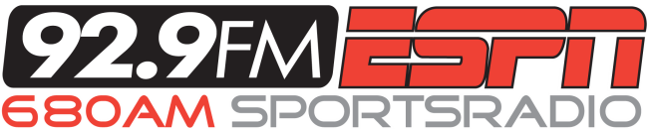 | 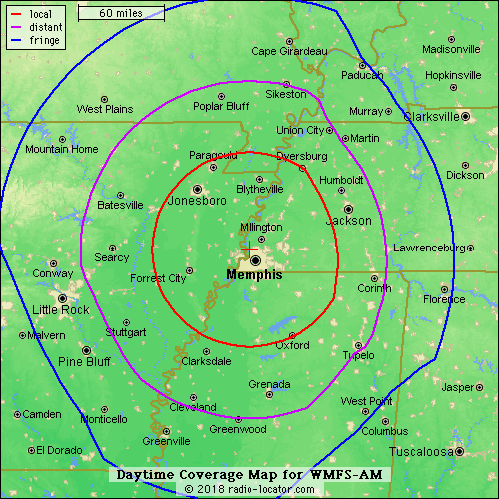

WMFS-AM – Memphis
This Entercome-owned station includes ESPN’s Golic & Wingo in the morning followed by locally-produced sports shows the rest of the day, including Geoff Calkins; Jason & John; Eric Hasseltine; and Gary Parrish. At night, starting at 6 PM Central, the station airs ESPN shows and play-by-play broadcasts.

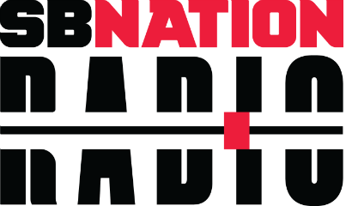  730 | 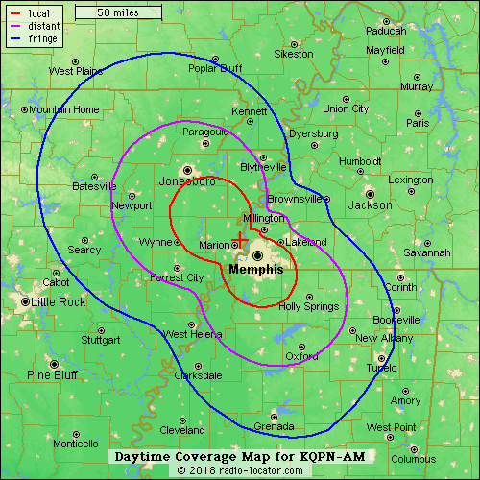

KQPN-AM – West Memphis, Arkansas
This is an independently-owned SB Nation Radio affiliate that serves the Memphis, Tennessee market as SB Nation Radio 730. This station has been an affiliate since 2011 and airs a mix of local programming and SB Nation Radio shows.

PARTNER SPORTS BOOKS:

- 1ST Jackpot Casino - Robinsonville
- Fitz Casino Hotel – Robinsonville
- Gold Strike Casino Resort – Robinsonville
- Harlow’s Casino Resort – Greenville
- Hollywood Casino & Hotel – Robinsonville
- Sam Town’s - Robinsonville
- Isle of Capri Casino & Resort – Lula
- Resorts Tunica – Robinsonville
- Tunica Roadhouse Casino & Hotel - Robinsonville

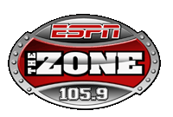 | 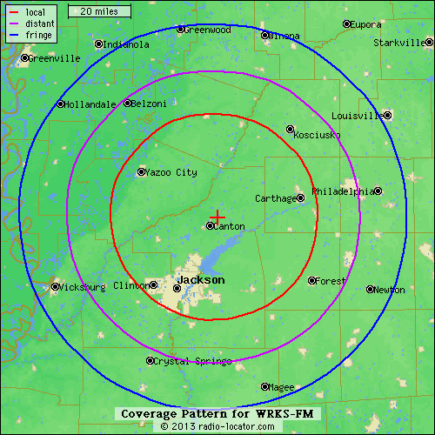

WRKS-FM - Jackson, Mississippi
This is an Alpha Media station that is positioned as Central Mississippi’s Sports FM. The station airs syndicated shows from ESPN, including Golic & Wingo and the Paul Finebaum Show. In addition, WRKS airs local shows with Bo Bounds, Matt Wyatt, Chris Brooks, and Jake Wimberly.

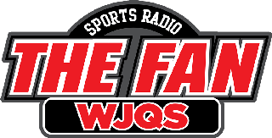 | 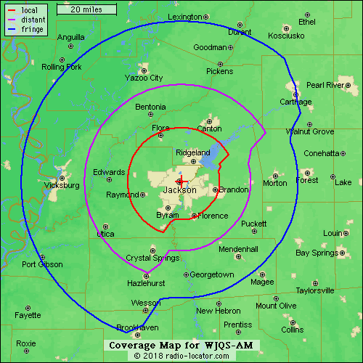

WJQS-AM – Jackson, Mississippi
This Alpha Media station is the sister station of WRKS-FM. Sports Radio 1400 The Fan airs all syndicated programming, including: Clay Travis; Dan Patrick; The Herd with Colin Cowherd; and Rich Eisen.

PARTNER SPORTS BOOKS:

- Ameristar Casino Hotel - Vicksburg
- Magnolia Bluffs Casino – Natchez
- WaterView Casino & Hotel – Vicksburg
- Bok Homg Casino – Heidelberg
- Pearl River Resort – Philadelphia
- Golden Moon Hotel & Casino @ Pearl River Resort – Philadelphia
- Silver Star Casino - Philadelphia
- Lady Luck Casino – Vicksburg
- Lighthouse Point Casino – Greenville

Nevada
New Jersey
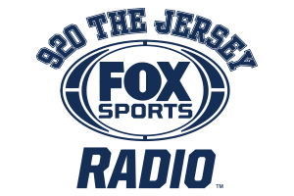 | 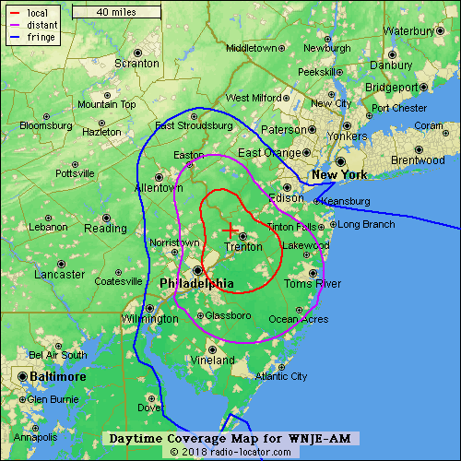

WNJE-AM
A Townsquare Media station based in Trenton, New Jersey has a signal that reaches into the Philadelphia suburbs. The station features mostly syndicated programming from Fox Sports, but includes Clay Travis, Dan Patrick, Colin Cowherd, and Doug Gottlieb. The station also includes a one-hour “House of Cards” Show that focuses on the business and entertainment side of the casino business. In addition, the station airs a locally-produce show called the Sports Skillet.

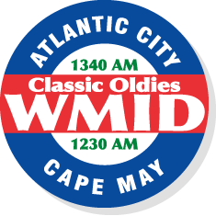 | 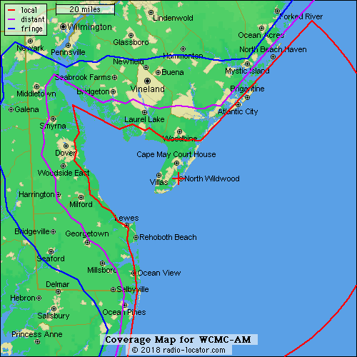 | 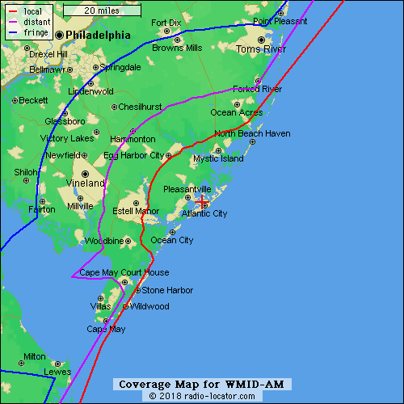

WCMC-AM & WMID-AM - Classic Oldies Radio 1230 & 1340
These stations

 | 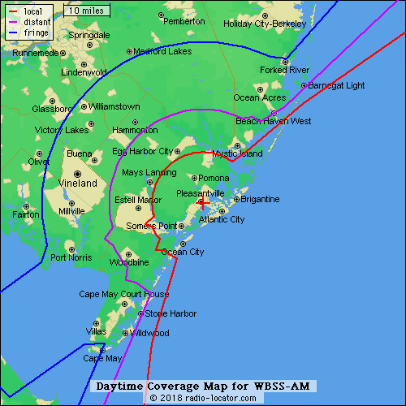

WBSS-AM (WKTU-FM Simulcast)
Loganport Media’s WTKU-FM is simulcast on WBSS-AM signal in Atlantic City. The station is a Classic Hits format. WTKU-FM is a stand-along broadcast signal, so this is a station that would be perfect for a format clipper proposal.

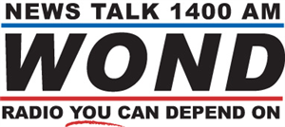 | 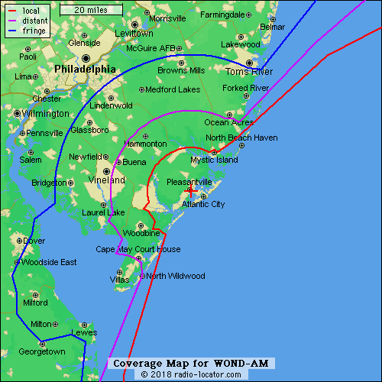

WOND-AM
This is a Loganport Media station that airs second-and-third-tier talk shows. The station includes the syndicated Jim Bohannon, America in the Morning, and Coast-to-Coast AM with George Noory. The station positions itself as Live and Local News and Talk for South Jersey.

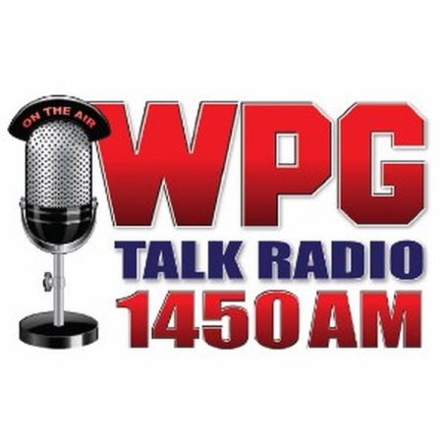 | 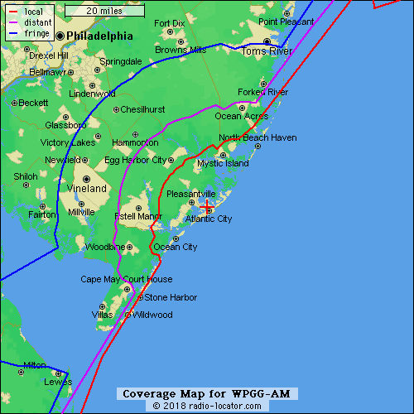

WPG-AM (1450) – Atlantic City
This is a Townsquare Media station that airs a news/talk format, including Sean Hannity, Mark Levin, the Savage Nation, and Joe Pags. Many of these shows are black listed by many advertising agencies for controversial content.

PARTNER SPORTS BOOKS:
- Monmouth Park Raceway – Monmouth
- Meadowlands Racetrack - Meadowlands
- Resorts Casino Hotel Sports Book – Atlantic City
- Ocean Resort Casino – Atlantic City
- Atlantic City’s Golden Nugget – Atlantic City
- Bally’s - Atlantic City
- Harrah’s – Atlantic City
- Caesars – Atlantic City
- Borgata Hotel, Casino Spa – Atlantic City

New Mexico

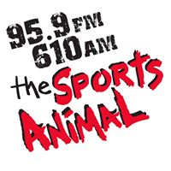 | 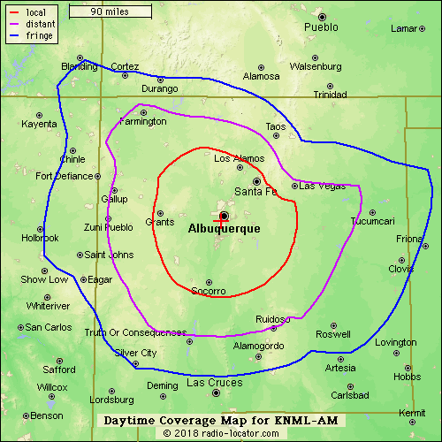 | 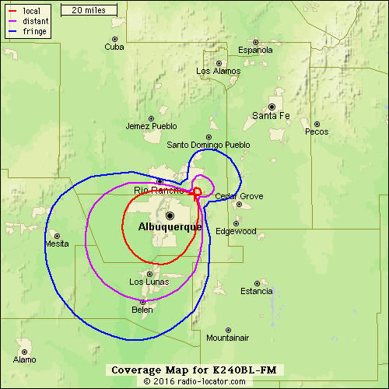

KNML-AM – Albuquerque
This is a Cumulus Media station that airs a locally-produced morning show (The Morning Drive) and afternoon show (The Sports Bar). In addition, the station airs Jim Rome and Dan Patrick.

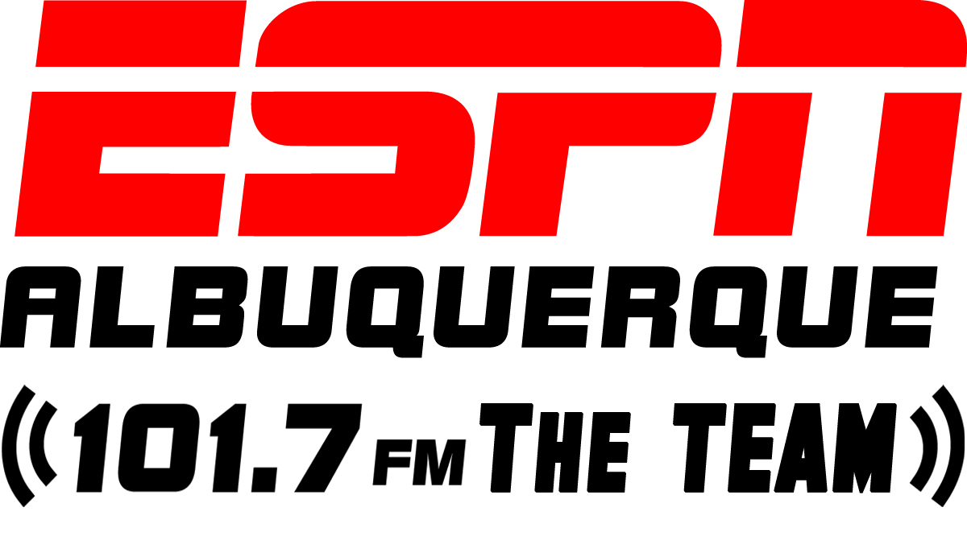 | 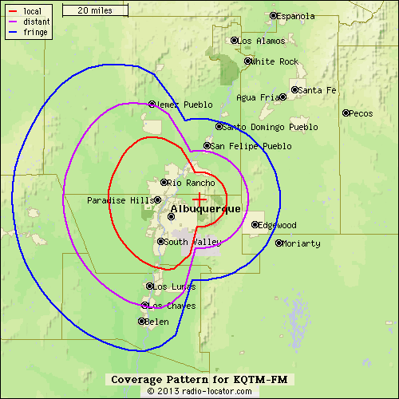

KQTM-FM – Albuquerque
This is an independently-owned radio station that airs mostly syndicated programming from ESPN Radio. The station is also the play-by-play home of the New Mexico Lobos, Los Angeles Dodgers, Dallas Cowboys, Denver Broncos, Oakland Raiders, and Notre Dame football. The station airs a locally-produced afternoon show that is hosted by Jim Villanucci.

PARTNER SPORTS BOOK
- Santa Ana Star Casino Hotel – Santa Ana Pueblo

Pennsylvania

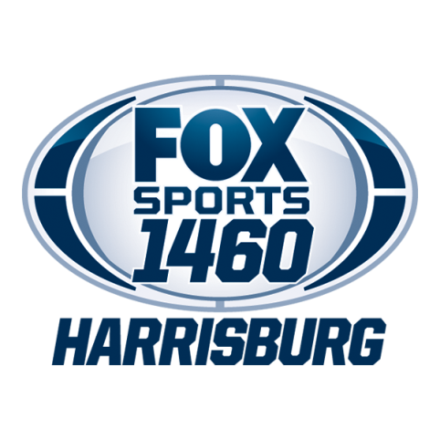 | 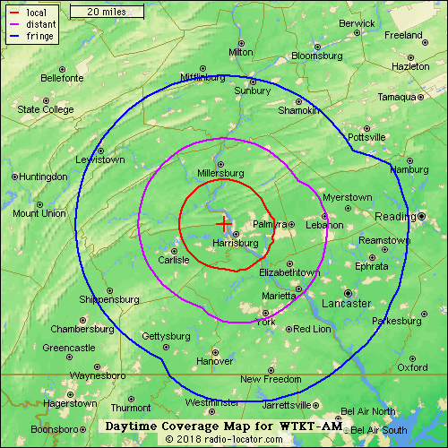

WTCT-AM – Harrisburg
This iHeart Media stations airs syndicated programming from Fox Sports.

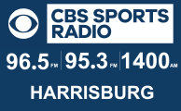 | 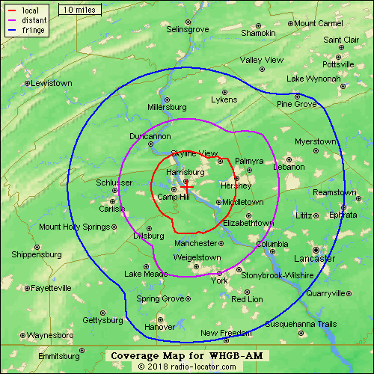

WHGB-AM - Harrisburg
Cumulus Media’s WHGB-AM air syndicated programming from CBS Sports Radio that originates at WGHB with translators that air the programming on 95.3 and 96.5 on the FM-band. Our research indicates that the station does not air local programming.

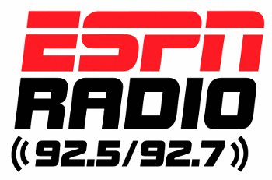 | 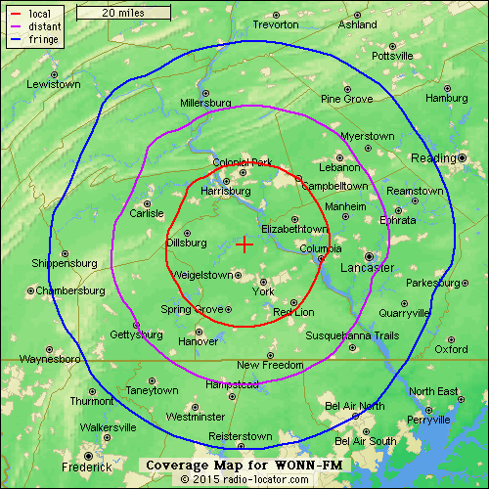

WONN-FM
Hall Communications’ WONN-FM airs syndicated programming from ESPN Radio.

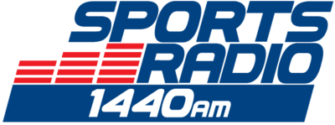 | 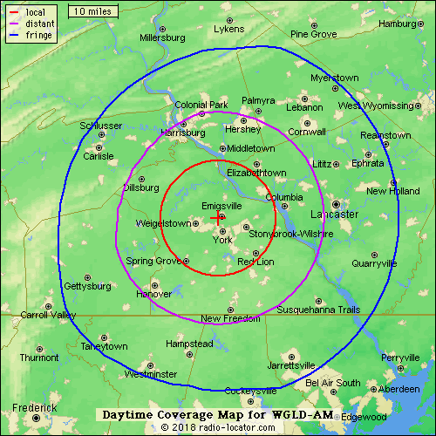
WGLD-AM – York
This is a Cumulus station that airs nationally-syndicated programming from CBS Sports Radio.

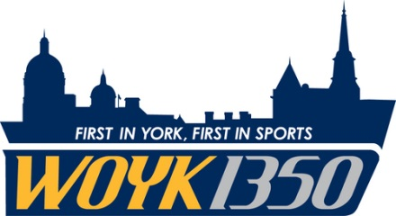 | 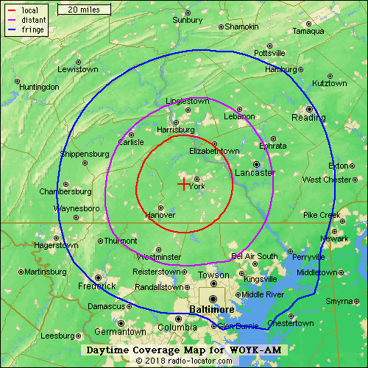

WOYK-AM – York
This is a station that is owned by the York Professional Baseball Club, LLC. The station airs syndicated programming from Fox Sports. This is the flagship for the York Revolution baseball team and airs a plethora of high school sports play-by-play broadcasts.

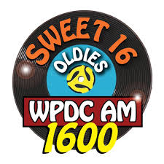 | 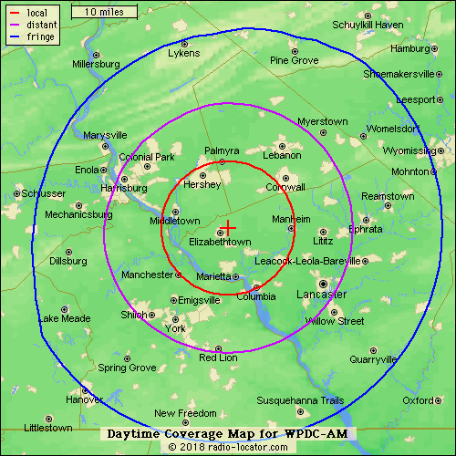

WPDC-AM – Elizabethtown
This is an independently-owned radio station based just outside of Harrisburg in Elizabethtown. Currently, the station format is oldies. This is a format flipper candidate.

PARTNER SPORTS BOOKS
- Hollywood Casino – Penn National Race Course - East Hanover Township, PA

540 | 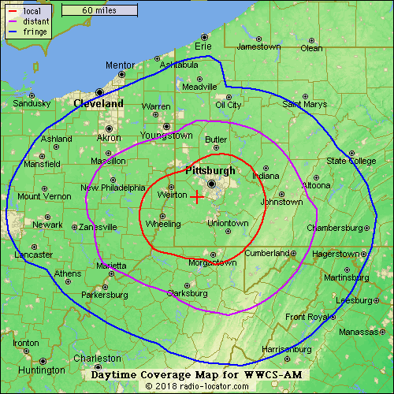

WWCS-AM – Pittsburgh
This station is 24/7/365 SB Nation Radio affiliate due to our partnership with Birach Broadcasting. At the flip of the format, this station will become VSiN 540 – Pittsburgh.

PARTNER SPORTS BOOKS
- Rivers Casino – Pittsburgh

Rhode Island

WPVD-AM – Providence
This is Providence’s ESPN Radio affiliate, airing the national lineup from the network.

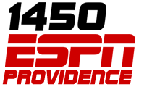 | 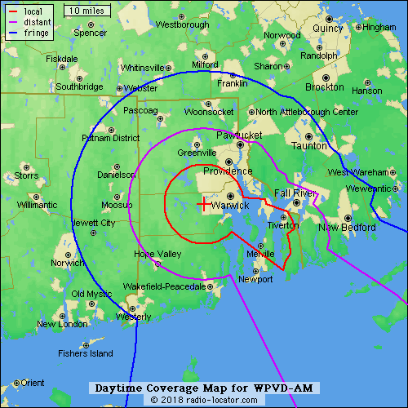

PARTNER SPORTS BOOK
- Twin River Casino Hotel - Providence

West Virginia

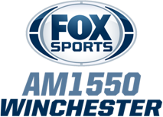 | 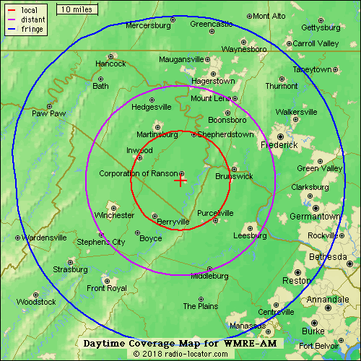

WMRE-AM
This is an iHeart Media station that airs syndicated programming from Fox Sports.

PARTNER SPORTS BOOK:
- Hollywood Casino @ Charles Town

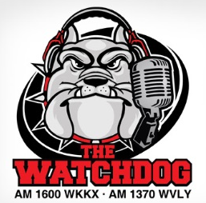 | 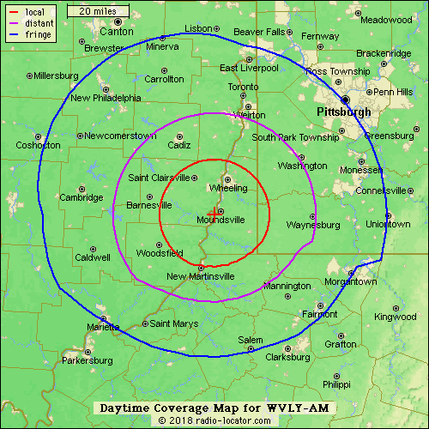 | 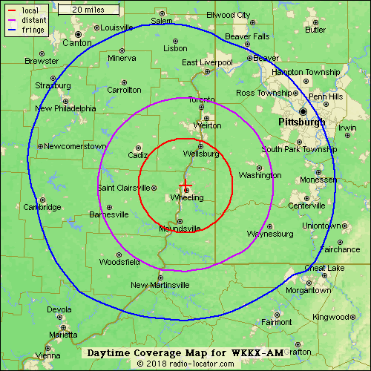

WVLY-AM & WKKX-AM – Wheeling, WV
This is an independently-owned station based in Wheeling. The station air locally-produces shows hosted by Howard Monroe and Steve Novotney. In addition, the station airs programming from West Virginia’s MetroNews Network, including show by Hoppy Kercheval and Tony Caridi. The station also airs nationally-syndicated programming, including Stephanie Miller, Dennis Miller, Jim Bohannon, and America in the Morning.

PARTNER SPORTS BOOKS
- Wheeling Island Hotel-Casino-Racetrack

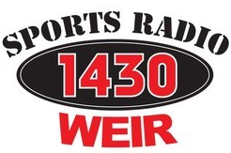 | 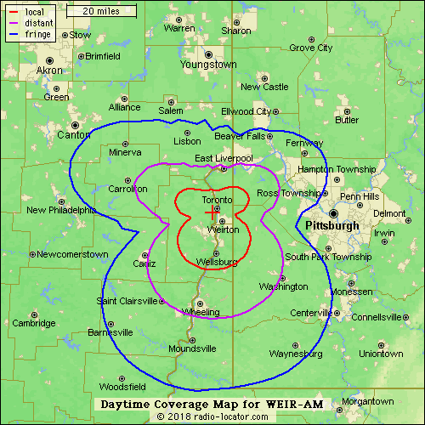 | 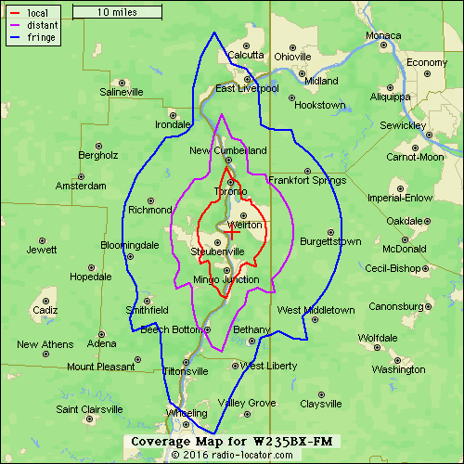

WEIR-AM & W235BX 94.9-FM – Weirton
This station is independently-owned by the Ohio Midland Newsgroup, LLC of Bellaire, Ohio. The station airs news/talk/sports programming with network affiliations with CBS Radio and West Virginia MetroNews. The station includes a FM translator on 94.9-FM.

PARTNER SPORTS BOOKS:
- Wheeling Island Hotel-Casino-Racetrack – Wheeling
- Rivers Casino - Pittsburgh

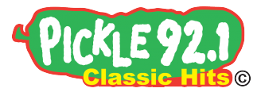 | 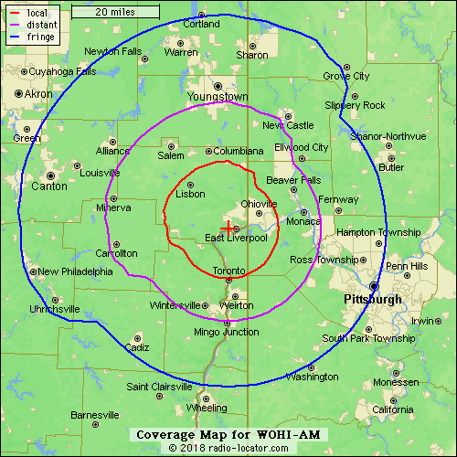

WOHI-AM – East Liverpool, Ohio
This station is a simulcast of Classic Hits station Pickle 92.1(WKPL-FM) that is owned by Forever Media. This group has radio stations in nine markets in Maryland, Pennsylvania, and West Virginia. The station is part of a group of stations that the ownership group markets as Forever Media Pittsburgh. If possible, we would encourage the station group to flip both stations to VSiN Radio. At a minimum, the hope would be to flip the AM signal to VSiN Radio.

PARTNER SPORTS BOOKS:
- Wheeling Island Hotel-Casino-Racetrack – Wheeling
- Rivers Casino - Pittsburgh

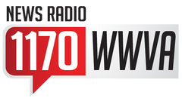 | 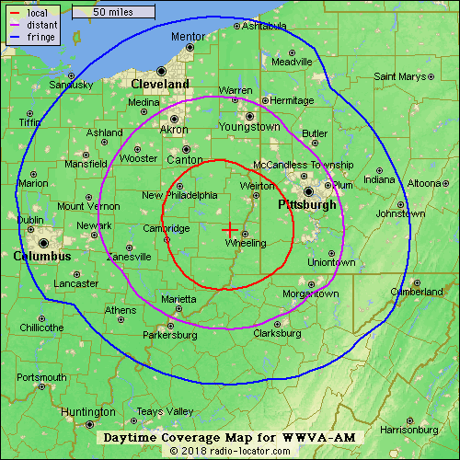

WWVA-AM – Wheeling
This iHeart Media station positions itself as Wheeling’s news/talk station. The station airs syndicated national programming from Rush Limbaugh and Sean Hannity.

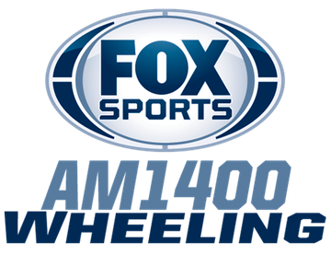 | 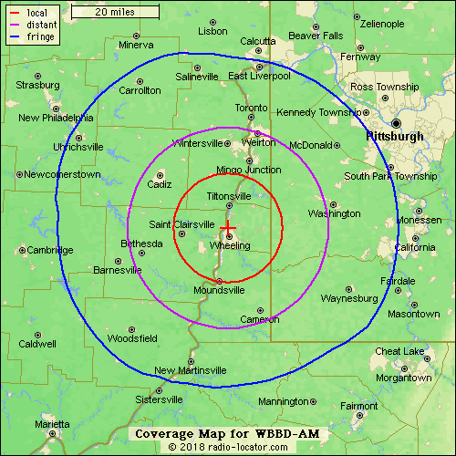

WBBD-AM – Wheeling
This is another iHeart Media station in Wheeling that airs syndicated programming from Fox Sports. Fox Sports Wheeling airs the Steelers, Pirates, and West Virginia Mountaineer football and basketball.

PARTNER SPORTS BOOKS:
- Wheeling Island Hotel-Casino-Racetrack – Wheeling
- Rivers Casino - Pittsburgh

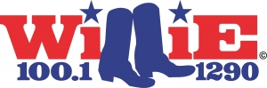 | 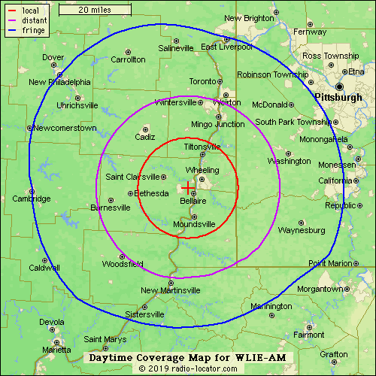

WILE-AM
This is a Forever Media station that currently airs a classic country format with the branding of Willie 1290 & 100.1

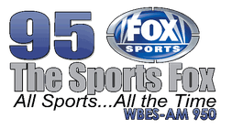 | 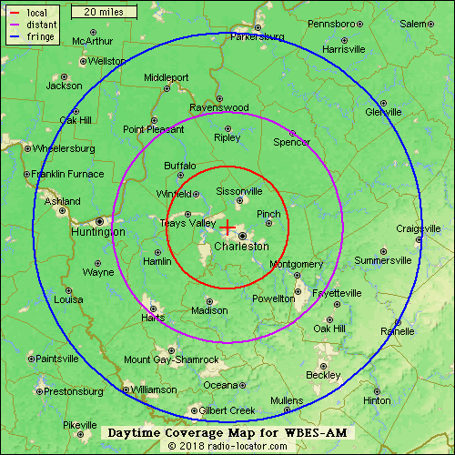

WBES-AM
This station is owned by Bristol Broadcasting and targets the Charleston, West Virginia market. The station airs syndicated programming for Fox Sports, a one-hour local show each afternoon, Marshall sports, and NASCAR racing.

 | 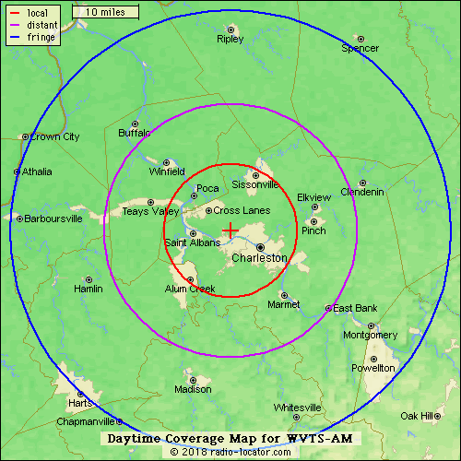

WVTS-AM
This is a Bristol Broadcasting station that includes shows from Sean Hannity, Glenn Beck, Michael Savage, and Laura Ingraham.

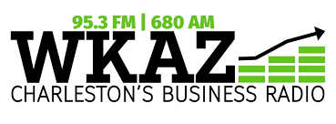 | 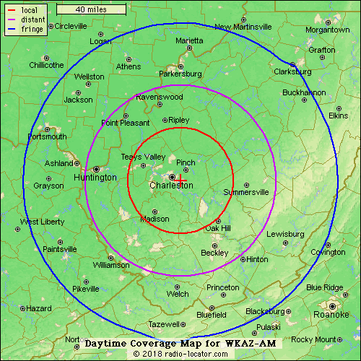

WKAZ-AM
This is a West Virginia Radio Corporation station that airs business news from Bloomberg. The station is position with sister station WCHS-AM and WSWW-AM to create the WCHS News Network that delivers news, sports, and business to Charleston listeners.

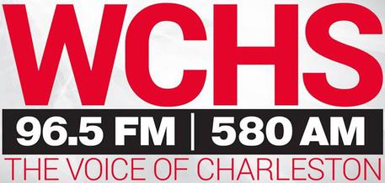 | 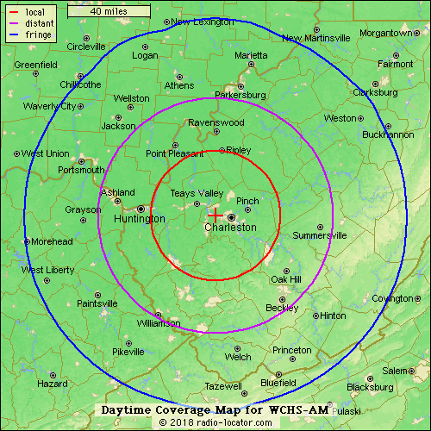
WCHS-AM
This is the flagship station of the WCHS News Network. The station includes national shows from Rush Limbaugh, Dave Ramsey, and Jim Bohannon, among others. The station is also the flagship for the statewide West Virginia Radio Network and includes MetroNews Talkline with Hoppy Kercheval and MetroNews SportsLine. The station also includes the locally produced Danny Jones Show and other local shows.

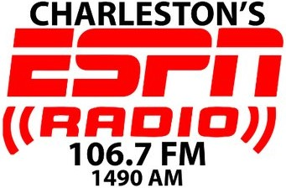 | 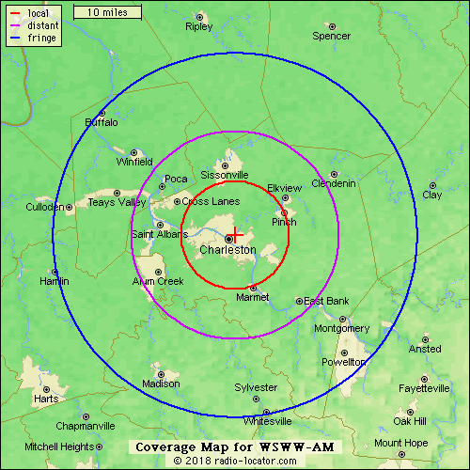

WSWW-AM
This is the sports station in West Virginia Radio’s WCHS News Network. The station airs an ESPN Radio lineup and play-by-play broadcasts.

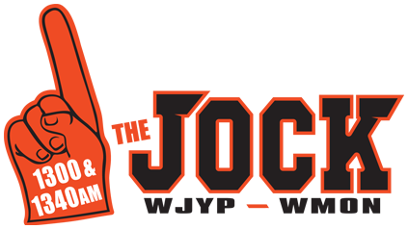 | 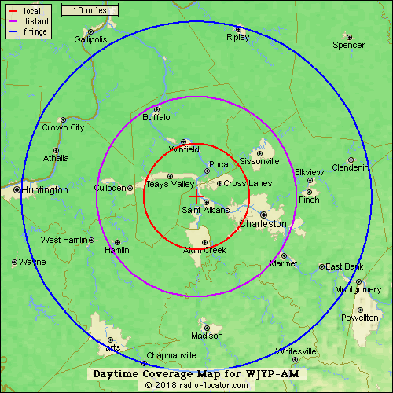 | 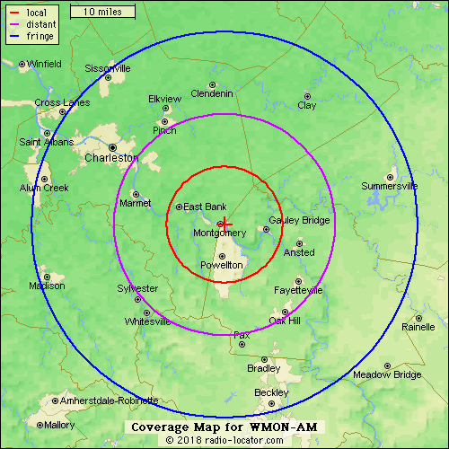

WJYP-AM & WMON-AM - Charleston/Beckley, WV
This is a current affiliate of SB Nation Radio. The stations are owned by LM Communications and reach both the Charleston and Beckley, WV radio markets. Two sports books are located inside the listening area.

PARTNER SPORTS BOOKS:
- Mardi Gras Casino – Cross Lanes, WV
- The Greenbrier – White Sulphur Springs WV

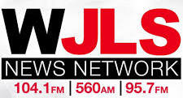 | 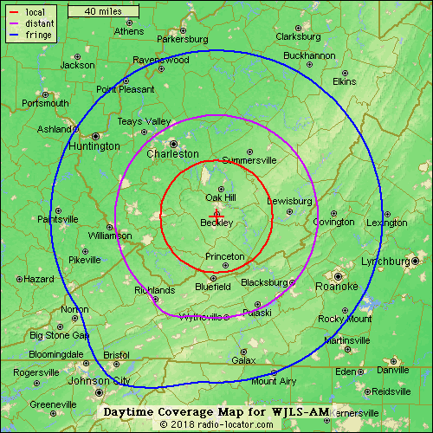

WCHS-AM
This West Virginia Radio Corporation station is the flagship station of the WJLS News Network. The station airs much of the same format as that of sister-station WCHS in Charleston. The station includes national shows from Rush Limbaugh, Dave Ramsey, and Jim Bohannon, among others. The station is also the flagship for the statewide West Virginia Radio Network and includes MetroNews Talkline with Hoppy Kercheval and MetroNews SportsLine. At night, the station drops its talk programming for music with a superstar country syndicated format.

 | 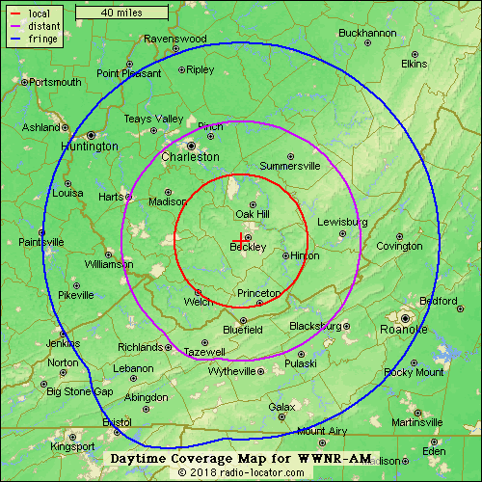

WWNR-AM – Beckley, WV
This Southern Communications station airs programming from mainly third-tier talk shows, including Hugh Hewitt, Clark Howard, Dennis Prager, Michael Savage, Mark Levin,and Ben Shapiro. The programs are from a patchwork of networks including Cumulus, Dial Global, Salem, and Westwood One. The station positions itself as conservative talk radio.

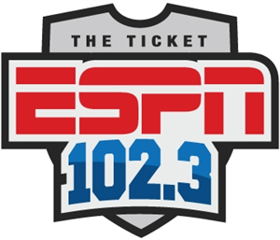 | 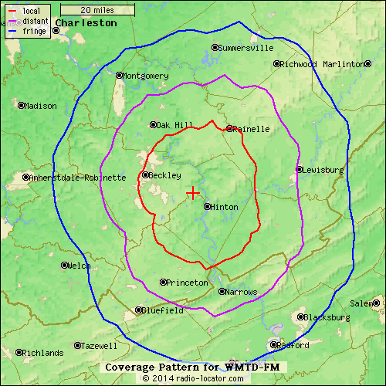

WMTD-FM
Hinton, WV-based WMTD-FM is owned by MontainPlex Media II, LLC. The station airs syndicated programming from ESPN, the Statewide Sportsline Show with Tony Caridi, and no locally-produced programming.

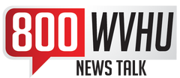 | 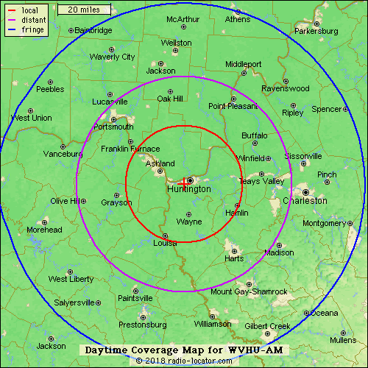

WVHU-AM – Huntington, WV
This is an iHeart Media station that includes programming from Glenn Beck, Rush Limbaugh, Sean Hannity, Clark Howard, and other syndicated hosts. The stations also airs the locally produced Tom Roten Morning Show.

“Follow The Money” has mass appeal and

Format flippers
In each market, we will work to identify under-performing radio stations that may benefit from a change of format to VSiN Radio. The change of format would be based on

Investing in paid clearances
The reality of the situation is that

A la carte show offerings
“Follow the Money” and “My Guys in the Desert” are two shows that we could market as a

Follow The Money - Mitch Moss & Pauly Howard
The morning show offers passionate, unique content on the biggest sports stories of the day.

A Number Game – Gill Alexander

The Edge – Jonathan Von Tobel and Matt Youmans

Between the Sidelines – Jonathan Von Tobel and Matt Youmans

My Guys in the Desert – Brent Musburger, Vinny Magliulo, and Amal Shah
The legendary Brent Musburger

Additional Hosts
Michael Lombardi
Patrick Meagher
Sam Panayotovich
Matt Brown
Erin Rynning

BetCast of the Week
VSiN hosts deliver a weekly BetCast of the week’s biggest sporting evnts.

BetCast of Major Championship Events
-College Football Playoff Championship
-Super Bowl
-Daytona 500, Indy 500
-NCAA Final Four
-Masters, U-S Open, Open Championship, PGA Championship
-NBA Finals
-World Series

Casino Partnerships for Local Affiliates
VSiN Branding of Local Stations

Top 50 Markets

DELAWARE

STATION/FORMAT | CITY | AFFILIATIONS | VSiN Action Updates
WWTX-AM  (SPORTS) | WILMINGTON, DE | FOX SPORTS  SB NATION AM | YES
WYUS-AM  (SPORTS) | DOVER, DE | ESPN | YES
WDOV-AM (NEWS/TALK/WEATHER | DOVER, DE | RUSH LIMBAUGH  SEAN HANNITY | NO

Potential sport book partners for our affiliate stations include:

- Delaware Park Casino;
- Dover Downs Hotel & Casino;
- Harrington Racing & Casino;
- Harrah’s Philadelphia;
- South Philadelphia Race & Sports Book; and,
- Sugar House Casino.

MISSISSIPPI

STATION/FORMAT | CITY | AFFILIATIONS | VSiN Action Updates
WANG-AM  WTNI-AM  (SPORTS) | BILOXI, MS | ESPN | NO
WODT-AM  (SPORTS) | NEW ORLEANS, LA | FOX SPORTS | NO

PARTNER SPORTS BOOKS

- Beau Rivage Resort & Casino – Biloxi
- Boomtown Casino - Biloxi
- Golden Nugget – Biloxi
- Hard Rock Hotel & Casino – Biloxi
- Harrah’s Gulf Coast – Biloxi
- Hollywood Casino Gulf Coast – Bay Saint Louis
- IP Casino Resort Spa - Biloxi
- Island View Casino Resort – Gulfport
- Palace Casino Resort – Biloxi
- Scarlett Pearl Casino Resort – D’Iberville
- Silver Slipper Casino – Bay St. Louis
- Treasure Bay Casino & Hotel – Biloxi

STATION/FORMAT | CITY | AFFILIATIONS | VSiN Action Updates
WJQS-AM  (SPORTS) | JACKSON, MS | FOX SPORTS | NO
WRKS-FM  (SPORTS) | JACKSON, MS | ESPN | NO

PARTNER SPORTS BOOKS:

- Ameristar Casino Hotel - Vicksburg
- Magnolia Bluffs Casino – Natchez
- WaterView Casino & Hotel – Vicksburg
- Bok Homg Casino – Heidelberg
- Pearl River Resort – Philadelphia
- Golden Moon Hotel & Casino @ Pearl River Resort – Philadelphia
- Silver Star Casino - Philadelphia
- Lady Luck Casino – Vicksburg
- Lighthouse Point Casino – Greenville

STATION/FORMAT | CITY | AFFILIATIONS | VSiN Action Updates
KQPN-AM  (SPORTS) | WEST MEMPHIS, AR | SB NATION | NO
WMFS-AM  (SPORTS) | MEMPHIS, TN | ESPN | NO

PARTNER SPORTS BOOKS:

- 1ST Jackpot Casino - Robinsonville
- Fitz Casino Hotel – Robinsonville
- Gold Strike Casino Resort – Robinsonville
- Harlow’s Casino Resort – Greenville
- Hollywood Casino & Hotel – Robinsonville
- Sam Town’s - Robinsonville
- Isle of Capri Casino & Resort – Lula
- Resorts Tunica – Robinsonville
- Tunica Roadhouse Casino & Hotel – Robinsonville

NEW JERSEY

STATION/FORMAT | CITY | AFFILIATIONS | VSiN Action Updates
WNJE-AM  (SPORTS) | TRENTON, NJ | FOX SPORTS | NO
WCMC-AM  WMID-AM  (OLDIES) | ATLANTIC CITY, NJ | NONE | NO
WBSS-AM  (CLASSIC HITS) | ATLANTIC CITY, NJ | NONE | NO
WOND-AM  (NEWS/TALK) | ATLANTIC CITY, NJ | JIM BOHANNON, AMERICA MORNING | NO
WPG-AM  (NEWS/TALK) | ATLANTIC CITY, NJ | SEAN HANNITY  MARK LEVIN  MICHAEL SAVAGE | NO

PARTNER SPORTS BOOKS:

- Monmouth Park Raceway – Monmouth
- Meadowlands Racetrack - Meadowlands
- Resorts Casino Hotel Sports Book – Atlantic City
- Ocean Resort Casino – Atlantic City
- Atlantic City’s Golden Nugget – Atlantic City
- Bally’s - Atlantic City
- Harrah’s – Atlantic City
- Caesars – Atlantic City
- Borgata Hotel, Casino Spa – Atlantic City

STATION/FORMAT | CITY | AFFILIATIONS | VSiN Action Updates
WBWD-AM  (ASIN) | ISLIP, NY | NONE | NO
WMCA-AM  (RELIGIOUS) | NEW YORK, NY | NONE | NO
WSNR-AM  (ETHNIC) | JERSEY CITY, NJ | NONE | NO
WFAN-AM  (SPORTS) | NEW YORK, NY |  | NO
WOR-AM  (NEWS/TALK) | NEW YORK, NY | NONE | NO
WABC-AM  (NEWS/TALK) | NEW YORK, NY | NONE | NO
WCBS-AM  (NEWS) | NEW YORK, NY | NONE | NO
WINS-AM  (NEWS) | NEW YORK, NY | NONE | NO
WPAT-AM  (ETHNIC) | NEW YORK, NY | NONE | NO
WNYM-AM  (NEWS/TALK) | NEW YORK, NY | NONE | NO
WBBR-AM  (BUSINESS) | NEW YORK, NY | NONE | NO
WVNJ-AM  (RELIGIOUS) | OAKLAND, NJ | NONE | NO
WLIB-AM  (GOSPEL MUSIC) | NEW YORK, NY | NONE | NO
WFAS-AM  (SPORTS) | WHITE PLAINS, NY | CBS SPORTS RADIO | NO
WMTR-AM  (OLDIES) | MORRISTOWN, NJ | NONE | NO
WADO-AM  (SPANISH NEWS) | NEW YORK, NY | NONE | NO
WWRV-AM  (SPANISH CHRISTIAN) | NEW YORK, NY | NONE | NO
WKDM-AM  (ASIAN) | NEW YORK, NY | NONE | NO
WNSW-AM  (RELIGIOUS) | NEW YORK, NY | NONE | NO
WVOX-AM  (NEWS/TALK) | NEW ROCHELLE, NY | NONE | NO
WZRC-AM  (ASIAN) | NEW YORK, NY | NONE | NO
WFME-AM  (RELIGIOUS) | NEW YORK, NY | NONE | NO
WWRL-AM  (ASIAN) | NEW YORK, NY | NONE | NO
WWRU-AM  (ASIAN) | JERSEY CITY, NJ | NONE | NO

NEW MEXICO

STATION/FORMAT | CITY | AFFILIATIONS | VSiN Action Updates
KNML-AM  (SPORTS) | ALQUQUERQUE | CBS SPORTS  JIM ROME  DAN PATRICK | YES
KQTM-FM  (SPORTS) | ALQUQUERQUE, NM | ESPN | NO

PARTNER SPORTS BOOK

- Santa Ana Star Casino Hotel – Santa Ana Pueblo

PENNSYLVANIA

STATION/FORMAT | CITY | AFFILIATIONS | VSiN Action Updates
WTCT-AM  (SPORTS) | HARRISBURG, PA | FOX SPORTS | NO
WHGB-AM  (SPORTS) | HARRISBURG, PA | CBS SPORTS RADIO | NO
WONN-AM  (SPORTS) | HARRISBURG, PA | ESPN | NO
WGLD-AM  (SPORTS) | YORK, PA | CBS SPORTS RADIO | NO
WOYK-AM  (NEWS/TALK/SPORTS) | YORK, PA | NONE | NO
WPDC-AM  (OLDIES) | ELIZABETHTOWN, PA | NONE | NO

PARTNER SPORTS BOOKS

- Hollywood Casino – Penn National Race Course - East Hanover Township, PA

STATION/FORMAT | CITY | AFFILIATIONS | VSiN Action Updates
WWCS-AM  (SPORTS) | PITTSBURGH, PA | SB NATION RADIO | NO
WBGG-AM  (SPORTS) | PITTSBURGH, PA | ESPN | YES
WHKB-AM  (CLASSIC HITS) | PITTSBURGH, PA | NONE | NO
WAMO-AM  (HIP HOP) | WILKINSBURG, PA | NONE | NO
WKFB-AM  (OLDIES/TALK) | PITTSBURGH, PA | NONE | NO
WEDO-AM  (VARIETY) | PITTSBURGH, PA | NONE | NO

PARTNER SPORTS BOOKS

- Rivers Casino – Pittsburgh
- Wheeling Island Hotel-Casino-Racetrack – Wheeling

STATION/FORMAT | CITY | AFFILIATIONS | VSiN Action Updates
WFLI-AM  (RELIGIOUS) | PHILADELPHIA, PA | NONE | NO
WTEL-AM  (SPORTS) | PHILADLEPHIA, PA | ESPN | NO
WWJZ-AM  (RELIGIOUS) | PHILADELPHIA, PA | NONE | NO
WPHE-AM  (SPANISH CHRISTIAN) | PHOENIXVILLE, PA | NONE | NO
WVCH-AM  (RELIGIOUS) | CHESTER, PA | NONE | NO
WTMR-AM  (RELIGIOUS) | CAMDEN, NJ | NONE | NO
WWDB-AM  (ETHNIC) | PHILADELPHIA, PA | NONE | NO
WURD-AM  (TALK) | PHILADELPHIA, PA | NONE | NO
WNJE-AM  (SPORTS) | TRENTON, NJ | FOX SPORTS | NO
WKDN-AM  (RELIGIOUS) | PHILADELPHIA, PA | NONE | NO
WNTP-AM  (NEWS/TALK) | PHILADELPHIA, PA | NONE | NO
WCHR-AM  (RELIGIOUS) | PHILADELPHIA, PA | NONE | NO
KYW-AM  (NEWS) | PHILADELPHIA, PA | NONE | NO
WNAP-AM  (GOSPEL MUSIC) | NORRISTOWN, PA | NONE | NO
WFYL-AM  (TALK) | KING OF PRUSSIA, PA | NONE | NO
WPHT-AM  (TALK) | PHILADELPHIA, PA | NONE | NO
WEMG-AM  (RELIGIOUS) | CAMDEN, NJ | NONE | NO
WHAT-AM  (TROPICAL) | PHILADELPHIA, PA | NONE | NO
WDAS-AM  (ADULT HITS) | PHILADELPHIA, PA | NONE | NO
WTTM-AM  (SPANISH) | LINDENWOLD, NJ | NONE | NO
WPEN-FM  (SPORTS) | PHILADELPHIA, PA |  | YES
WKXW-FM  (NEWS/TALK) | TRENTON, NJ | NONE | NO

PARTNER SPORTS BOOKS

- Harrah’s Philadelphia;
- Parx;
- South Philadelphia Race & Sports Book;
- Valley Forge Race & Sports Book; and,
- Sugar House Casino.

RHODE ISLAND

STATION/FORMAT | CITY | AFFILIATIONS | VSiN Action Updates
WPVD-AM  (SPORTS) | PROVIDENCE, RI | ESPN | NO

PARTNER SPORTS BOOK

- Twin River Casino Hotel – Providence

WEST VIRGINIA

STATION/FORMAT | CITY | AFFILIATIONS | VSiN Action Updates
WMRE-AM  (SPORTS) | WINCHESTER, VA | FOX SPORTS | NO

PARTNER SPORTS BOOK:

- Hollywood Casino @ Charles Town

STATION/FORMAT | CITY | AFFILIATIONS | VSiN Action Updates
WVLY-AM  WKKX-AM  (NEWS/TALK) | WHEELING, WV | WV METRONEWS | YES
WEIR-AM  (NEWS/TALK) | WEIRTON, OH | CBS RADIO  WV METRONEWS | NO
WOHI-AM  (CLASSIC HITS) | EAST LIVERPOOL, OH | NONE | NO
WWVA-AM  (NEWS/TALK) | WHEELING, WV | RUSH LIMBAUGH  SEAN HANNITY | NO
WBBD-AM  (SPORTS) | WHEELING, WV | FOX SPORTS | NO
WILE-AM  (CLASSIC COUNTRY) | WHEELING, WV | NONE | NO

PARTNER SPORTS BOOKS:
- Wheeling Island Hotel-Casino-Racetrack – Wheeling
- Rivers Casino - Pittsburgh

STATION/FORMAT | CITY | AFFILIATIONS | VSiN Action Updates
WBES-AM  (SPORTS) | CHARLESTON, WV | FOX SPORTS | NO
WVTS-AM  (NEWS/TALK) | CHARLESTON, WV | SEAN HANNITY  MICHAEL SAVAGE | NO
WKAZ-AM  (BUSINESS) | CHARLESTON, WV | BLOOMBERG | NO
WCHS-AM  (NEWS/TALK) | CHARLESTON, WV | WV METRONEWS | NO
WSWW-AM  (SPORTS) | CHARLESTON, WV | ESPN | NO
WJYP-AM  WMON-AM  (SPORTS) | CHARLESTON, WV  BECKLEY, WV | SB NATION RADIO | NO
WCHS-AM  (NEWS/TALK) | BECKLEY, WV | RUSH LIMBAUGH | NO
WWNR-AM  (NEWS/TALK) | BECKLEY, WV | SALEM-WWO  HUGH HEWITT | NO
WMTD-FM  (SPORTS) | HINTON, WV | ESPN | NO
WVHU-AM  (NEWS/TALK) | HUNTINGTON, WV | RUSH LIMBAUGH  WV METRONEWS | NO

PARTNER SPORTS BOOKS:
- Mardi Gras Casino – Cross Lanes, WV
- The Greenbrier – White Sulphur Springs WV

VSiN Radio launches as the 5th “Sports” Radio Network

PRO | CON
-Additional Inventory | -Direct Competitor
-New Markets | -NBC Sports Radio failure
-Narrow Target of Specific States | -
-Capitalize on an emerging market
-Unlike NBC Sports Radio, not truly a direct competitor, as VSiN Radio will feature different content

