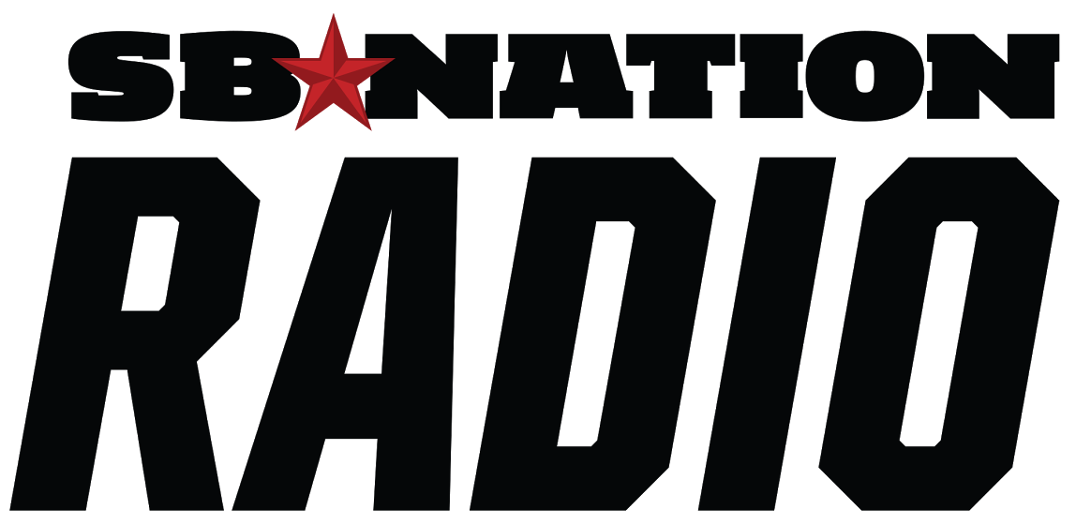
SB NATION RADIO
NETWORK AGREEMENT

THIS AGREEMENT, entered into this (Insert date of agreement) is between Gow Media, d/b/a SB Nation Radio (“SBNR”), having its principal offices at 5353 West Alabama, Suite 415, Houston, TX. 77056, and (Insert station’s corporate name) (“BROADCASTER”), the owner and operator of (insert station call letters and ID (“STATION”), whose business address (Insert station’s physical address) for the streaming radio programing and services of SB Nation Radio.

SBNR PROGRAMMING

  - SBNR will make its programming available to the STATION to air as needed or desired. By making the programming available to the STATION, the STATION can use the programming as needed during vacations, sickness, and other needs.

STATION COMMITMENT

  - STATION will consistently air SBNR programming from (Insert day and time station will incorporate SBNR programming) (at the “BASE LEVEL”). STATION will have the right to preempt SBNR programming with its local shows.
  - If STATION wants to add additional SBNR programming on a consistent basis – e.g., if the STATION changes its lineup by removing a local show and substituting an SBNR show, then STATION will notify SBNR of this decision.
c) During SBNR Programming the STATION will conform to SBNR’s broadcast clock. Specifically, STATION will air 6 minutes and 30 seconds of network minutes of inventory each hour of programming.

AGREEMENT TERM

  - This Agreement will extend for twelve (12) months from inception, provided, however, that either party will have the right to terminate this Agreement at any time with 30 days written notice.
  - This Agreement shall be auto-renewed by successive further terms of one year (renewal term) unless a 30-day written notice is provided, pursuant to the terms and conditions stated herein.
  - Notice of election to terminate this AGREEMENT or not to renew this AGREEMENT from either BROADCASTER or SBNR must be in writing, and sent to SBNR or to the BROADCASTER at their respective addresses set forth on the signature page hereto, or at such other address as the parties shall indicate in writing.
  - BROADCASTER agrees to begin airing SBNR programming and the commensurate clearance of network commercial advertising on (Insert day and time station will start SBNR programming).

4) GENERAL PROVISIONS

- SBNR shall make all Network programming decisions, and may make such additions, deletions or adjustments to
its programming offerings as it deems desirable and consistent with good program practices, and will make reasonably commercial efforts to advise BROADCASTER sufficiently in advance of said changes to allow for easy accommodation by STATION.
- BROADCASTER will, within 30 days of broadcast week, submit proof of performance affidavits, to SBNR electronically, on link, provided by SBNR. BROADCASTER and SBNR mutually acknowledge that it is SBNR's obligation to provide its advertisers with this information, and that failure by BROADCASTER to submit such reports in a timely fashion or submission of false, inaccurate, or deliberately misleading reports, shall constitute a material default under this Agreement.
- Except as provided in this Agreement, neither the BROADCASTER and/or SBNR shall incur any liability
to the other hereunder because of SBNR's inability to deliver, or STATION’S inability to broadcast any or all of SBNR programs and/or commercials due to failure of facilities, labor disputes, acts of God, or further causes beyond the control of either party failing to broadcast, or deliver.
- SBNR warrants and represents that it is sufficiently self-insured for errors and omissions including any claims by advertisers having advertising in or in conjunction with the broadcast hereunder of the program(s), and any other person claiming under or through the BROADCASTER, against any and all liability resulting from the broadcast hereunder of the program(s).
- BROADCASTER shall indemnify and hold harmless SBNR against any and all claims, damages,
liabilities, costs and expenses including legal expenses and reasonable counsel fees, arising out of the broadcasting of any material, other than material furnished by SBNR hereunder, which BROADCASTER may broadcast in connection with the programs. SBNR shall indemnify and hold harmless BROADCASTER against any and all claims, damages, liabilities, costs and expenses including legal expenses and reasonable counsel fees, arising out of the broadcasting of any material furnished by SBNR hereunder including but not limited to commercial announcements on behalf of SBNR. The foregoing indemnities shall survive this Agreement.
- Neither this Agreement, nor the rights and privileges granted to BROADCASTER pursuant to this Agreement, may be assigned to another party by BROADCASTER without the prior written consent of SBNR.
- No inducements, representations, or warranties, except as specifically set forth herein, have been made by any of the parties to this Agreement. This Agreement constitutes the entire Agreement between the parties and supersedes and replaces any and all prior Agreements or understandings of any nature whatsoever between the parties. No provision of this Agreement shall be changed, modified or discharged except by an instrument in writing signed by the party against whom such change, modification of discharge is claimed or sought to be enforced.
- This Agreement shall be governed by and construed in accordance with the laws of the State of Texas, U.S.A., excluding the conflict of laws provisions thereof. In the event that any dispute arises between the parties concerning the terms, interpretation, construction or application of this Agreement, the parties hereby agree and consent to litigate their disputes exclusively in the federal or state courts located in the State of Texas and both parties hereby consent to the jurisdiction of such federal or state courts located in the State of Texas for such purpose.

Therefore, this Agreement constitutes the entire understanding between the parties and is hereby executed by signature below, on the date as first written herein.

(Insert station call letters and ID) SB Nation Radio
Craig Larson, Jr. //s//

(Name of station’s PD or president) Craig Larson, Jr. Program Director/Affiliate Manager

DATED: DATED:

EXHIBIT:

The following is the “BASE LEVEL” of SBNR programming to be streamed consistently on STATION.

Will stream (Insert date)
(Inset time)

