To: Bill Schulz

From: Mike Sinnott

Date: August 2, 2019

Re: BetR Network on Reno Media Group

NOTE: BetR is pronounced BETTOR

On August 5, the Vegas Stats & information Network (VSiN) will launch “The BetR Network,” the nation’s first-ever terrestrial radio network that focuses exclusively on sports betting. BetR Network programming will originate from the multi-million-dollar, glass-enclosed “fish bowl” studio located inside the sports book of the South Point Hotel Casino on Las Vegas Boulevard. This programming is unique in the sports-format category and will appeal to not just sports bettors, but anyone who enjoys sports.

Without specifics, I’m taking creative liberties when discussing the possible options for Reno Media Group, so at different times I may use any or all of your stations as examples in this proposal. This does not necessarily represent our desires, but represents a hypothetical exercise for the purposes of this proposal.

Here are our goals:

- The BetR Network – Full-Time Affiliate
Our primary goal is to land a full-time terrestrial radio station in the Reno market. This does not preclude the development of local radio shows or play-by-play broadcasts on the station. In fact, we strongly encourage you to develop an identity that includes locally-produce sports betting show. BetR Network will even help you to develop local shows.

We recommend that Reno Media Group flip one of its current radio stations from a music format to the BetR Network. We would work with you to develop branding for your new sports betting radio station. For example, the station could be The BetR 1270 & 96.1, Reno’s home of the BetR Network. Pronounced “The Bettor,” the station will focus on the news, stories and information that matters most to sports bettors AND sports fans.

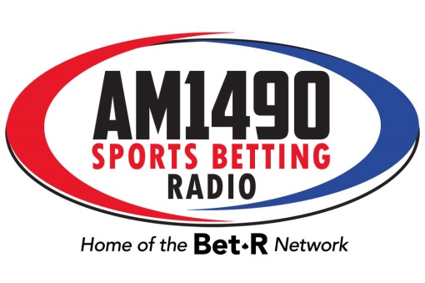
If you wanted to create your own identity, we can help with that as well. In Atlantic City, our full-time affiliate is branded as Sports Betting Radio 1490 WBSS. We will assist you in helping you to find and identify branding that will help your station resonate with the audience. In fact, if needed, we can even help with logo design.

- Marketing Advantage: A sports station that actually talks about sports
Currently, all of the sports networks, including our owned-and-operated SB Nation Radio, struggle to talk about what listeners want to hear about most, the sports news and information that impact the outcome of the games. Too often, sports talk devolves into politics, guy talk, and sophomoric humor.

The BetR Network is laser-focused on what matters most to sports bettors. We deliver the news, information, and analysis on focuses on the games, players, coaches, and fans that have more than a rooting interest in sports.

In a crowded marketplace of multiple sports networks, the BetR Network is a breath of fresh air, a network that sounds different than anything that’s currently on-air in the Reno market. When compared to ESPN, Fox Sports, and CBS Sports Radio, the BetR Network will be a breath of fresh air to the listener that is craving a radio station that actually talks about sports.

- Airing of Brent Musburger’s Action Updates on Lotus Reno stations
This 60-second, short-form feature delivers betting news and information and is currently heard on more than 120 radio stations across the country, including the biggest brands in sports radio:

-Boston’s 98.5 The Sports Hub;
-Chicago’s 670 The Score;
-San Francisco’s KNBR;
-Philadelphia’s 97.5 The Fanatic; and,
-SiriusXM’s Mad Dog Sports Radio.

As our partner in the Reno market for BetR Network, our hope is that you’ll clear our VSiN Action Updates on the station and your non-music stations in the market, including:

-103.7 The River;
-Ten Country KOLC-FM;
-96.9 The Rodeo; and,
-Bob 96.1.

In this instance, we would use the Action Updates to promote the BetR Network affiliate. For example, we could have Brent Musburger record this intro to the Action Updates.

“This 103.7 The River Action Update is powered by BetR 1230 & 92.5”

That’s one method of cross-promotion that would benefit the new BetR Network station. It is also possible for you to sell local sponsors to the updates and we would include that in your updates.

PROGRAM | PLATFORM | INVENTORY
BETR NETWORK | HD Sideband | 10.5 LOCAL/5.5 NETWORK  per hour during network programming
BETR NETWORK | AM/FM/HD  Channel of Choice | 10.5 LOCAL/5.5 NETWORK  per hour of network programming
VSiN Action Update | KODS-FM  KOLC-FM  KLCA-FM  KZTQ-AM  KBZZ-AM | BetR receives only the “billboard” read contained in the action update and no additional inventory. Reno Media Group has the right to sell the Action Updates to local sponsors.

Again, please consider this a framework of what our potential relationship could look like with the Reno Media Group. This is a conversation starter for us to explore the opportunity for a mutually beneficial business relationship.

If you have any questions, please let us know.

Let’s talk again soon.

