To: JR Smith

From: Mike Sinnott

Date: February 17, 2020

Re: BetR Network – Monroe, Louisiana

Vegas Stats & information Network (VSiN): Delivering content to multiple platforms
The Vegas Stats & information Network is the nation’s first-ever multimedia network dedicated to delivering relevant, real-time news and actionable information for sports bettors. “The BetR Network” is VSiN’s radio platform, delivering this unique content to terrestrial radio stations nationwide.

Our programming originates from the floor of the sportsbook at the South Point Hotel & Casino on the strip in Las Vegas, Nevada. Each month, VSiN programming makes more than 41-million impressions on multiple platforms, including:

-VSiN.com;
-The BetR Network;
-SiriusXM;
-TuneIn;
-Madison Square Garden (MSG) Networks;
-New England Sports Network (NESN);
-Marquee Network;
-Sportsnet (Canada);
-Game Plus (Canada);
-fuboTV; and,
-Sling TV.

Even in the highly-competitive sports media landscape, “The BetR Network” stands alone with its unique content offering for radio stations.

BetR Network: delivering a competitive edge for your station
Currently, there are five full-time sports radio networks in the country. Gow Media manages two of those networks: SB Nation Radio and The BetR Network. The others are ESPN; Fox Sports Radio; and CBS Sports Radio. Currently, all of the national sports-radio networks, including SB Nation Radio, sound pretty much the same. The guests, topics, callers, and content are essentially alike with only slight variations between the networks.

The BetR Network offers a unique, financial perspective on sports with passionate, entertaining hosts who have a real, vested interest in the games. No more sophomoric guy talk; no “hot” takes; no more politics invading sports; no more hosts begging for callers and then berating them.

The BetR Network delivers sports talk that focuses on the games, the players, the coaches, and the fans that live for sports. Our approach to sports-talk radio is refreshing and creates an opportunity for you to position your station as an alternative to the homogenous sports-talk networks. Our programming will stand out in this crowded marketplace.

ESPN, Fox Sports, CBS Sports Radio, and even our very own, SB Nation, will deliver more of the same while “The BetR Network” delivers a new, refreshing, passionate, invested perspective of sports. No network can duplicate our content.

Status of sports betting in LOUISIANA
On the final day of the 2019 legislative session, state lawmakers failed to approve sports betting in the state. A bill to authorize sports betting in the state House did not make it out of committee. The state Senate considered a bill that would authorize sports betting at casino’s and race tracks. That bill, however, required a local referendum to approve sports betting in each parish. That legislation (SB 153) was passed by the Senate in 2019. Yet, in May, the House Appropriations committee torpedoed the bill with amendments that included video poker parlors and a mandate to use official league data. State lawmakers return to work in March. With the success of sports betting in Mississippi, a real concerted push is likely to approve sports betting in the state in 2020.

MISSISSIPPI: $526.3-MILLION in sports wagers since legalization
Since taking its first sports bet in August 2018, Mississippi has “handled” more $526.3-million in sports wagers. The “handle” is the total amount of money bet on sports.

TOTAL MONEY WAGERED ON SPORTS IN MISSISSIPPI

MONTH | HANDLE
Aug-18 | $6,270,128
Sep-18 | $31,770,270
Oct-18 | $32,837,334
Nov-18 | $44,499,883
Dec-18 | $41,762,048
Jan-19 | $35,190,774
Feb-19 | $25,148,135
Mar-19 | $32,421,264
Apr-19 | $19,188,763
May-19 | $17,438,288
Jun-19 | $15,190,666
Jul-19 | $13,383,383
Aug-19 | $19,876,370
Sep-19 | $37,870,989
Oct-19 | $48,019,481
Nov-19 | $56,369,036
Dec-19 | $49,076,433
 | $526,313,245
MISSISSIPPI HANDLE-2018: $157-MILLION

MONTH | HANDLE
Aug-18 | $6,270,128
Sep-18 | $31,770,270
Oct-18 | $32,837,334
Nov-18 | $44,499,883
Dec-18 | $41,762,048
 | $157,139,663

MISSISSIPPI HANDLE-2019: AN INCREASE OF $212-MILLION FROM 2018

MONTH | HANDLE
Jan-19 | $35,190,774
Feb-19 | $25,148,135
Mar-19 | $32,421,264
Apr-19 | $19,188,763
May-19 | $17,438,288
Jun-19 | $15,190,666
Jul-19 | $13,383,383
Aug-19 | $19,876,370
Sep-19 | $37,870,989
Oct-19 | $48,019,481
Nov-19 | $56,369,036
Dec-19 | $49,076,433
 | $369,173,582

With online/mobile sports betting not available in the state, Mississippi bettors can only place wagers at “brick-and-mortar” sports book locations. State lawmakers are considering legislation to expand sports betting in the state to online and/or mobile betting. The inclusion of online/mobile betting is likely to be added to the state’s gaming menu due to the significant amount of state tax revenue the state is missing out on without online/mobile betting.

Mobile betting will surpass the money spent at retail sports-book locations
In New Jersey, online/mobile betting has increased from $21.7-million in August 2018 to more than $488.9-million in December 2019. In fact, 87.6-percent of all money wagered on sports in New Jersey was bet online or through a mobile app. This expands sports betting beyond retail locations. With online/mobile betting, people can bet from anywhere inside the state. This will dramatically increase the number of bettors in the state.

NEW JERSEY: SPORTS BETTING HANDLE

MONTH | RETAIL HANDLE | ONLINE HANDLE | TOTAL
Dec-19 | $ 68,933,821.00 | $ 488,931,379.00 | $ 557,865,200.00
Nov-19 | $ 75,890,898.00 | $ 486,784,645.00 | $ 562,675,543.00
Oct-19 | $ 70,959,985.00 | $ 416,964,519.00 | $ 487,924,504.00
Sep-19 | $ 71,317,160.00 | $ 374,246,343.00 | $ 445,594,503.00
Aug-19 | $ 44,357,272.00 | $ 249,237,590.00 | $ 293,594,862.00
Jul-19 | $ 38,332,533.00 | $ 213,038,739.00 | $ 251,371,272.00
Jun-19 | $ 46,520,409.00 | $ 226,702,566.00 | $ 273,222,975.00
May-19 | $ 55,388,358.00 | $ 263,552,319.00 | $ 318,940,677.00
Apr-19 | $ 59,743,318.00 | $ 253,976,244.00 | $ 313,719,562.00
Mar-19 | $ 74,169,188.00 | $ 298,282,154.00 | $ 372,451,342.00
Feb-19 | $ 61,496,490.00 | $ 258,871,597.00 | $ 320,368,087.00
Jan-19 | $ 80,305,676.00 | $ 304,973,986.00 | $ 385,279,662.00
Dec-18 | $ 78,130,359.00 | $ 241,043,289.00 | $ 319,173,648.00
Nov-18 | $ 92,132,952.00 | $ 238,615,611.00 | $ 330,748,563.00
Oct-18 | $ 86,341,617.00 | $ 174,369,684.00 | $ 260,711,301.00
Sep-18 | $ 79,062,731.00 | $ 104,885,673.00 | $ 183,948,404.00
Aug-18 | $ 73,919,891.00 | $ 21,714,157.00 | $ 95,634,048.00
Jul-18 | $ 40,682,237.00 | N/A | $ 40,682,237.00
Jun-18 | $ 16,409,619.00 | N/A | $ 16,409,619.00
TOTAL |  |  | $ 5,830,316,009.00

Audience Profile
This audience of engaged listeners will deliver results for your station and your advertising partners. According to the American Gaming Association, sports bettors are:

-male (69% of sports bettors are men);
-young (44% under the age of 35);
-educated (53% bachelor’s degree or better); and,
-professional (29% with a household income of more than $100,000).

The sports betting audience is younger than the traditional sports-talk audience, more educated, and with more disposable income to spend outside of sports betting. A number of traditional categories appeal to the sports bettor, including:

-entertainment (sporting events, movies);
-travel & leisure;
-financial services;
-insurance;
-electronics; and,
-luxury automobiles.

Advertising partners will extend well beyond sports books and sports betting web sites. This is a desirable audience that goes well beyond those advertisers. VSiN has delivered results for many national advertisers, including:

-Indeed;
-Lumber Liquidators;
-Blink Home Security;
-Blue Emu;
-Med Men; and,
-O’Reilly Auto Parts, among others.

Non-Traditional Revenue Opportunities
Our recommendation is to expand your sales offerings beyond the traditional commercial campaigns for your local advertisers. While these campaigns are effective, there are additional ways to generate revenue for the station, including:

-brokered programming blocks paid for and produced by the sportsbooks;
-live shows from the sportsbooks paid for and produced by the sportsbooks; and,
-hourly sponsorships to the exclusion of other sports books.

Exclusive, Exclusionary Programming Hours
The brokered programming will generate revenue at an hourly rate with minimal cost to the station. Outside of the brokered programming, the station could sell exclusionary hours in which BetR Network programming is sponsored by the sports book to the exclusion of their competitors. Local liners would proclaim that this hour is brought to you by the advertiser and only that sports book will be allowed to advertise during that hour. This would be a premium hour of advertising for the sports book.

Sports-betting seminar
The entire southeastern United States is a nascent sports betting market. Although there are some seasoned sports bettors who have previously placed bets - whether legally or on the black market - a higher percentage of potential sports book customers are new to the game. We will work with your stations to host a sports-betting seminar to educate potential sports bettors about how to place bets, mistakes to avoid, the different betting markets available, and the nuances of sports betting.

The seminar will be hosted at a local sportsbook or casino ball room. The two-day seminar will include sports betting experts, odds makers, professional bettors, and sports personalities, delivering the info that the public needs to beat the sportsbook. A portion of the show will be broadcast live on your stations, The BetR Network, and VSiN.

In addition to sponsorship opportunities for advertisers, including the title sponsorship of the event, the right to host the seminar, and access to the list of attendees, we will charge a fee to attend event. That cost could be determined at a later date, but a fee of $250 per person for this exclusive opportunity to learn the ins-and-outs of sports betting from prominent pro bettors, handicappers, and bookmakers. It would be a reasonable investment for serious sports bettors and those interested in learning more about how to bet and win at the sports book.

Station branding to set it apart from the competition
Now it’s time for something completely different . . . The BetR Network offers an alternative to the current sports-radio landscape. The BetR Network is sports talk that actually talks about sports, delivering relevant, actionable information that bettors can use to win at the sports book. We will work with you to develop your station branding.

Here are a few branding suggestions:

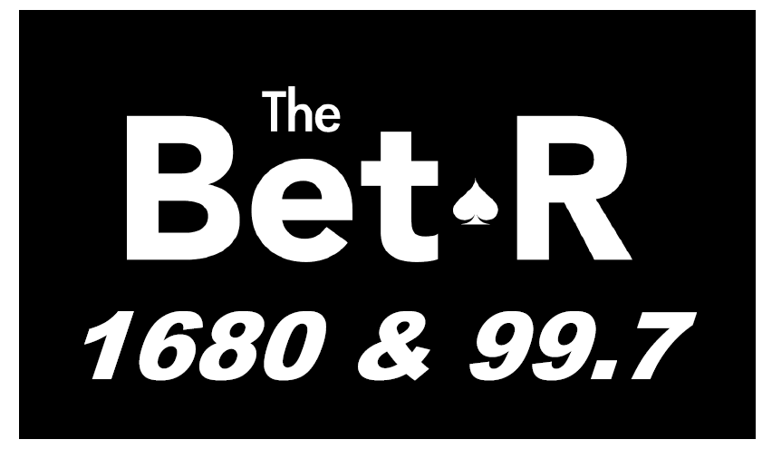

BetR 1680 & 99.7 (BetR = Bettor)
The BetR Network is new, fresh, and decidedly different than the other network sports-radio brands available in radio. Besides, The BetR speaks directly to our audience of bettors and those looking for a different perspective on the games of the day. We focus on delivering relevant, real-time information that the bettor can use to win. The BetR Network focuses on the news, information that the bettor needs to win at the sportsbook.
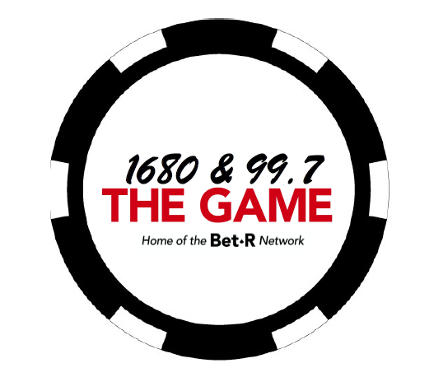
1680 & 99.7 The GAME
This station will focus on what matters most to sports fans – The Game. There’s a double meaning here in that bettors are concerned with not only the game on the field, but also the game that they’re playing, whether they’re betting point spreads; money lines; totals; season win total; and/or prop bets.

The station will feature programming that focuses on the games on the field and the games our listeners play at the sports books. No more sophomoric guy talk; no more hot takes; no more politics invading sports; no more hosts begging for callers and then berating them. The Game will feature sports talk that actually talks about sports, focusing on the games, the players, the coaches, and the fans that live for sports. At the end of the day, for our listeners, “THE GAME” is what matters most.

AM 1680 & FM 99.7 – The EDGE
Featuring an unprecedented lineup of sports betting experts from across the country, the station will give listeners “The Edge” they need to beat the books.

Our affiliate station in Reno, Nevada is using a variation of this branding as “The Player’s Edge.” Here’s is the station logo:

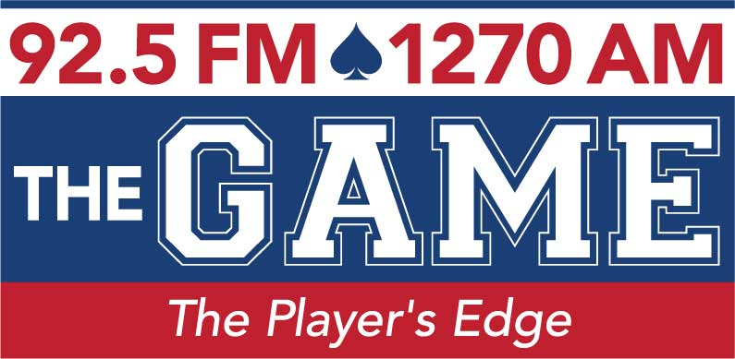

Sports Betting Radio 1680 & 99.7 – Monroe’s home of the BetR Network
We have found that branding as “Sports Betting Radio” helps to differentiate the station in the marketplace, giving a clear message to listeners about exactly what listeners will hear on the station.

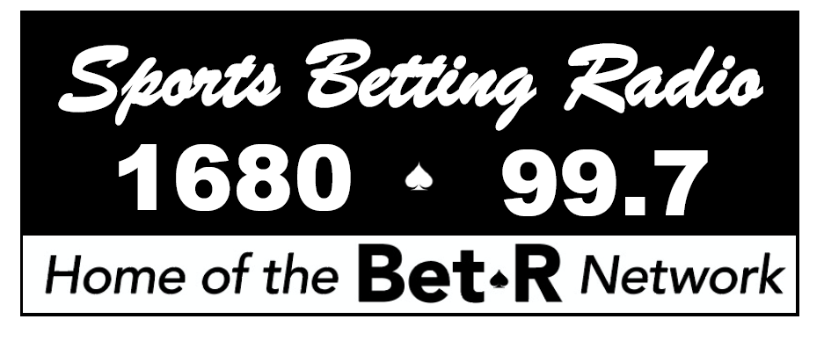

Our full-time affiliate in Atlantic City, New Jersey chose the branding “Sports Betting Radio.” Here’s that station’s logo:
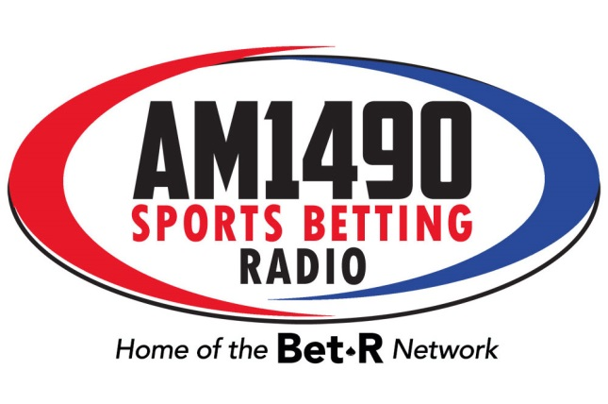
Brent Musburger’s VSiN Action Updates
This is our short-form programming feature that focuses on the betting information on the teams that matter most to your listeners. This is a self-contained feature and we only require the “live read” included in the report from Brent Musburger for our national advertisers. If you want to sell a local sponsor, just send us the copy and we’ll have Brent record that copy to include in the updates. In that instance, we would require ROS inventory in exchange for that local sponsor insertion.

Promotion of your BetR Network affiliation
We will leverage our many assets to promote BetR Network programming on your station, including:

-promotion of station on our television platforms;
-click-through banner ads on VSiN.com;
-advertisement in our daily newsletter; and,
-advertisement in our weekly digital sports-betting publication, Point Spread Weekly.

Sales & Marketing support for your station
As a BetR Network affiliate, we will provide support to your sales efforts to attract local and national advertising. We will leverage our contacts in the gaming industry to help secure advertising partnerships for you with your local casinos and sports books.

Summary
We welcome the opportunity to flip one of your stations to a full-time BetR Network affiliate. If that’s not possible, we can deliver our programming a-la-carte to you, based on your programming needs.

If full-time affiliation is not possible, then we do propose the following:

-airing of “Follow the Money” and/or “My Guys in the Desert” from the BetR Network;
-airing of weekend, evening, and or overnight programming based on your needs;
-airing of our Brent Musburger Action Updates during your broadcast day.

This is a tremendous revenue opportunity for your station to secure a significant revenue stream from not only sportsbook properties, but also advertisers interested in this educated, professional audience with plenty of disposable income.

Let’s talk again soon.

Mike

